From: | Diane Brandon <dianebrandonauthor@gmail.com>
Subject: | "Dr. Pat Show," Your Higher Soul Awareness, Online Class, & Other Tidbits
Reply: | dianebrandonauthor@gmail.com


  Having trouble viewing this email? www.dianebrandon.com/index_files/page0178.htm

You are receiving this email from Diane Brandon because you purchased a product/service or subscribed on our website or at an event. To ensure that you continue to receive emails from us, add dianebrandon@bellsouth.net to your address book today. If you haven't done so already, click to confirm your interest in receiving email campaigns from us.

You may unsubscribe if you no longer wish to receive our emails.

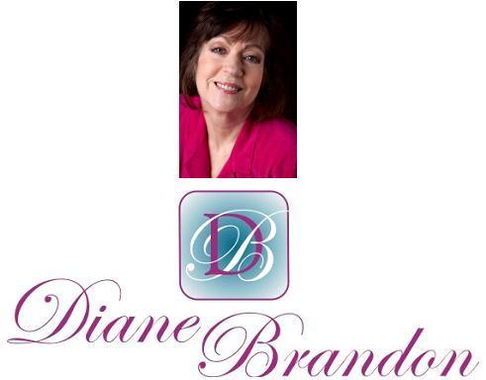

Integrative Intuitive Counselor, Intuition Teacher,
Speaker, & Author

August 17, 2015

"Dr. Pat Show," Your Higher Soul Awareness, Online Class, French Edition, & Other Tidbits

  In This Newsletter
  "Dr. Pat Show" & Other Radio Appearances
  New Book on Dreams
  Animals and Trust
  New Email Address
  French & Other Foreign Editions
  Online Class on Intuition
  Whale Asking for Help
  Skype for Recordings of Sessions
  Video on Benefits of Meditation
  A Call for Dreams
  Guided Meditation for Healing
  My Schedule at Dancing Moon
  Mentoring in Intuition
  Refer a Friend & Gift Certificates
  Donate Free to Causes
  Share
  Signature Block
  Links
  My Newest Book
  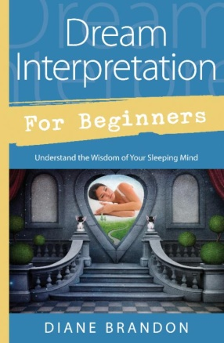
  Now Out & Available in Bookstores & Online
  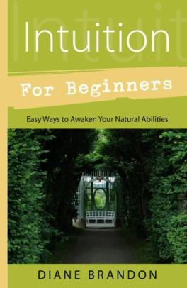
  Intuition for Beginners
  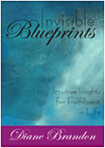
  Invisible Blueprints
  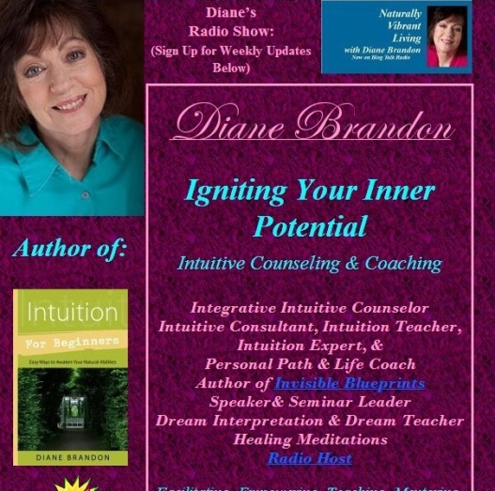
  My Site -- www.dianebrandon.com
  Dream Group on Facebook:
  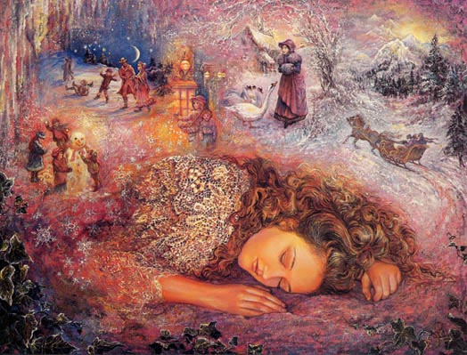
  Your Dream World
  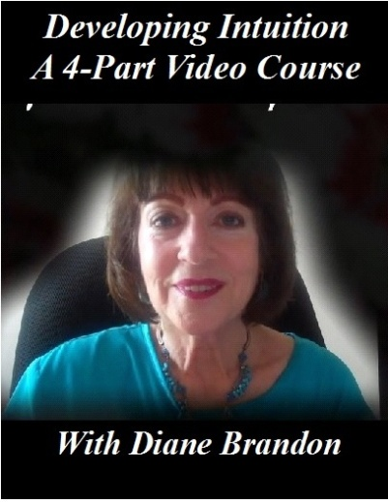
  A Four-Part Video Course on Developing Intuition
  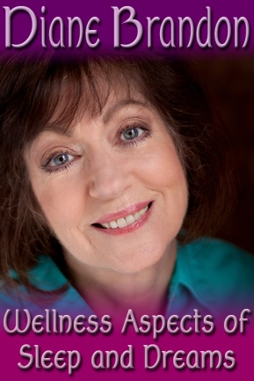
  Video, "The Wellness Aspects of Sleep & Dreams"
  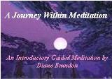
  "A Journey Within Meditation"
  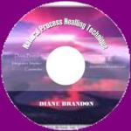
  "Natural Process Healing"
  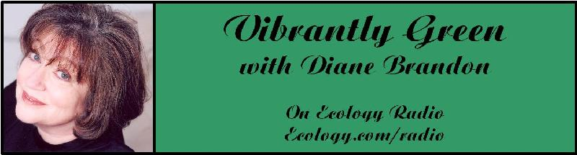
  "Vibrantly Green with Diane Brandon" Radio Show on Ecology.com
  
  Speaking Out
  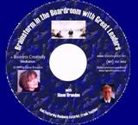
  "Brainstorm in the Boardroom with Great Leaders" Business Meditation CD
  More Cds/Mp3s, Including Intuition Exercises at
  http://www.dianebrandon.com/index_files/page0122.htm
  Find Me on:
  
  Twitter
  
  https://www.facebook.com/pages/Diane-Brandon/128849587146042
  I hope that this newsletter finds you well!
  We seem to be in the middle of another, somewhat intense phase of shifting -- a transition period. I started sensing this three or four weeks ago. You may have felt a heaviness in the energy or that people seem more reactive than usual or that you need more alone time to replenish and recharge your energy and center or that old issues appear to be surfacing. The drama on the world stage seems to have amped up and we've been seeing more severe weather events. I personally started to feel a few months ago that we had entered a new period in which weather problems would increase.
  This may sound alarming and/or negative. However, it's all part of the shifts going on. In some ways, we're beginning to see more effects of our actions as humans that have been harming the environment and wildlife. Unfortunately sometimes we need to see things worsening before we're led or ready to make healthier and more positive choices.
  I'm an optimist -- a spiritually based optimist, so I always feel that things are happening for a reason and that it's important for us to trust that everything is happening for a higher purpose.
  It's so important for us to remember that everyone and everything is intrinsically and inexorably connected and intertwined in a web of connection and mutuality and that whatever we do affects the whole.
  We know that we're in the middle of a paradigm shift, which can create friction and discord. Keeping our eyes on a positive outcome is so important and can help us move through the difficult aspects.
  We're also going through spiritual shifts, and it feels increasingly important to keep this in mind. Even though for centuries, those who were spiritual felt that they were "not of this world" and tended to focus solely on higher levels, I feel that we're now being called to realize that this physical world is also spiritual and important for us to include in our spiritual focus. The same Divine consciousness runs through everything on this level and animates all beings. At a time of environmental degradation and wildlife species extinction, it's very important to remember that our dishonoring the Earth and wildlife also dishonors that which is spiritual. I feel that we are spiritually being called to be stewards of the physical in a more positive, protective, and inclusive fashion.
  In some ways, we may be being called to try to connect the seen and unseen, both the higher spiritual levels and the physical. Tapping into our Higher Soul Awareness becomes increasingly important to do, I feel. This, at the same time that we're being asked to clear our personal stuff -- those issues that can hamper both ourselves and others. And, in actuality, the more we clear our personal issues, the easier it gets to access our Higher Soul Awareness and see things from a higher perspective.
  Being centered, while allowing ourselves to be inner-guided and led, while also tapping into our Higher Soul Awareness and trusting in the process and outcomes are becoming more and more important.
  Just some thoughts I wanted to share with you!
  I have some items to share with you below and wish you joyful and positive unfolding.
  As always, I wish you great joy, health, love, peace, and prosperity! Please contact me should you want to schedule a private session!
  Take care,
  Diane
  P. S. If you have any trouble reading this, just go to www.dianebrandon.com/index_files/page0178.htm, where it will be archived in a day or two.
  "Dr. Pat Show" & Other Radio Appearances
  I'm pleased to have been asked to appear on the "Dr. Pat Show," a popular spiritual radio show. If you'd like to listen, the details are below.
  
  "Dr. Pat Show"
  Wednesday, August 19th
  2:00 - 3:00 PM EDT
  To Listen Live, Go to http://www.thedrpatshow.com/
  The show is also carried on several terrestrial radio stations and radio networks
  To Listen to the Archived Show, Go to http://www.thedrpatshow.com/episode/dream-interpretation-for-beginners-understand-the-wisdom-of-your-sleeping-mind-with-expert-and-author-diane-brandon,21000.html
  (The Archived interview may not be posted for a few days.)
  I've been doing a number of radio appearances in the past few weeks, primarily discussing dreams and my new book, Dream Interpretation for Beginners -- Understand the Wisdom of Your Sleeping Mind. I've had some wonderful conversations -- some spiritual and some more mainstream. I'm listing some of the shows I've been on below. If you'd like to listen to any of these interviews that are archived, you'll find a list and links on my website, at http://www.dianebrandon.com/index_files/page0210.htm.
  NSOL Radio with Robbie Cornelius
  To Listen, Go to http://www.nsolradio.com/nsol-radio-free-downloads
  "Life in the Universe" with Madeline Rudy
  To Listen, Go to http://www.dianebrandon.com/Interview_by_Madeline_Rudy_Life_in_the_Universe_Aug_2015_Dreams.mp3
  "Creative Consciousness Radio" with Cabrini Greco
  To Listen, Go
  to to http://www.dianebrandon.com/Interview_by_Cabrini_Greco_Creative_Consciousness_on_Dreams_June_2015.mp3
  "See You on the Other Side" with Mike Huberty
  To Listen, Go to http://othersidepodcast.com/53
  "Journey for Truth" with Tami Urbanek
  To Listen, Go to http://webtalkradio.net/internet-talk-radio/2015/08/10/journey-for-truth-intuition-and-dreams/
  I also have several more interviews coming up in the next month, including the following:
  "Second Sight NYC" Radio Show with Victor Fuhrman
  Thursday, August 20th
  8:00 - 10:00 PM EDT
  To Listen, Go to http://www.blogtalkradio.com/dtm-radio/2015/08/21/second-sight-radio
  "Out of the Fog" Radio Show with Karen Hager
  Wednesday, August 26th
  6:00 PM EDT
  To Listen, Go to http://www.blogtalkradio.com/fogcitypsychic
  "Bringing Inspiration to Earth" Radio Show with Robert Sharpe
  Monday, August 31st
  4:00 PM EDT
  To Listen, Go to
  http://www.blogtalkradio.com/biteradiome/2015/08/31/understand-the-wisdom-of-your-sleeping-mind
  "The Jordan Rich Show"
  Friday, September 11th
  12:00 Midnight
  On WBZ in Boston and WCCO in Minneapolis
  To listen, Go to http://boston.cbslocal.com/tag/wbz/ or http://minnesota.cbslocal.com/
  Please tune in! And, if you'd like to check for future interviews, which I'm continuing to have booked, just go to http://www.dianebrandon.com/index_files/page0007.htm. I'm trying to post their times there.)
  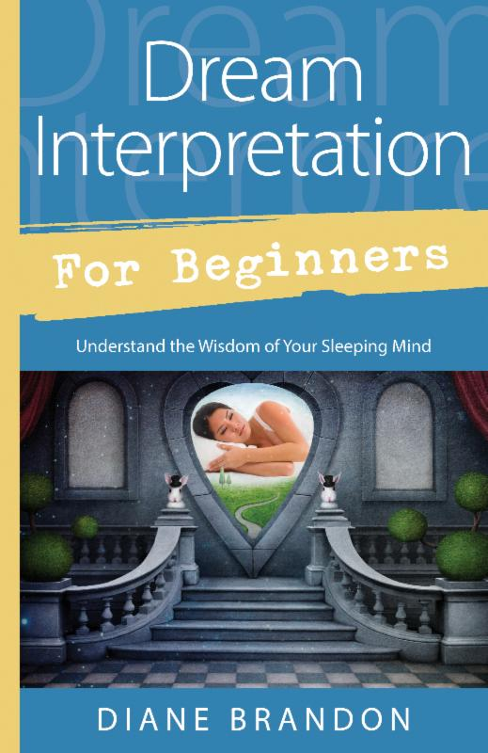
  My New Book,
  Dream Interpretation for Beginners -- Understand the Wisdom of Your Sleeping Mind, Was Published in March and is
  Available in Bookstores and Online
  My new book on dreams was published in March. It's entitled "Dream Interpretation for Beginners -- Understand the Wisdom of Your Sleeping Mind." It's a fairly comprehensive treatment of our world of sleep and dreams, how to interpret and understand our dreams, and how to use the insight we gain from them. It will also include many sample dreams with their interpretations and ideas on how to apply their insight.
  It is available on Amazon, at http://www.amazon.com/exec/obidos/ASIN/0738741914/dianebrandonintul,
  and on Barnes & Noble, at http://www.barnesandnoble.com/w/dream-interpretation-for-beginners-diane-brandon/1119693777?ean=9780738741918 as well as in book stores.
  A Wonderful Video on Animals & Trust
  I just saw this video and found it to be wonderful. It's about a technique used with animals that enhances our relationships with them, building a bond of trust. The video I saw is at https://www.facebook.com/video.php?v=10153236824642745.
  You can learn more about this technique at http://trust-technique.com/
  Being able to have a relationship with animals as shown in the video would be a beautiful experience!
  New Email Address
  After having had seemingly regular problems with my Bellsouth email address, I have switched to a new one. Please contact me via the following email address, effective immediately:
  dianebrandonauthor@gmail.com
  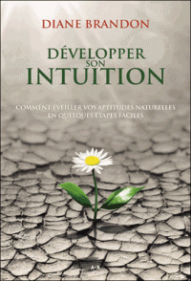
  The French Edition of Intuition for Beginners is Now Out
  I was quite surprised and pleased to receive a package from the publisher of my last two books to see that the French edition ofIntuition for Beginners was out.
  The book will also be translated into Chinese, Korean, Russian, Estonian, and for India -- thus far. Of course, it's still available in English!
  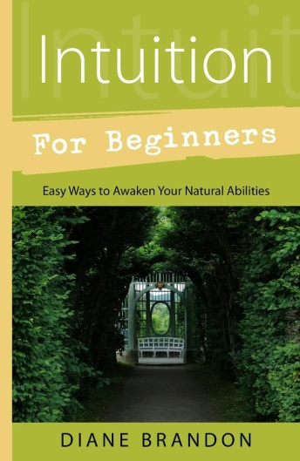
  Free Online Class on Intuition
  
  I'll be teaching some online classes on Learn it Live in their new Spirituality Center, and my first class is scheduled for Wednesday, September 16. Below are the details:
  How Does Your Intuition Speak to You?
  Wednesday, September 16th
  6:00 PM EDT/3:00 PM PDT - 6:45 EDT/3:45 PDT
  To Register, Go to https://www.learnitlive.com/class/6750/How-Does-Your-Intuition-Speak-to-You
  Free
  I'll be teaching more classes there in the coming months on Intuition, Dreams, Personal Empowerment, and additional topics.
  The Whale Asked for Help -- A Wonderful Rescue Video
  I loved what these people did. In this video, a whale actually approaches a boat for help because he or she had a plastic bag restricting his or her movements. You can see it at http://www.cnn.com/videos/world/2015/08/13/desperate-whale-stuns-boaters-pkg.seven-network
  Skype for Recordings of Sessions
  Having a recording of a session is a really useful tool, and I offer recordings for sessions in-person and by phone. Unfortunately, I've been having some intermittent problems with my recording equipment (which is used for phone sessions). The good thing is that sessions cam be recorded using Skype. So, if you'd like for phone sessions to be recorded, please download and install Skype on your computer. It's free and has been available for years, and "calling" via Skype is also free. You can download Skype at www.skype.com.
  A Video on the Benefits of Meditation
  A tremendous amount of research has been conducted on meditation in the past several years, and many physiological and psychological benefits of it have been identified. I recently came across this short video which details some of meditation's beneficial effects on the brain. You can view it at https://www.youtube.com/watch?v=Aw71zanwMnY
  A Call for Dreams
  I'm planning on writing another book on dreams, which will follow the one coming out in a year. It will primarily be dreams with their interpretations. I'm in the process of collecting dreams for that book. If you have some interesting ones, please do send them to me. Please note that all dreams are included anonymously to protect the dreamers' privacy Below is more information:
  Please Submit Dreams
  Your Dreams will be Included Anonymously
  I Will Interpret Your Dreams for Free
  I Will Send You a Free Copy of the Book After it's Published if Your Dream is Included
  Please Send Your Dreams in Complete Detail, as They Unfolded -- No Short Summaries
  The Publisher Requires, of Course, that a Release be Signed
  Please Email Them to Me at dianebrandonauthor@gmail.com
  I do have a Dream Group on Facebook, where people can record their dreams and receive interpretations. It's called Your Dream World and is at https://www.facebook.com/groups/125990490759247/ I would love to have you join!
  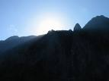
  Using Individualized Guided Meditation for Healing
  Many of us have been working on healing and clearing some of our old issues -- the pain and fears from unpleasant experiences in our past that can hold us back and block our happiness. This is one aspect of my intuitive work with other people. I strive to assist people on their paths to find more fulfillment, development their potential, and be happier.
  One modality that I have found extremely useful in my work is Guided Meditation. I do individualized Guided Meditation with people for several things: to enable people to meditate for the first time and find their center; to begin to find their own answers within; to meet guides; and to work on healing old issues. Doing this work via individualized Guided Meditation can be a gentle, yet powerful way of shifting and moving energy. Meditation in and of itself can have profound benefits. Using it for healing can be even more beneficial and powerful.
  I do individualized Guided Meditation both in person and by phone. Just contact me if you'd like to experience it in a session!
  My Schedule at Dancing Moon in Raleigh
  Below are the dates through September when I'll be available for sessions at Dancing Moon in Raleigh. I also have the dates on my website, at http://www.dianebrandon.com/index_files/page0007.htm (I should have the dates for the 4th Quarter of the year before the end of September.)
  I am always available for sessions in person or by phone at my home.
  Dancing Moon in Raleigh
  1840 Wake Forest Road
  12:00 Noon - 6:00 PM
  For Appointments, Call 919 833-8081
  Sunday, August 30
  Thursday, September 10
  And don't forget that I'm always available for sessions in person or by phone from my home as well! Just email me atdianebrandonauthor@gmail.com or call me at 919 237-3204.
  Mentoring Group on Intuition
  I am mentoring some people who are in development for working professionally with their intuition and facilitating others. As you may know, my intuitive work is centered around facilitating others and assisting others on their paths. We're living in a time now when more people will be needed who can truly assist others and help to facilitate. The mentoring allows people to gain facilitating skills in a more rapid manner than the "on-the-job" training period one goes through when starting to work with others.
  My mentoring group is doing beautifully and I'm tickled with how those involved are doing and the perceptive questions they ask.
  If you are interested in being part of my mentoring group, please contact me. One prerequisite is first attending one of my workshops on developing intuition. Thereafter, we will meet in small groups for mentoring, practice, and guidance.
  Gift Certificates and a New Refer-a-Friend
  
  Gift Certificates
  I have been asked to offer gift certificates from time to time, whenever someone would like to give a friend or relative a session. I always seem to forget to mention that these are a possibility. So, if you would like to give the gift of a session to someone, please know that they are available.
  Refer-a-Friend
  I also wanted to let you know that, if you've had a session with me and wanted to refer someone you know, whenever you refer someone to me who has an hour session, I'll be happy to give you 15 minutes free for your next session with me. Just let me know whenever you refer someone!
  Websites Where You can Donate to Various Causes -- for Free
  The following is a listing of websites where you can donate to various causes, all for free. This is a wonderful idea!
  I'd like to thank Diana Henderson for this. She has an excellent weekly Prayer List and includes these sites in her weekly mailing.
  The Rainforest Site: http://www.therainforestsite.com/cgi-bin/WebObjects/CTDSites
  The Animal Rescue Site: http://www.theanimalrescuesite.com/clickToGive/home.faces?siteId=3
  (also several others along the top at this location)
  Care2.com's click-to-donate site http://www.care2.com/click2donate/ makes it easy to help many causes. Click on any one of them (rainforest, oceans, big cats, primates, et al) and the next page will show all of them listed near the top. Then click on each to donate to every single cause. It's a major help to have so many click-to-donate buttons on one site!
  The Ecology Fund: Save land for free at http://ecologyfund.com/ecology/_ecology.html
  (You'll be clicking four times on the Ecology Fund site: Click first the button that says Save Land; on the next page click the Save Land Coastal button; on the following page, click on Save Land under Species; on the following page, click on Save Land under U.S.A. and finally click on the Clean Air button.)
  Plant an Oak Tree: http://cannecy.free.fr/iforest/en/
  Help plant a tree (every five clicks plants a tree): http://www.landcareniagara.com/
  Save Old Growth Forests (Sweden): http://ettklickforskogen.se/
  Surrey Wildlife Trust: http://www.theenvironmentsite.org/donate.php
  Save rainforest: http://www.redjellyfish.com/wildlifeconservation.html
  Plant a tree in the rainforest: http://www.tree4life.com/ingles/ingles.htm.
  Feed Hungry Children in Argentina (click on button that says GRATIS): http://www.porloschicos.com/PorLosChicos.NET/
  Fight Hunger: http://www.hungerfighters.com/
  Feed Children: http://www.hungrychildren.com/
  Employ/Educate Impoverished: http://www.solvepoverty.com/
  If you'd like to share this email with anyone else, please fee free to forward it.
  As always, I wish you peace, light, love, and prosperity!
  Take care, Diane
  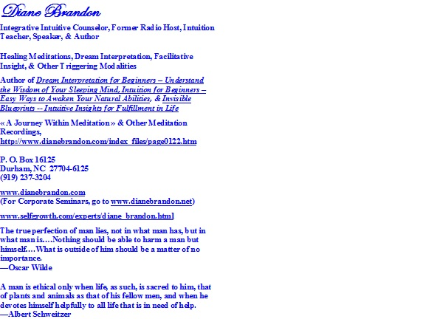
  P. O. Box 16125
  Durham, NC 27704
  (919) 237-3204

Forward email
This email was sent to dianebrandonauthor@gmail.com by dianebrandonauthor@gmail.com |
Update Profile/Email Address | Rapid removal with SafeUnsubscribe™ | About our service provider.

Diane Brandon | P. O. Box 16125 | Durham | NC | 27704

