From: | Diane Brandon <dianebrandonauthor@gmail.com>
Subject: | Happy New Year, Pole Shift, RIP George Ward, Ohana Arts & Wellness Center, & Other Tidbits
Preheader:
Reply: | dianebrandonauthor@gmail.com


  Having trouble viewing this email? www.dianebrandon.com/index_files/page0178.htm

You are receiving this email from Diane Brandon because you purchased a product/service or subscribed on our website or at an event. To ensure that you continue to receive emails from us, add dianebrandon@bellsouth.net to your address book today. If you haven't done so already, click to confirm your interest in receiving email campaigns from us.

You may unsubscribe if you no longer wish to receive our emails.

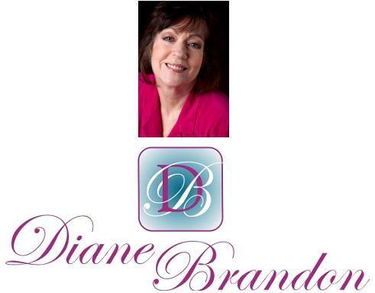

Integrative Intuitive Counselor, Intuition Teacher,
Speaker, & Author

December 15, 2015

Happy New Year, Pole Shift, RIP George Ward, Ohana Arts & Wellness Center, & Other Tidbits

  In This Newsletter
  Pole Shift?
  News about My Books
  Parallel Universes & Black Holes
  Radio Interviews
  New Email Address
  Online Classes Live & On-Demand
  Seal Just Wanting to be Petter
  Skype for Recordings of Sessions
  Video on Benefits of Meditation
  A Call for Dreams
  My Schedule at Dancing Moon & Ohana
  Guided Meditation for Healing
  Mentoring in Intuition
  Refer a Friend & Gift Certificates
  Donate Free to Causes
  Share
  Signature Block
  Links
  My Newest Book
  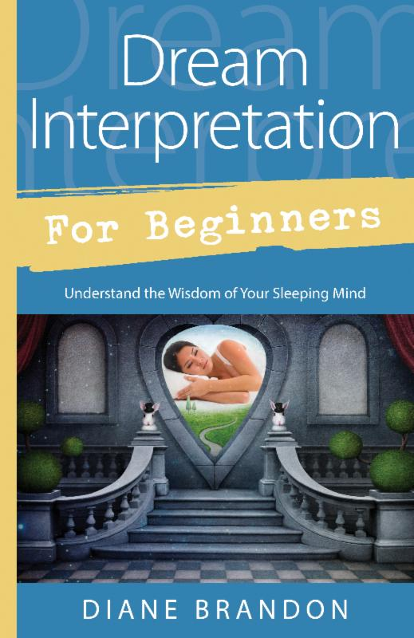
  Now Out & Available in Bookstores & Online
  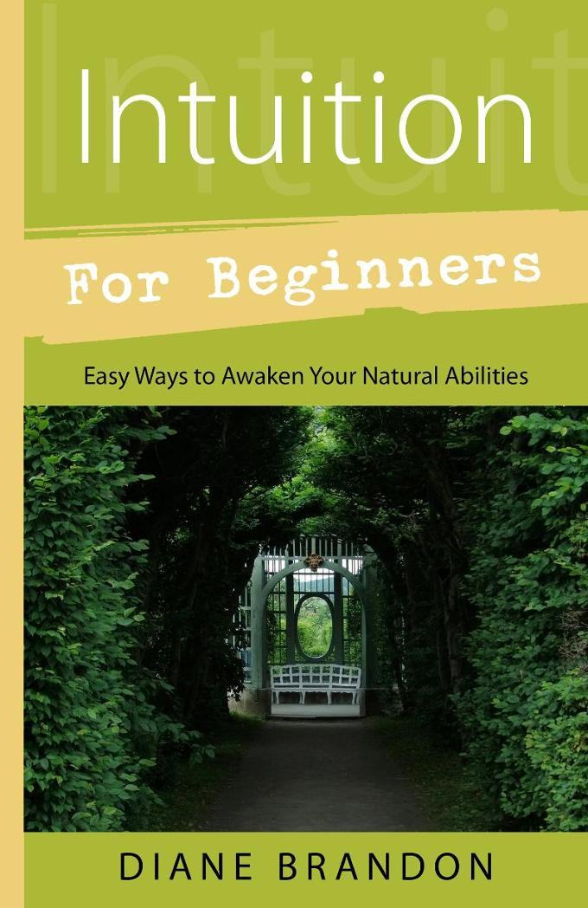
  Intuition for Beginners
  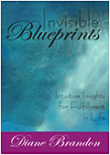
  Invisible Blueprints
  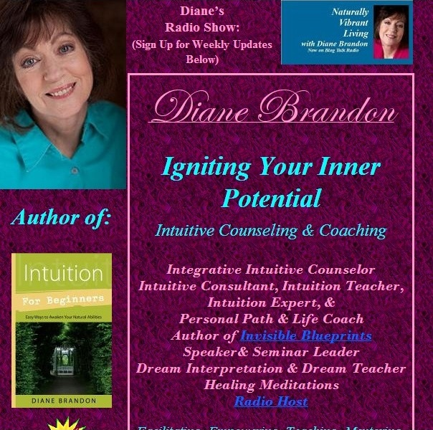
  My Site -- www.dianebrandon.com
  Dream Group on Facebook:
  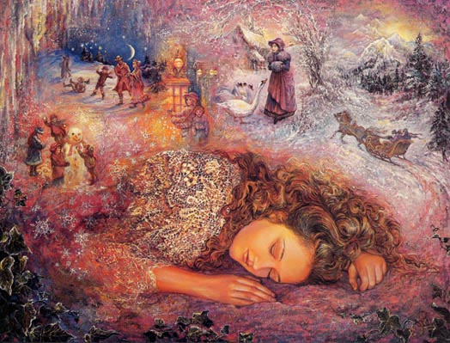
  Your Dream World
  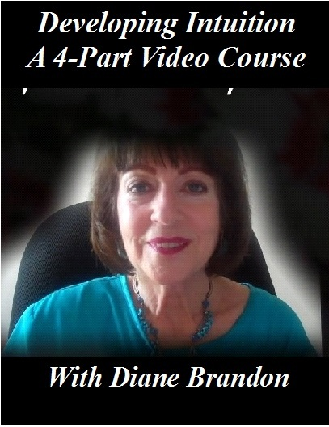
  A Four-Part Video Course on Developing Intuition
  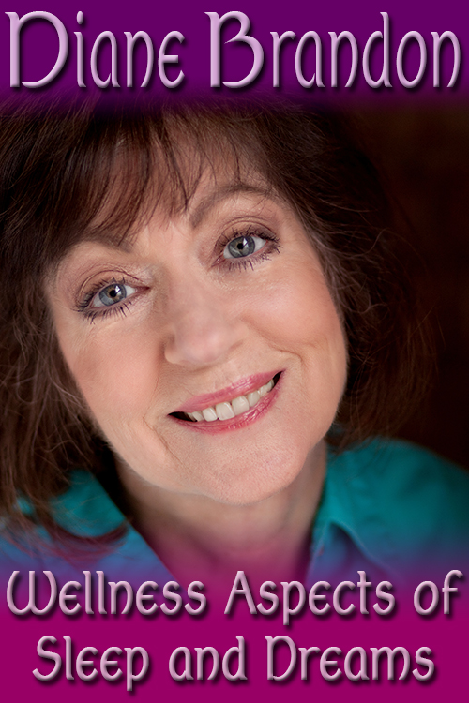
  Video, "The Wellness Aspects of Sleep & Dreams"
  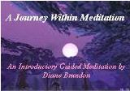
  "A Journey Within Meditation"
  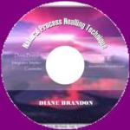
  "Natural Process Healing"
  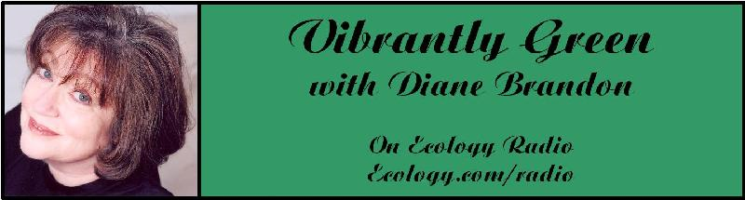
  "Vibrantly Green with Diane Brandon" Radio Show on Ecology.com
  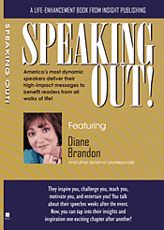
  Speaking Out
  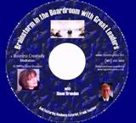
  "Brainstorm in the Boardroom with Great Leaders" Business Meditation CD
  More Cds/Mp3s, Including Intuition Exercises at
  http://www.dianebrandon.com/index_files/page0122.htm
  Find Me on:
  
  Twitter
  
  https://www.facebook.com/pages/Diane-Brandon/128849587146042
  We're almost at the end of 2015, and I hope that this has been a good year for you!
  2015 seems to have been a wild ride for many people, as well as for events in our external world. The last three or four months have felt very intense to many people, and it would appear that they represented an intense phase of healing and clearing. If you found yourself tunneled in, overwhelmed at times, and with too much on your plate, you're not alone. If the energy felt heavy to you, you're also not alone. Many people have reported feeling that way.
  The positive thing is that we seem to have gone through an energy shift about two weeks ago. Since then, the energy has felt a little lighter.
  It would appear that we were indeed being asked to work on personal healing and clearing, probably because of the intense energy and strange events in the world. The more we work on clearing and healing, the less vulnerable we may feel to problematic energies and the more easily we may find ourselves able to be observers (as well as access our Higher Soul Awareness).
  I do feel that, even though the energy feels a little lighter now, strangeness will continue in the world for a while. It seems that we're at a point of extreme abrading between the new paradigm and the old one, on its way out. This has been evidenced by a heightened tension and polarization between and among people, along with strong, damaging storms and weather events in different places in our physical world. It's certainly not always a comfortable time, although it's happening, of course, to usher in a new and more positive phase. As I've mentioned before, being centered and in touch with our inner knowing is so important these days. Healing and clearing work make this easier to do and allow us to feel more immune to any swirling ambient energies that are negative. We can find ourselves to more easily be the "eye of the storm."
  One healing tool that I delved into several months ago is one that I would recommend for personal clearing and healing. It's called The Healing Codes, and you can learn the technique in the book, The Healing Code, by Alexander Loyd and Ben Johnson. (You can find it on Amazon at http://www.amazon.com/Healing-Code-Minutes-Success-Relationship/dp/1455502006/ref=sr_1_1?s=books&ie=UTF8&qid=1450131385&sr=1-1&keywords=the+healing+code/dianebrandonintul or in your local metaphysical store.) It really is effective at healing old issues. Sometimes the healing takes place quickly and sometimes it may take up to a couple of months. The healing effect may be strongly noticeable at times or it may be subtle.
  I can't emphasize strongly enough the transition phase we find ourselves in. Even though things in the world may seem to have gotten worse, it's really an indication of moving forward. It's quite natural in times of massive change that there will be tension between the old and the new. Repressed negativity, especially when under pressure from general changes externally, may erupt in a volatile fashion. It really reflects the new energies taking hold more.
  Another interesting -- and, to me, quite welcome -- transition, according to the astrologer Carl Boudreau, has to do with a return to integrity and a concern for the common good. In his December report, he shared that a long-range Pluto-Saturn cycle had begun in the early 80s, which ushered in a long period of materialism, greed, corruption, and me-centeredness. Saturn has now moved to a point that will shift that trend back to more integrity and a concern for the common good.
  Unfortunately, in this intense period of change, we've also seen more people transitioning, including some in the metaphysical community. Many of you know George Ward, an astrologer who also worked at Dancing Moon in Raleigh. I met George back in 1994, when he started working at the store. (I had started doing sessions there back in 1993.) George was a dear friend, and we shared many things with each other over the years. He was a fixture for me at Dancing Moon and a permanent part of my world.
  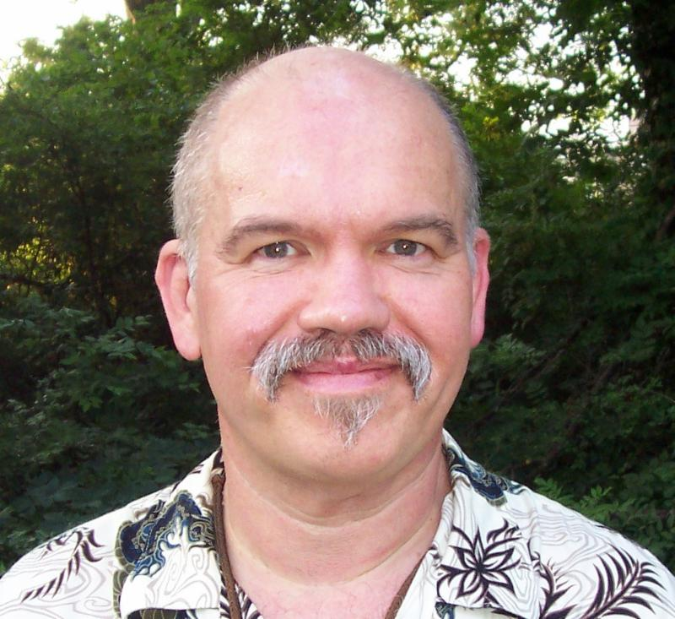
  It was George who took it upon himself to teach me about astrology. Prior to my conversations (or impromptu lessons) with George, I only knew some basics, primarily sun signs. At that point, I thought astrology was quaint and probably didn't mean much. Well, that was my attitude pre-George. If it weren't for George, I wouldn't have the astrological knowledge that I now do (although my knowledge is tiny compared to George's and that of professional astrologers). I even bring astrology into my intuitive sessions now.
  Well, George left us on September 15th. I was shocked when Bev from the store called to let me know a few hours after they had learned. He died in his sleep, probably due to a heart attack. (His father had transitioned at a young age from one.) I was completely shocked and stunned, and it was very difficult and painful to sustain that loss. Fortunately I had just seen him the Thursday before and we had had a nice chat, when he shared with me that a childhood friend of his, who had a theatre group in New York, had asked George to co-write a play about Pluto. George was buoyed up at the prospect and I felt so positive about it for him. We had also emailed briefly a couple of days later. So our conversation and emails right before his transition were a wonderful gift.
  If you knew George and/or had your chart done by him and hadn't heard, then you may also be shocked. He was only 54.
  When I learned that he had transitioned, the thought ran through my mind that he might have had something else he was supposed to do. I later tuned in and that information was confirmed. He had no difficulty adjusting to having transitioned, and I got him in a place of study, preparing for the work he was to do. I've also communicated with him, and one was quite comical, as he sat on my closed toilet seat lid while I brushed my teeth and he shared some of the things he could now do physically. I have since gotten that he has started the work, which he's doing with other souls, and it has to do with all the changes here on this planet and the work in trying to keep the planet and environment from degrading further. Wonderful work for him to be doing!
  There was a memorial service for him in Raleigh and several of us who had known him spoke. I shared some of my memories, although it was difficult to try not to cry as I shared some pleasant memories. There was a wonderfully large turnout, which just showed how many people loved him.
  George loved to garden and he always planted the flowers in the planters in front of the store. I knew that the ones he had planted in the Spring wouldn't last permanently. So I took some photos of them.
  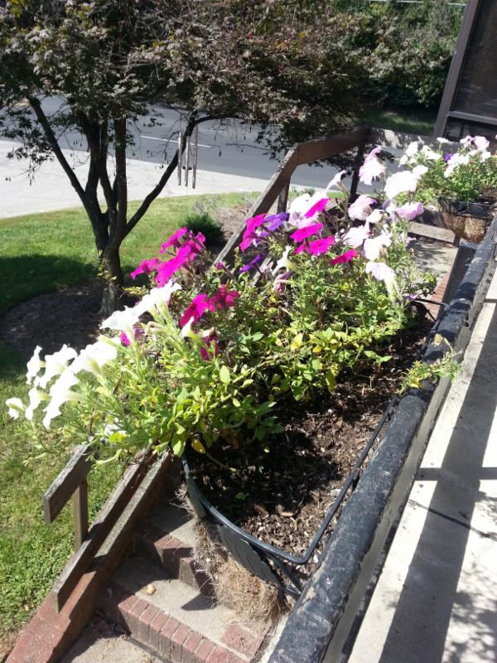
  I'm so grateful to have known George! He was a dear person, who helped many people, and it's start hard to remember that he's not here physically, especially whenever I'm at Dancing Moon.
  This is a time of such major shifts, many of which are positive. One positive one is a new spiritual center and store in High Point (in North Carolina). It's called Ohana Arts & Wellness Center and has wonderful light, positive energy. I'll be doing sessions there, as well as some classes (preliminary dates are below), and you'll find several classes and practitioners there. I would recommend it! Their website is still being built and is at http://www.ohanaawc.com/
  I have several other things to share with you in this newsletter, which you'll find below.
  As always, I wish you great joy, health, love, peace, and prosperity! Please contact me should you want to schedule a private session!
  Warmly,
  Diane
  P. S. If you have any trouble reading this, just go to www.dianebrandon.com/index_files/page0178.htm, where it will be archived in a day or two.
  A Pole Shift?
  Several people have felt that we would see a strong pole shift in the 20th Century. This forecast was part of the information circulating about earth changes. In fact, one novel was written about this possibility and it was very popular -- The Hab Theory. I read it back in the 70s and loved it. A sudden pole shift of several degrees would be cataclysmic and devastating to life. Fortunately, this has not happened. However, it would appear that we might have had a smaller pole shift.
  Back in July I noticed that it seemed to be getting dark much earlier than it typically does at that time. In August, I saw a few trees with leaves that were already changing color. Friends in a few other states were seeing the same thing. In addition, beginning in June I started to have foot pain and swelling. I then learned that at least five other people were having similar symptoms.
  I then learned that the Inuits had observed several changes and were saying, for example, that the sun was at a different place in the sky. You can read about what the Inuits have been saying at http://www.thebigwobble.org/2014/12/their-sky-has-changed-inuit-elders.html, http://www.whitewolfpack.com/2015/04/earth-has-shifted-inuit-elders-issue.html, and http://www.naturalnews.com/048906_inuit_elders_nasa_earth_axis.html.
  If there has been a slight pole shift, the geomagnetic field would be affected -- and this, in turn, could affect our nervous systems and possibly cause some of the physical symptoms that some of us have experienced.
  I just saw another article implicating snow melt with helping to bring about longer days and the pole shifting, which is at http://www.theguardian.com/science/2015/dec/11/climate-change-longer-days-glaciers-north-south-pole.
  It's too soon to know definitely what is happening and the causes. However, it would appear that we're having some other physical changes on the planet that might be unexpected.
  News About My Books
  My New Book,
  Dream Interpretation for Beginners -- Understand the Wisdom of Your Sleeping Mind -- Will be Translated into Estonian
  My new book on dreams was published in March, and I was pleased to learn that rights have already been sold for an Estonian edition.
  It's a fairly comprehensive treatment of our world of sleep and dreams, how to interpret and understand our dreams, and how to use the insight we gain from them. It will also include many sample dreams with their interpretations and ideas on how to apply their insight.
  It is available on Amazon, at http://www.amazon.com/exec/obidos/ASIN/0738741914/dianebrandonintul,
  and on Barnes & Noble, at http://www.barnesandnoble.com/w/dream-interpretation-for-beginners-diane-brandon/1119693777?ean=9780738741918 as well as in book stores.
  Chinese and French Editions of Intuition for Beginners Now Out
  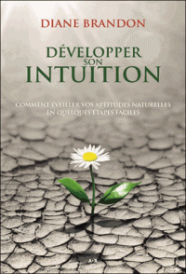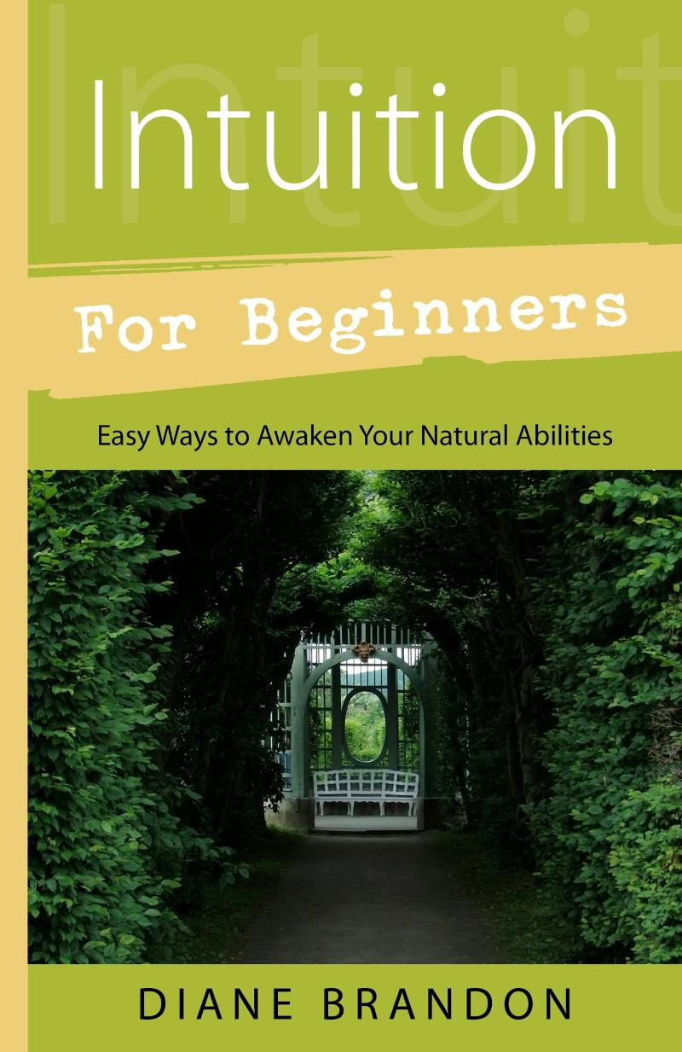
  I was pleased to receive a few copies of the Chinese edition of my book, Intuition for Beginners. It's now out in French and Chinese, in addition to English, and will additionally be translated into Korean and Russian thus far.
  Fascinating News about Time in Black Holes & about Parallel Universes
  We've been seeing some fascinating information coming out from research into our cosmos, which may be stretching some of our minds. It's fascinating!
  Recent research has found that time may run backwards in black holes. You can read about that at http://www.csmonitor.com/Science/2015/1101/Does-time-run-backward-inside-black-holes
  And other research has found some evidence of parallel universes. You can read more at http://www.msn.com/en-us/news/technology/study-may-have-found-evidence-of-alternate-parallel-universes/ar-BBmNQ3a?li=AAa0dzB
  This was the stuff of science fiction in the past, but it's becoming reality instead. Reality is much more complex than we may have felt!
  "Dr. Pat Show" & Other Radio Appearances
  I'm continuing to do radio appearances in which I'm interviewed, primarily about dreams. I've been working with dreams and poring over sleep and dream research for over 40 years, and I'm still learning about new facets of our sleep and dreams. Our sleeping world is beautifully complex and gives us so many things. We can use our dreams as a tool in our lives, as I detail in Dream Interpretation for Beginners. However, dreams aren't the only enriching aspect of our sleeping world. There are many spiritual aspects as well for us to experience. There's a lot going on in our sleeping world that can enrich our lives!
  I have more radio appearances coming up in January and am adding more past January.
  I try to post upcoming appearances and interviews at http://www.dianebrandon.com/index_files/page0007.htm.
  Many, although not all, interviews are archived and available for on-demand listening. For a list of these if you'd like to listen to some, just go to http://www.dianebrandon.com/index_files/page0210.htm.
  And please remember that I'm also available for dream interpretation and aiding you in dreamwork in private sessions. So just contact me whenever you'd like to schedule an appointment for some dreamwork!
  New Email Address
  After having had seemingly regular problems with my Bellsouth email address, I have switched to a new one. Please contact me via the following email address, effective immediately:
  dianebrandonauthor@gmail.com
  Online Classes on Intuition and Dreams
  
  I've started teaching some online classes on Learn it Live in their new Spirituality Center. Although the classes are live, they are also archived for on-demand viewing. I'll be teaching a multi-part intuition course beginning in February or March, as well as additional classes.
  If you'd like to take any of my classes -- whether live or archived ones -- just go tohttps://www.learnitlive.com/search.php?type=classes-events&srcval=diane%20brandon
  A Seal Who Wants to be Petted -- Video
  I saw this video recently and just loved it! This seal is so sweet and affectionate and just wants to be petted. You can see it at http://www.boredpanda.com/seal-belly-rub-diver-gary-grayson/
  Skype for Recordings of Sessions
  Having a recording of a session is a really useful tool, and I offer recordings for sessions in-person and by phone. Unfortunately, I've been having some intermittent problems with my recording equipment (which is used for phone sessions). The good thing is that sessions cam be recorded using Skype. So, if you'd like for phone sessions to be recorded, please download and install Skype on your computer. It's free and has been available for years, and "calling" via Skype is also free. You can download Skype atwww.skype.com.
  A Video on the Benefits of Meditation
  A tremendous amount of research has been conducted on meditation in the past several years, and many physiological and psychological benefits of it have been identified. I recently came across this short video which details some of meditation's beneficial effects on the brain. You can view it at https://www.youtube.com/watch?v=Aw71zanwMnY
  A Call for Dreams
  I'm planning on writing another book on dreams, which will follow the one coming out in a year. It will primarily be dreams with their interpretations. I'm in the process of collecting dreams for that book. If you have some interesting ones, please do send them to me. Please note that all dreams are included anonymously to protect the dreamers' privacy Below is more information:
  Please Submit Dreams
  Your Dreams will be Included Anonymously
  I Will Interpret Your Dreams for Free
  I Will Send You a Free Copy of the Book After it's Published if Your Dream is Included
  Please Send Your Dreams in Complete Detail, as They Unfolded -- No Short Summaries
  The Publisher Requires, of Course, that a Release be Signed
  Please Email Them to Me at dianebrandonauthor@gmail.com
  I do have a Dream Group on Facebook, where people can record their dreams and receive interpretations. It's called Your Dream World and is at https://www.facebook.com/groups/125990490759247/ I would love to have you join!
  My Schedule at Dancing Moon in Raleigh
  Below are the dates through March when I'll be available for sessions at Dancing Moon in Raleigh. I also have the dates on my website, at http://www.dianebrandon.com/index_files/page0007.htm
  I'll also be doing sessions at a new wellness center in High Point, Ohana Arts & Wellness Center.
  Of course, I am always available for sessions in person or by phone at my home.
  Dancing Moon in Raleigh
  1840 Wake Forest Road
  12:00 Noon - 6:00 PM
  For Appointments, Call 919 833-8081
  Thursday, December 31
  Thursday, January 14
  Sunday, January 31
  Thursday, February 11
  Sunday, February 28
  Thursday, March 17
  I mentioned the new metaphysical center in High Point above. It has wonderful energy and light, and I'll be doing sessions and some classes there (TBA). Below are just a couple of dates, with more to come.
  Ohana Arts & Wellness Center
  615 Greensboro Road
  High Point, NC 27260
  For Appointments, Call 336 804-5779
  Saturday, December 19
  Saturday, February 6
  And don't forget that I'm always available for sessions in person or by phone from my home as well! Just email me at dianebrandonauthor@gmail.com or call me at 919 237-3204.
  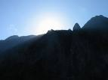
  Using Individualized Guided Meditation for Healing
  Many of us have been working on healing and clearing some of our old issues -- the pain and fears from unpleasant experiences in our past that can hold us back and block our happiness. This is one aspect of my intuitive work with other people. I strive to assist people on their paths to find more fulfillment, development their potential, and be happier.
  One modality that I have found extremely useful in my work is Guided Meditation. I do individualized Guided Meditation with people for several things: to enable people to meditate for the first time and find their center; to begin to find their own answers within; to meet guides; and to work on healing old issues. Doing this work via individualized Guided Meditation can be a gentle, yet powerful way of shifting and moving energy. Meditation in and of itself can have profound benefits. Using it for healing can be even more beneficial and powerful.
  I do individualized Guided Meditation both in person and by phone. Just contact me if you'd like to experience it in a session!
  Mentoring Group on Intuition
  I am mentoring some people who are in development for working professionally with their intuition and facilitating others. As you may know, my intuitive work is centered around facilitating others and assisting others on their paths. We're living in a time now when more people will be needed who can truly assist others and help to facilitate. The mentoring allows people to gain facilitating skills in a more rapid manner than the "on-the-job" training period one goes through when starting to work with others.
  My mentoring group is doing beautifully and I'm tickled with how those involved are doing and the perceptive questions they ask.
  If you are interested in being part of my mentoring group, please contact me. One prerequisite is first attending one of my workshops on developing intuition. Thereafter, we will meet in small groups for mentoring, practice, and guidance.
  Gift Certificates and a New Refer-a-Friend
  
  Gift Certificates
  I have been asked to offer gift certificates from time to time, whenever someone would like to give a friend or relative a session. I always seem to forget to mention that these are a possibility. So, if you would like to give the gift of a session to someone, please know that they are available.
  Refer-a-Friend
  I also wanted to let you know that, if you've had a session with me and wanted to refer someone you know, whenever you refer someone to me who has an hour session, I'll be happy to give you 15 minutes free for your next session with me. Just let me know whenever you refer someone!
  Websites Where You can Donate to Various Causes -- for Free
  The following is a listing of websites where you can donate to various causes, all for free. This is a wonderful idea!
  I'd like to thank Diana Henderson for this. She has an excellent weekly Prayer List and includes these sites in her weekly mailing.
  The Rainforest Site: http://www.therainforestsite.com/cgi-bin/WebObjects/CTDSites
  The Animal Rescue Site: http://www.theanimalrescuesite.com/clickToGive/home.faces?siteId=3
  (also several others along the top at this location)
  Care2.com's click-to-donate site http://www.care2.com/click2donate/ makes it easy to help many causes. Click on any one of them (rainforest, oceans, big cats, primates, et al) and the next page will show all of them listed near the top. Then click on each to donate to every single cause. It's a major help to have so many click-to-donate buttons on one site!
  The Ecology Fund: Save land for free at http://ecologyfund.com/ecology/_ecology.html
  (You'll be clicking four times on the Ecology Fund site: Click first the button that says Save Land; on the next page click the Save Land Coastal button; on the following page, click on Save Land under Species; on the following page, click on Save Land under U.S.A. and finally click on the Clean Air button.)
  Plant an Oak Tree: http://cannecy.free.fr/iforest/en/
  Help plant a tree (every five clicks plants a tree): http://www.landcareniagara.com/
  Save Old Growth Forests (Sweden): http://ettklickforskogen.se/
  Surrey Wildlife Trust: http://www.theenvironmentsite.org/donate.php
  Save rainforest: http://www.redjellyfish.com/wildlifeconservation.html
  Plant a tree in the rainforest: http://www.tree4life.com/ingles/ingles.htm.
  Feed Hungry Children in Argentina (click on button that says GRATIS): http://www.porloschicos.com/PorLosChicos.NET/
  Fight Hunger: http://www.hungerfighters.com/
  Feed Children: http://www.hungrychildren.com/
  Employ/Educate Impoverished: http://www.solvepoverty.com/
  If you'd like to share this email with anyone else, please fee free to forward it.
  As always, I wish you peace, light, love, and prosperity!
  Warmly, Diane
  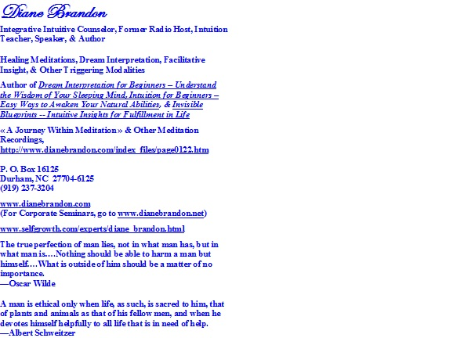
  P. O. Box 16125
  Durham, NC 27704
  (919) 237-3204

Forward email
This email was sent to dianebrandonauthor@gmail.com by dianebrandonauthor@gmail.com |
Update Profile/Email Address | Rapid removal with SafeUnsubscribe™ | About our service provider.

Diane Brandon | P. O. Box 16125 | Durham | NC | 27704

