From: | Diane Brandon <diane@dianebrandon.com>
Subject: | Intuition Workshop, Rhine Presentation, A Call for Dreams, & More
Reply: | diane@dianebrandon.com
You are receiving this email from Diane Brandon because you purchased a product/service or subscribed on our website or at an event. To ensure that you continue to receive emails from us, add dianebrandon@bellsouth.net to your address book today. If you haven't done so already, click toconfirm your interest in receiving email campaigns from us.

You may unsubscribe if you no longer wish to receive our emails.
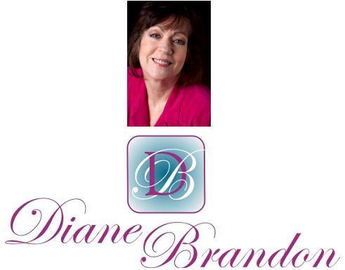

Integrative Intuitive Counselor, Radio Host, Intuition Teacher, & Author

February 24, 2014

Intuition Workshop, Rhine Presentation, A Call for Dreams, & More

  In This Newsletter
  An Article on Tomiko & Jerry Pittman
  Workshop on Intuition
  Radio Appearance
  Rhine Research Center Dream Presentation
  New Book on Dreams
  A Call for Dreams
  Chinese Year of the Horse
  Your Earliest Spiritual Memory
  Guided Meditation for Healing
  Important TED Video
  Wellness Aspects of Sleep & Dreams
  Statement by the Elders
  My Schedule at Dancing Moon and Eclectic by Nature
  Mentoring in Intuition
  Dream Group
  Refer a Friend & Gift Certificates
  A Journey Within Meditation CD
  Donate Free to Causes
  Share
  Signature Block
  Links
  New Book:
  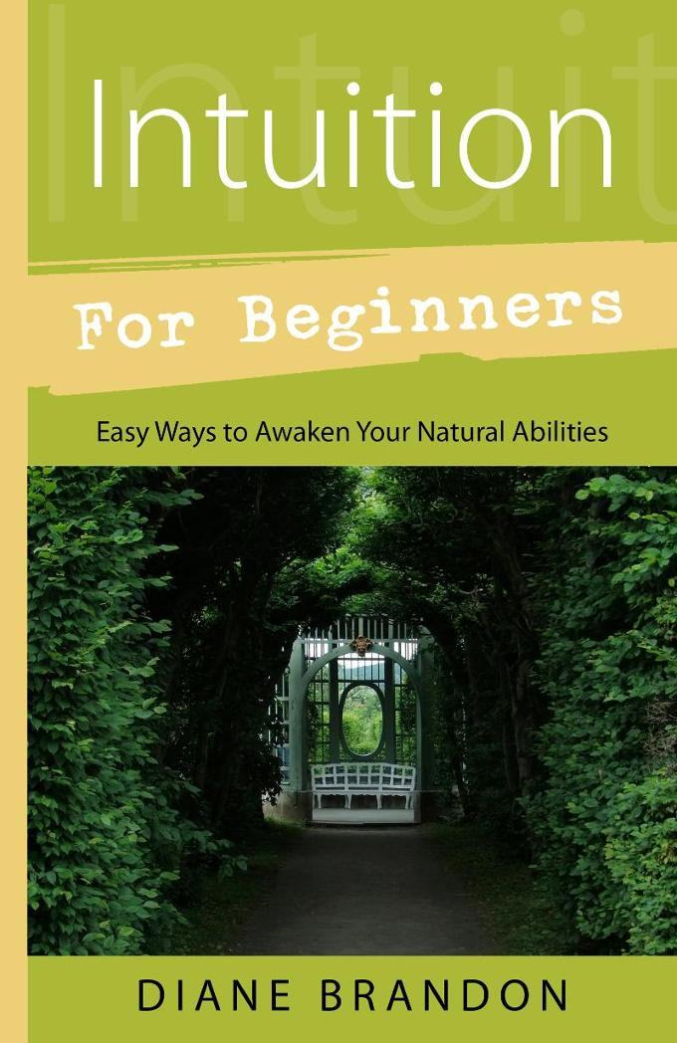
  Now Out!
  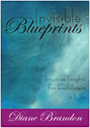
  Invisible Blueprints
  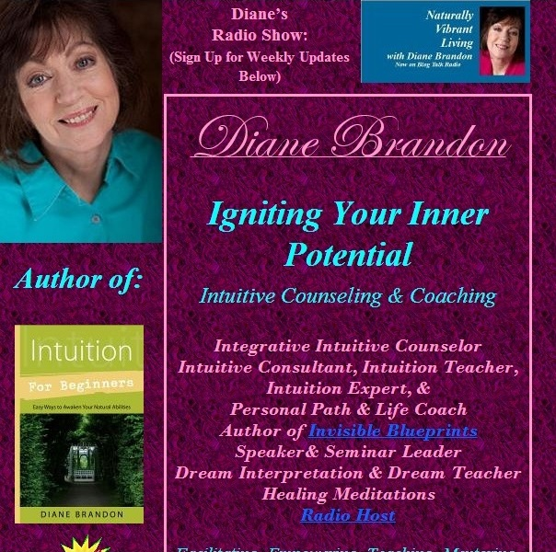
  My Site -- www.dianebrandon.com
  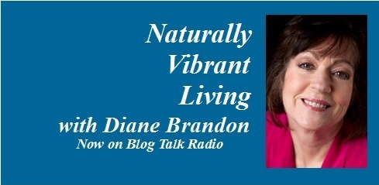
  "Naturally Vibrant Living" Radio Show on Blog Talk Radio has Now Ended -- Archived Shows Still Available for Listening
  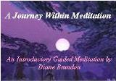
  "A Journey Within Meditation"
  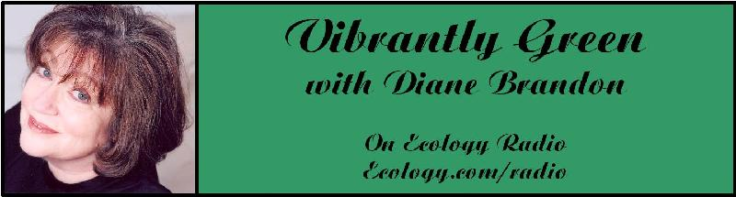
  "Vibrantly Green with Diane Brandon" Radio Show on Ecology.com
  
  Speaking Out
  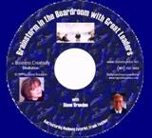
  "Brainstorm in the Boardroom with Great Leaders" Business Meditation CD
  Find Me on:
  
  Twitter
  
  https://www.facebook.com/pages/Diane-Brandon/128849587146042
  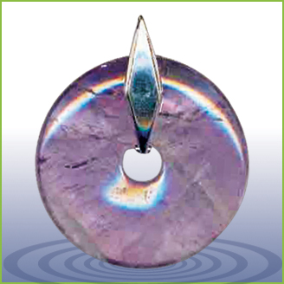
  EMF Radiation Protection Pendants
  I hope this newsletter finds you well and safe!
  I apologize for not having sent anything out to you since October. I've been working solidly, except for a few weeks, on my new book on dreams, which is due out next year, trying to meet two separate deadlines with the publisher and that, combined with my intuitive counseling work, has had me buried under.
  We're now in 2014 and it feels as if the energies have been accelerating. Some have said that this year is about clearing and working on personal stuff in preparation for 2015 when things are supposed to move forward more externally. We've had some interesting astrological configurations creating a feeling of tension, which is supposed to increase through April and May, when we'll have a Super Grand Cross (which creates tension). I know that doesn't sound pleasant, but I feel that we're being stretched and worked with in ways that should allow us to yield and surrender, rather than buck prevailing energies, and to find ourselves feeling clearer and freer.
  I'm still an optimist and feel that all is happening for a reason and that we're headed towards a time of healing and connection.
  As you know, we've seen extreme weather and other more man-made problems in our world, with worries about the continued radiation from Fukushima and water supply pollution, such as the spill in West Virginia and the coal ash spill in North Carolina. We're getting lessons on appreciating and protecting our world and environment and that, ultimately, Nature is more powerful than we are. I hope that you haven't been negatively impacted by all that has been going on.
  In these times of change, polarization, weather problems, and man-made catastrophes, I feel it's important to trust that all is in Divine order and that we are indeed moving towards healing and improvement.
  I still feel that it's critical to listen to your inner voice and allow yourself to be guided by it. I personally could not imagine living my life without doing that. And it's important that we continue to do our personal work on personal healing and clearing. We not only feel better as a result, but we also contribute to world healing and find it easier to connect with higher levels spiritually and feel more positive when we do that personal work.
  As I'm sure you know, I'm always available for sessions, both by phone and in person. These times of change can feel unsettling at times, I know, and a reading can help to put things into perspective while yielding helpful insight.
  I have several things to share with you in this newsletter, including a workshop, presentation, etc. I would also like to have you participate in some projects of mine, all of which you'll find below.
  As always, I wish you great joy, health, love, peace, and prosperity! Please contact me should you want a private session!
  Take care,
  Diane
  P. S. If you have any trouble reading this, just go to www.dianebrandon.com/index_files/page0178.htm, where it will be archived in a day or two.
  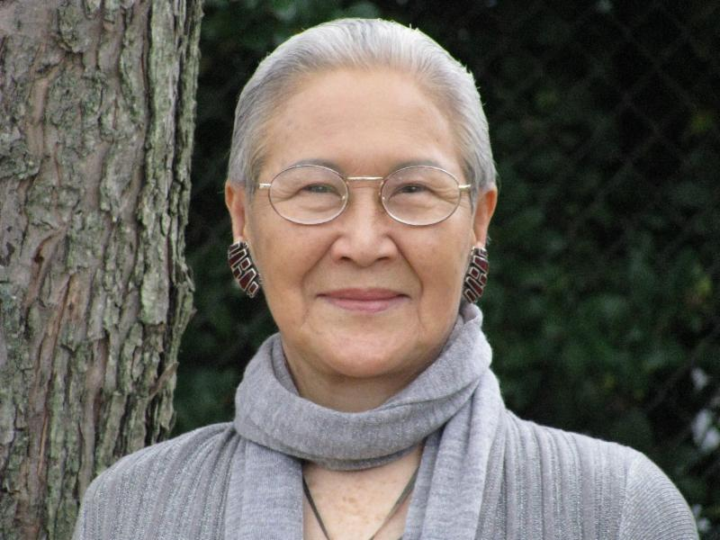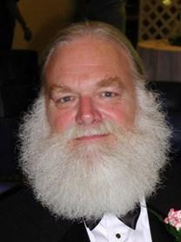
  An Article on Tomiko and Jerry Pittman
  I had shared with you how shocked and saddened I was to learn of Tomiko's passing. Then on the heels of that news, I learned that Jerry Pittman, M. D. had passed away just after I last emailed you in October. These two people were giants here in the Research Triangle and had a positive influence on the lives of many people. I had shared Tomiko's influence on me with you. Jerry's influence was also profound. Without my acquaintance with him, I would not have half of the knowledge that I do of findings in new science.
  Karen Newton of Innerchange Magazine asked me to write an article memorializing both Tomiko and Jerry, which I did. You can find that article on Innerchange's website athttp://innerchangemag.com/articles/the-loss-of-two-beloved-giants. You'll also find a somewhat expanded version on my website, at http://www.dianebrandon.com/index_files/page0123.htm.
  Whether you knew them or not, you have been affected by them through your work with me. I deeply grieve their losses!
  Workshop
  On Developing Intuition & Accessing it On Demand
  Most people have had experiences with their intuition when they have received information spontaneously. However, we can also learn how to access intuitive information on demand. Once we have learned that critical skill, developing it can be a lot easier. Of course, we also want to make sure that we're receiving information that is as pure and reliable as possible.
  Intuition can be a powerful tool for us in our lives. It helps us to find some of our own answers within, connect more with the Divine, and can be quite empowering. Paying attention to our inner voice can also aid in our own unfolding and lead us to be more centered, less reactive, and feel more confident --
  and can benefit our relationships -- as well as other areas of our lives.
  Some of us who have developed our intuition and regularly listen to our inner voice can not only attest to it being an aid in our daily living, but have also found that it can lead us to live our lives at times as somewhat of a walking meditation.
  Developing our intuition can be a matter of learning how ours works, and which form(s) it takes, learning to listen to it and not doubt it, learning how to get pure information unclouded or affected by our personal "stuff," learning how to work with the information we receive, and remembering to be open to what we're given. Using our intuition for others can also require developing our own set of ethics and personal responsibility.
  I have been teaching others this wonderful skill since 1996 and will be teaching an all-day workshop on it in September that will go from the basics to advanced exercises. Below are the details:
  Accessing Intuitive Information on Demand -- Workshop
  Dancing Moon
  1840 Wake Forest Road
  Raleigh, NC
  http://dancingmoonraleigh.com
  Saturday, May 17, 2014
  10:30 AM - 5:30 PM
  $95.00 if Registered & Paid in Advance, $105.00 at the Door
  To Register, Just Contact Me
  Radio Interview on "I am Well" Show
  I will be a guest on the "I am Well" radio show hosted by Annemieke van Eijkeren on Tuesday, February 25th at 9:00 PM EST/6:00 PM PST. We'll be discussing my intuitive work and work with dreams, as well as spirituality.
  This is a radio show on the internet, and you can listen to the show live or on-demand afterwards, as it will be archived for on-demand listening. The link to listen to it is http://www.blogtalkradio.com/renford/2014/02/26/i-am-well-show-with-guest-diana-brandon
  Please tune in!
  Presentation on Dreams at the Rhine Research Center
  I will be doing a presentation at the Rhine Research Center on dreams, entitled "Using Our Dreams for Personal Insight and Unfolding," on Friday, March 21st. I'm a huge proponent of using our dreams as a tool in our lives and have been working with and researching dreams for many years. In fact, I'll have a new book coming out in a year on the topic. Below are the details of my presentation:
  "Using Our Dreams for Personal Insight and Unfolding"
  Rhine Research Center
  Stedman Auditorium on the Duke Center for Living Campus
  3475 Erwin Road
  Durham, NC 27705
  Friday, March 21st, 2014 -- 7:00 - 9:00 PM EST
  Contact
  Phone: 919-309-4600
  For More Information, Go to
  http://goo.gl/R4OwVz
  New Book on Dreams, "Dream Interpretation for Beginners"
  My new book on dreams will be published in Winter of 2015 and will be entitled "Dream Interpretation for Beginners -- Understand the Wisdom of Your Sleeping Mind." It will be a fairly comprehensive treatment of our world of sleep and dreams, how to interpret and understand our dreams, and how to use the insight we gain from them. It will also include many sample dreams with their interpretations and ideas on how to apply their insight.
  I've almost finished the revisions to the manuscript for my March 7th deadline!
  A Call for Dreams
  I'm planning on writing another book on dreams, which will follow the one coming out in a year. It will primarily be dreams with their interpretations. I'm in the process of collecting dreams for that book. If you have some interesting ones, please do send them to me. Please note that all dreams are included anonymously to protect the dreamers' privacy Below is more information:
  Please Submit Dreams
  Your Dreams will be Included Anonymously
  I Will Interpret Your Dreams for Free
  I Will Send You a Free Copy of the Book After it's Published if Your Dream is Included
  Please Send Your Dreams in Complete Detail, as They Unfolded -- No Short Summaries
  Please Email Them to Me at diane@dianebrandon.com
  I do have a Dream Group on Facebook, where people can record their dreams and receive interpretations. It's called Your Dream World and is at https://www.facebook.com/groups/125990490759247/ I would love to have you join!
  Chinese Year of the Horse
  We're now in the Chinese Year of the Horse. Chinese astrology is somewhat different from Western astrology, as I'm sure you know. I found the following forecast for the Year of the Horse to be interesting, http://www.markborax.com/pages/cosmic_wthr_rpt.html
  What is Your Earliest Spiritual Memory?
  I have always remembered what I thought when I was born. I never shared that with anyone until the past several years because I hadn't realized that it was unusual. I have come to know two other people who remember their thoughts as an infant or extremely young child before they learned to speak.
  I've been wondering if there are more of us who have these memories than we may realize. Scientists would pooh-pooh the thought of babies having such awareness, but I know firsthand that they can.
  If you remember having spiritual thoughts or awarenesses at a very young age, please do let me know. (You can email me at diane@dianebrandon.com.) I feel that it's important for us to know that we're not alone and it may be interesting for us to share our experiences with each other.
  Using Individualized Guided Meditation for Healing
  Many of us have been working on healing and clearing some of our old issues -- the pain and fears from unpleasant experiences in our past that can hold us back and block our happiness. This is one aspect of my intuitive work with other people. I strive to assist people on their paths to find more fulfillment, development their potential, and be happier.
  One modality that I have found extremely useful in my work is Guided Meditation. I do individualized Guided Meditation with people for several things: to enable people to meditate for the first time and find their center; to begin to find their own answers within; to meet guides; and to work on healing old issues. Doing this work via individualized Guided Meditation can be a gentle, yet powerful way of shifting and moving energy. Meditation in and of itself can have profound benefits. Using it for healing can be even more beneficial and powerful.
  I do individualized Guided Meditation both in person and by phone. Just contact me if you'd like to experience it in a session!
  An Important TED Video
  I feel that increasing numbers of people have been becoming more sensitized to animals and the need to protect our environment. As you may know, my radio show that I hosted for over six years was focused on green topics. As a result, I learned more and more about the problems in our world and the unfortunate growing environmental damage, as well as threats to our health.
  One thing that many don't realize is how complex ecosystems can be and how interwoven they are. The demise of one type of animal can affect the health of an ecosystem. I just saw a Ted video that I found mind-blowing. It shows the effect of just one animal on an entire ecosystem. You can watch it at
  http://blog.ted.com/2014/02/18/video-how-wolves-can-alter-the-course-of-rivers/
  The Wellness Aspects of Sleep and Dreams
  As part of my research on dreams, I've also delved into our world of sleep and have been fascinated by the amount of research that has been done on it. A whole body of research findings have come out in the past ten years on the health aspects of this other world of ours. As a result, I've done some lectures on the Wellness Aspects of Sleep and Dreams.
  There is now a video available of one of my lectures and it's now accessible to rent or to purchase. Just go to
  http://vimeo.com/ondemand/sleepanddreams
  I also have a page on my website where all my Books, CDs, Recordings, and Videos can be found. I did have them scattered throughout, but it should be easier to find things with them all on one page. They're at http://www.dianebrandon.com/index_files/page0122.htm
  A Statement by the Native American Elders
  From time to time, the Native American Elders issue a statement on our world and the condition of it, especially in these times of change. I find their words to be profound and often prophetic. They recently issued a new one, and you can read it at http://caretakersofmotherearth.com/
  My Schedule at Dancing Moon in Raleigh and Eclectic by
  Nature in Greensboro
  Below are the dates through March when I'll be available for sessions at Dancing Moon in Raleigh and at Eclectic by Nature in Greensboro. I also have the dates on my website, at www.dianebrandon.com
  I am always available for sessions in person or by phone at my home.
  Dancing Moon in Raleigh
  1840 Wake Forest Road
  12:00 Noon - 6:00 PM
  For Appointments, Call 919 833-8081
  Thursday, February 27
  Thursday, March 20
  Eclectic by Nature in Greensboro
  402 State Street
  For Appointments, Call 336 373-0733
  Sunday, March 9
  And don't forget that I'm always available for sessions in person or by phone from my home as well! Just email me at diane@dianebrandon.com or call me at 919 237-3204.
  Mentoring Group on Intuition
  I am mentoring some people who are in development for working professionally with their intuition and facilitating others. As you may know, my intuitive work is centered around facilitating others and assisting others on their paths. We're living in a time now when more people will be needed who can truly assist others and help to facilitate. The mentoring allows people to gain facilitating skills in a more rapid manner than the "on-the-job" training period one goes through when starting to work with others.
  My mentoring group is doing beautifully and I'm tickled with how those involved are doing and the perceptive questions they ask.
  If you are interested in being part of my mentoring group, please contact me. One prerequisite is first attending one of my workshops on developing intuition. Thereafter, we will meet in small groups for mentoring, practice, and guidance.
  Dream Group
  If you're on Facebook and are interested in Dreams, I wanted to let you know about a dream group I have there, Your Dream World. As a member, you can post your dreams and receive comments, as well as post comments on others' dreams.
  I've been working with dreams for over 30 years now, helping others to understand theirs and use them as a tool for unfolding in their lives. I know how powerful our dreams can be and how much they can enrich our lives.
  If you'd like to join the group, just go to http://www.facebook.com/group.php?gid=125990490759247&ref=search&sid=KZDFUfM7BzZqEwsalPR2OA.1574544751..1#!/group.php?gid=125990490759247
  Gift Certificates and a New Refer-a-Friend
  
  Gift Certificates
  I have been asked to offer gift certificates from time to time, whenever someone would like to give a friend or relative a session. I always seem to forget to mention that these are a possibility. So, if you would like to give the gift of a session to someone, please know that they are available.
  Refer-a-Friend
  I also wanted to let you know that, if you've had a session with me and wanted to refer someone you know, whenever you refer someone to me who has an hour session, I'll be happy to give you 15 minutes free for your next session with me. Just let me know whenever you refer someone!
  "A Journey Within"
  New Guided Meditation Recording Now Available
  I'm so pleased to now be able to offer this guided meditation recording. I'm a huge proponent of guided meditation for several reasons, and I do individualized guided meditations with clients regularly. Meditation allows us to get into our center and when one does this for the first time it can be very striking. We immediately feel more centered afterwards and begin to feel more in command of ourselves. It also allows us to begin to find our inner voice and intuition.
  I also use Guided Meditation to work on specific issues. In fact, "A Journey Within Meditation" is an introductory guided meditation and I plan on doing a series of meditation recordings.
  Meditation also gives us many health benefits, including the following ones:
  The Gifts Meditation can Give
  · Stress Reduction via reduced levels of two stress hormones, cortisol and lactate
  · Reduction of High Blood Pressure
  · Enhanced Concentration and Mental Focus
  · Better Skin Conductance (indicative of lowered stress)
  · Enhancement of Relaxation
  · Decreased Anxiety
  · Decreased Depression (increases production of serotonin)
  · Decreased Irritability and Enhanced Sense of Contentment
  · Lowered Cholesterol
  · Improved Memory
  · Improved Breathing Air Flow
  · Higher Level of DHEA in Elderly
  · Lowered Metabolic Rate, Heart Rate, and Reduced Burden on Heart
  · Reduction of Free Radicals
  · Reduces PMS Symptoms
  · Enhances Immune System
  · Has Anti-Aging Effects
  Meditation has also been shown to reduce crime and increase compassion.
  "A Journey Within" is available either as an MP3 file that you can download or as a hard-copy CD.
  "A Journey Within"
  Hard-Copy of CD: $18.95 + Shipping
  To Order the CD, Go to www.dianebrandon.net/products.asp
  MP3 Downloadable File of Meditation: $16.95
  To Order the MP3 File, Go to www.dianebrandon.com/index_files/page0176.htm
  I'm excited to finally be able to offer some Guided Meditation Recordings and feel very positive about the future ones I'll be doing as well!
  Websites Where You can Donate to Various Causes -- for Free
  The following is a listing of websites where you can donate to various causes, all for free. This is a wonderful idea!
  I'd like to thank Diana Henderson for this. She has an excellent weekly Prayer List and includes these sites in her weekly mailing.
  The Rainforest Site: http://www.therainforestsite.com/cgi-bin/WebObjects/CTDSites
  The Animal Rescue Site: http://www.theanimalrescuesite.com/clickToGive/home.faces?siteId=3
  (also several others along the top at this location)
  Care2.com's click-to-donate site http://www.care2.com/click2donate/ makes it easy to help many causes. Click on any one of them (rainforest, oceans, big cats, primates, et al) and the next page will show all of them listed near the top. Then click on each to donate to every single cause. It's a major help to have so many click-to-donate buttons on one site!
  The Ecology Fund: Save land for free at http://ecologyfund.com/ecology/_ecology.html
  (You'll be clicking four times on the Ecology Fund site: Click first the button that says Save Land; on the next page click the Save Land Coastal button; on the following page, click on Save Land under Species; on the following page, click on Save Land under U.S.A. and finally click on the Clean Air button.)
  Plant an Oak Tree: http://cannecy.free.fr/iforest/en/
  Help plant a tree (every five clicks plants a tree): http://www.landcareniagara.com/
  Save Old Growth Forests (Sweden): http://ettklickforskogen.se/
  Surrey Wildlife Trust: http://www.theenvironmentsite.org/donate.php
  Save rainforest: http://www.redjellyfish.com/wildlifeconservation.html
  Plant a tree in the rainforest: http://www.tree4life.com/ingles/ingles.htm.
  Feed Hungry Children in Argentina (click on button that says GRATIS): http://www.porloschicos.com/PorLosChicos.NET/
  Fight Hunger: http://www.hungerfighters.com/
  Feed Children: http://www.hungrychildren.com/
  Employ/Educate Impoverished: http://www.solvepoverty.com/
  If you'd like to share this email with anyone else, please fee free to forward it.
  As always, I wish you peace, light, love, and prosperity!
  Take care, Diane
  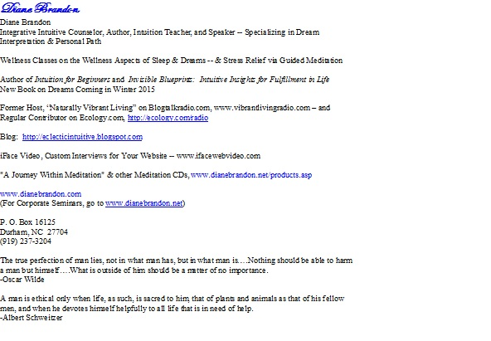
  P. O. Box 16125
  Durham, NC 27704
  (919) 237-3204

Forward email

This email was sent to dianebrandon@bellsouth.net by diane@dianebrandon.com |
Update Profile/Email Address | Instant removal with SafeUnsubscribe™ | Privacy Policy.
Diane Brandon | P. O. Box 16125 | Durham | NC | 27704

