From: | Diane Brandon <dianebrandonauthor@gmail.com>
Subject: | A time of Clearing & Trusting, New Insights, & Other Tidbits
Preheader:
Reply: | dianebrandonauthor@gmail.com


  Having trouble viewing this email? www.dianebrandon.com/index_files/page0178.htm

You are receiving this email from Diane Brandon because you purchased a product/service or subscribed on our website or at an event. To ensure that you continue to receive emails from us, add dianebrandon@bellsouth.net to your address book today. If you haven't done so already, click to confirm your interest in receiving email campaigns from us.

You may unsubscribe if you no longer wish to receive our emails.

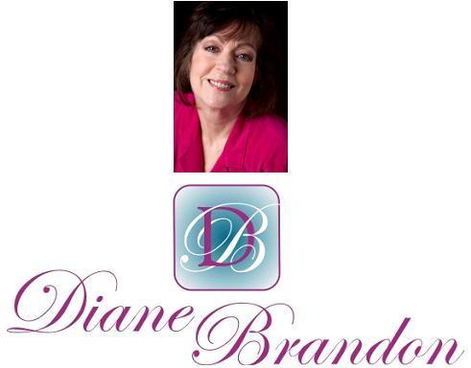

Integrative Intuitive Counselor, Intuition Teacher,
Speaker, & Author

February 26, 2017

A Time of Clearing and Trusting, New Insights, & Other Tidbits

  In This Newsletter
  New Book, "Born Aware," Coming Out
  Connecting Spiritually with Animals
  Discernment vs. Judgment
  Your Intuitive Body: Embodied Cognition
  Trees Nurture Others
  Calming Music
  Universal Consciousness
  Wolves Change Rivers
  Skype for Recordings of Sessions
  A Call for Dreams
  My Schedule at Dancing Moon
  Guided Meditation for Healing
  Mentoring in Intuition
  Refer a Friend & Gift Certificates
  Donate Free to Causes
  Share
  Signature Block
  Links
  My Newest Book (Coming Out in July)
  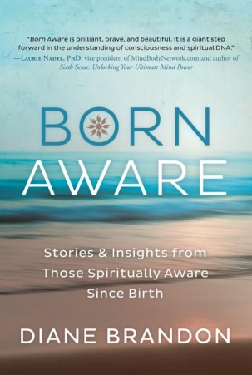
  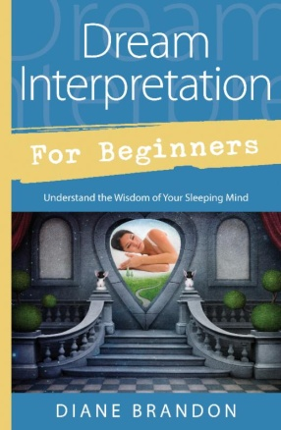
  Dream Interpretation for Beginners
  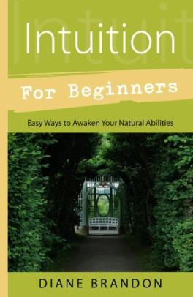
  Intuition for Beginners
  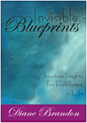
  Invisible Blueprints
  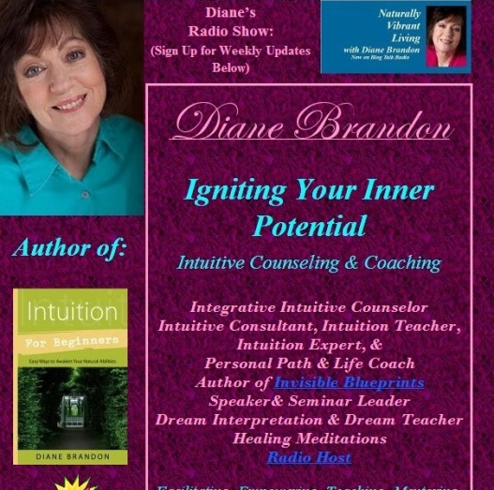
  My Site -- www.dianebrandon.com
  Dream Group on Facebook:
  
  Your Dream World
  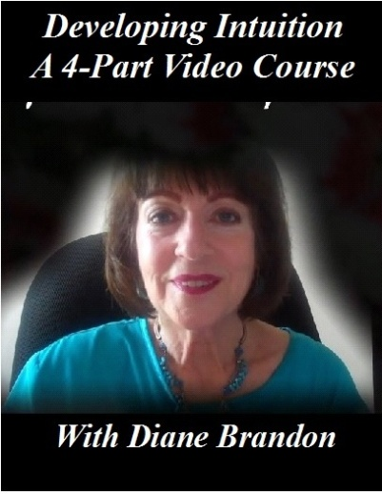
  A Four-Part Video Course on Developing Intuition
  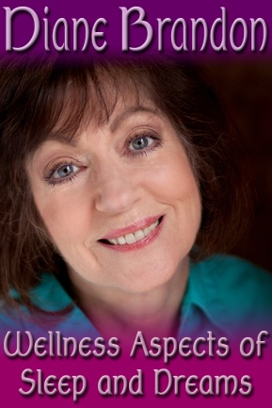
  Video, "The Wellness Aspects of Sleep & Dreams"
  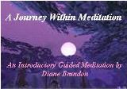
  "A Journey Within Meditation"
  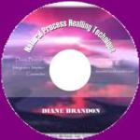
  "Natural Process Healing"
  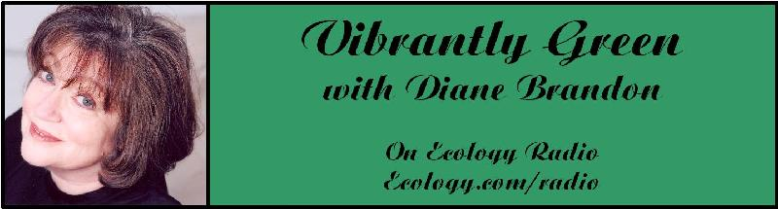
  "Vibrantly Green with Diane Brandon" Radio Show on Ecology.com
  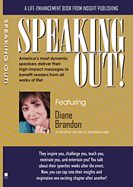
  Speaking Out
  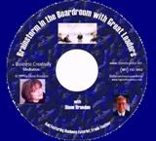
  "Brainstorm in the Boardroom with Great Leaders" Business Meditation CD
  More Cds/Mp3s, Including Intuition Exercises at
  http://www.dianebrandon.com/index_files/page0122.htm
  Find Me on:
  
  Twitter
  
  https://www.facebook.com/pages/Diane-Brandon/128849587146042
  "All that is human must retrograde if it does not advance."
  -Edward Gibbon
  Oh, what churning, turbulent times we're living in! The energies continue to feel strange, with short tempers, polarization, and less tolerance of others. I continue to have people ask me what is going on, since the spiritual view is that we're supposed to be moving forward with more people becoming aware.
  I covered this topic at length in my last newsletter (from August 2016), and I still feel the same way.
  I used the image of a boil coming to a head. Well, now it certainly feels that the boil has erupted, spewing toxic pus. Witness the nasty invective we hear these days, both verbally and in writing. When a boil erupts, the healing can often then start. Unfortunately I'm not convinced that cultural healing has started yet - but it will.
  I sense so much uncertainty and fear these days in the general consciousness. Of course this should come as no surprise, given the events playing out on the world stage. If you consider yourself to be spiritually aware and find these energies difficult, just imagine what it must be like to be living through this time without the awareness that you have. I'm very grateful to have the innate spiritual awareness that I have, or I might find myself scared to death, not knowing what in the world is going on, when the world that used to feel familiar and so predictable no longer is. This is a good time to be grateful for our spiritual awareness and try to imagine what we might feel like without it.
  As I mentioned in my last newsletter, we are living in a time of huge change. Consider the Paradigm Shift. We have astrological triggers for change these days -- and not the slower, more comfortable means to get there. (If you would like a refresher on what I covered in my last newsletter, you can read an archived copy at http://www.dianebrandon.com/index_files/page0178.htm.) So many people are fearful these days and acting out their fears, especially those of the unknown that can spring from the lower human instincts. Sadly, there are increased incidents of racism and acts of violence against those from other countries and religions. Racism and xenophobia have sadly grown.
  I feel that we're in the midst of getting some mass lessons, especially in discernment and denial. As you may know, I'm big on doing our personal work. Hanging out on higher levels spiritually feels great (and I'm the first one to say that I miss being on the other side), but we can't neglect our personal work, meaning working on clearing our personal stuff and healing it. By "personal stuff" I don't mean just any emotional issues we may have developed from painful experiences or abuse in our past, but also our mindsets, fears, beliefs, assumptions, etc.
  Our personal stuff serves as a filter for our perceptions, meaning that we simply can't perceive things (other people, events, etc.) clearly and objectively until we've cleared those mindsets, assumptions, and beliefs. Instead, we perceive in a very biased, subjective fashion that is not aligned with reality - but rather from our often limited and biased point of view. And perceiving clearly is a spiritual attribute.
  This can affect every area of our lives. I have seen it in my work over and over again over the years with my clients' relationships. We've probably all experienced this at some point: dealing with a painful relationship or break-up. What I have typically seen is that there was a lack of discernment at the outset. We often want to be in a romantic relationship really badly, which obviously can serve as a motivator to get into one. When we meet someone we feel attracted to and because we want to be in a relationship, our urge to do so can lead us to forget discernment. We may see aspects of the other person that we really like -- and may also overlook any red flags. When we come out the other side of the relationship, we may then in retrospect be able to look back and see those problematic red flags and realize that we didn't allow ourselves to pay attention to them.
  Discernment (and being in denial) can be applied to many areas of our lives: prospective jobs, places to live, friends, politics, etc. Being able to read and discern where others are coming from and what they're like on the inside is a vital skill. And reading others and where they're truly coming from is neither impossible nor difficult.
  Our beliefs and mindsets, if not worked on, can lead us to be in denial -- and to subsequent regret. I would recommend that everyone work on the skill of reading others -- not just how they appear on the outside or what they say, but who they truly are on the inside.
  I'll say it again: Perceiving clearly is a spiritual attribute.
  Knowing who we are on the inside (our true essence, not our personal stuff) can also guide us. We then know what resonates with who we are and what doesn't.
  Some people may feel that discernment is the same thing as being judgmental and will shy away from any stance that seems judgmental. Discernment and judgment are two different things. I wrote about this in my last newsletter, but it bears repeating. If you would like more information on the differences between the two, there's a good article on this, at https://www.psychologytoday.com/blog/sapient-nature/201105/dont-be-judgmental-be-discerning.
  At the same time that we want to learn discernment, we also want to remember to be open to others, including those who look, act, or believe differently. At a time of heightened fears, we may feel like "circling the wagons" and retreating to a more tribal -- and less developed or spiritual -- mentality, fearing that which we don't know or seems unfamiliar. We're unfortunately seeing a lot of this regressive attitude these days, with the rise of xenophobia and prejudice. Of course, it's neither healthy nor spiritual.
  So, yes, we're living through a very messy, difficult time that is ripe with mass lessons. This is indeed a momentous time, and it's important to do our personal work and be as clear as possible, while remembering and embracing our spirituality and awareness that we are all indeed and ultimately connected.
  Carl Boudreau wrote a very insightful piece on the eclipse of February 26th and how it connects to both releasing old issues and moving forward from Piscean Age attitudes to more Aquarian ones. You can read it at https://www.facebook.com/notes/carl-boudreau/february-2017-a-spontaneous-epilogue-to-or-epitaph-for-february-2017/10212469632764306.
  I have gotten very strongly that there is a Divine plan in place, which needs to play out. I have sensed a Divine transmuting energy start to "pour" in, although at a very slow rate since around October. Higher Soul Awareness energies are coming in. (I first noticed this in the Fall of 2015 during a monthly meditation that I do with two friends, who were also born aware.)
  I do feel that there will be more light and that things may start to feel lighter this year, possibly around April/May, although at this point this timing doesn't feel firm to me.
  So this is not a time to abandon our spiritual awareness or lose hope. I feel that it's important to stay on our spiritual path, while we strive for objectivity and clarity - and discernment. It's important to do our personal work and work on our personal stuff. Remaining open and embracing integrity and ethics is crucial, as is our stewardship of the environment and wildlife (and, yes, that's a spiritual responsibility). And being open to others, using discernment, and living our spirituality are important.
  We are in a period of clearing, freeing us up to move forward in the Paradigm Shift. It may not feel very good at present, but it's apparently a vital phase in the process.
  Don't lose heart!
  We really can work with the energies of positive, transformative change -- and this is an important time to do so.
  As always, I wish you great joy, health, love, peace, and prosperity! Please contact me should you want to schedule a private session!
  Warmly,
  Diane
  P. S. If you have any trouble reading this, just go to http://www.dianebrandon.com/index_files/page0178.htm,
  where it will be archived in a day or two.
  Born Aware: Stories and Insights from Those Spiritually Aware Since Birth
  New Book Coming Out in July
  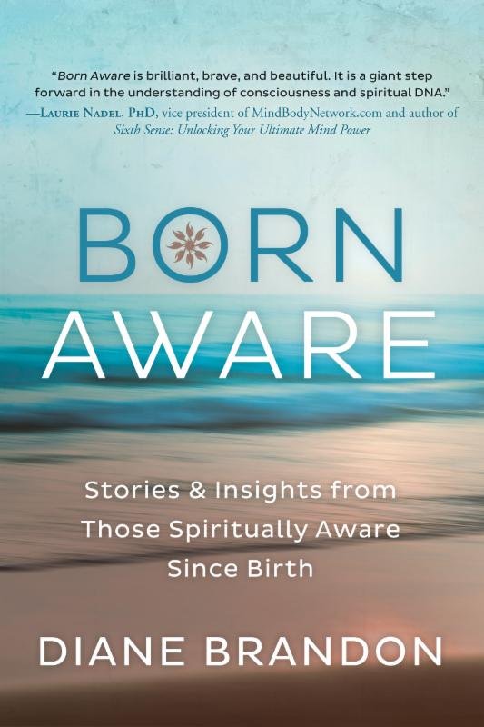
  I have always remembered what I thought when I was born. My thoughts were spiritual ones, about wanting to be back with God, not wanting to be here, etc. Fortunately, I have always felt a deep, direct connection with God that has never diminished.
  I never knew that this was unusual, until much later. I tended not to share this with others. Then, in 2014, two people spontaneously shared their at-birth memories with me. I knew I was being given a message to write about this phenomenon.
  I searched for more people with these memories to interview and discovered that it's indeed a rare phenomenon. I did find others though, conducted interviews, and gradually shaped the material into a book.
  I can't express how wonderful I feel the material in the book is, especially each person's account. As I interviewed each person, I was enraptured by the information. In addition to the personal accounts, I also share spiritual implications of the material and how one can groom a spiritual state of consciousness.
  The book will come out in July and is already listed on Amazon.
  Our Connection with Animals and the Environment is a Spiritual One
  For those of us who are spiritually aware and/or oriented, animals and the environment are special. We love them. We feel their energy. We want to protect them.
  Despite our cultural mindset, this love of animals and nature is truly a spiritual one, because on the highest levels we're all connected and Divine energy runs through everyone and everything. I fell that increasing numbers of people have been opening more to animals and the environment, a wonderful trend.
  In my new book, Born Aware, I discuss the spiritual basis of our connection with animals. They're truly a part of being spiritual.
  I recently saw an article on connecting more with other species and it's got some wonderful information. You can read it at http://www.kosmosjournal.org/article/unheard-invitations-piercing-the-veil-between-species/
  A Helpful Tool: Discernment
  Because I feel, as I wrote above, that discernment is an important skill and quite timely, I'm including this piece again (which appeared in my last newsletter).
  As we all know, romantic relationships that aren't going well can be extremely painful. I've often seen people learning strong lessons and growing through difficult relationships, so they can indeed serve a purpose for our unfolding. In fact, I saw a quotation years ago, "Relationships are the best seminar in town." (I wish I knew where it came from!)
  As I learned over the years from my intuitive work, many relationships are what I call "learning relationships." We're in them in order to learn learns and grow Often one of the lessons we learn has to do with discernment, being able to discern where someone else is coming from and whether that person is a good fit for us.
  Although we often learn discernment through romantic relationships, it's important in all relationships and in making choices that don't include personal relationships.
  Some people confuse discernment with judgment, or being judgmental. These two are quite different from each other, though.
  There's a good article on this at https://www.psychologytoday.com/blog/sapient-nature/201105/dont-be-judgmental-be-discerning
  Of course, I would strongly recommend developing your intuition and your ability to read others, in order to get a sense of where they're coming from on the inside. Intuition can benefit our lives in a variety of ways, and reading where others are coming from is certainly one of them!
  Embodied Cognition: Parts of Your Body are Intuitive Too
  I wrote about this in my book, Intuition for Beginners -- Easy Ways to Awaken Your Natural Abilities. There are several different forms of intuition, and one that may not be known as well as others is what is called "embodied cognition," meaning that our bodies have awareness. Of course, we typically think that it's just our minds/brains that have awareness, but science has taught us the opposite.
  The Institute of HeartMath has done a huge body of research on awareness residing in the heart. Some of their more recent research has shown a precognitive awareness in the heart, meaning that the heart registers information a few seconds before the brain does. (I don't want to complicate this at present in this short section, but there is also research showing that it is our unconscious that makes some decisions slightly before we're consciously aware of having made them.)
  As I mentioned, I cover some of this in Intuition for Beginners. You can also read a recent article on just some of this at http://www.collective-evolution.com/2014/11/28/precognition-science-shows-how-our-body-reacts-to-events-up-to-10-seconds-before-they-happen/
  Older Trees Nurture and Communicate with Younger Ones
  There's been a lot of fascinating research and information coming out on trees. Some research has shown that they communicate with each other via their roots.
  New research is showing that older trees actually nurture younger ones. You can read about it here: http://www.ecology.com/2012/10/08/trees-communicate/
  We're learning that the world of animals and plants is much richer and more complex than we thought. (And this is just one piece of recent research. I've read article after article showing animal intelligence, which I tend to share on Facebook.)
  Lost Continent(s) Found
  A quite surprising discovery was recently made. A previously unknown continent was found. If that wasn't enough, shortly after that announcement another lost continent was announced to have been found. The first is close to Mauritius and the second, close to New Zealand under the ocean. They've named the second one Zealandia.
  You can read about these two new finds at http://www.cnn.com/2017/02/03/world/lost-continent-mauritius-trnd/index.html and http://www.bbc.com/news/world-asia-39000936.
  Despite our sometimes jaded attitudes that we already know all there is to know, we are still finding new things -- whether continents, animal intelligence, aspects of science, etc. I feel that it's important to know that there's so much that we truly don't know -- and to inject a sense of wonder back into our world and our lives.
  A Recording that is Said to Reduce Anxiety by 65%
  We're all familiar with meditation music and often have our favorites to use when we meditate. I recently read about a piece of music that is said to calm anxiety by 65%. It's called "Weightless" and you can listen to it at https://www.youtube.com/watch?v=sYoqCJNPxv4
  Moving Towards a Global Consciousness -- and Even a Universal Consciousness
  In my last newsletter, I shared an article with you about global shifts in consciousness. (It's at http://www.huffingtonpost.com/gustavo-tanaka/something-extraordinary-happening-in-the-world_b_8820154.html?ncid=txtlnkusaolp00000592. )
  Since then, I've had new information come in. (I'm blessed to receive information frequently on where we're headed.) Some of this information will be in my next book,
  Born Aware.
  A couple of months ago, one of the people in that book introduced me to the founder of a relatively new organization, The Edgar Mitchell Foundation for Research into Extraterrestrial Encounters (F. R. E. E.). I spoke with him at length a few weeks ago and have looked at some of their research findings. Extremely interesting!
  These are not the Hollywood type of scary abductions -- at least for the most part. Over half of the respondents thus far reported having positive experiences and for many people the experiences are spiritual. Yes, spiritual!
  Our universe is filled with awareness and aware beings, and it would appear that increasing numbers of people are making contact with them or being contacted. This seeming increasing contact leads me to feel that we are moving towards a more universal consciousness.
  If you've ever had an ET encounter, you can participate in the foundation's research. Their website is at http://experiencer.org. You can also find their research findings thus far on the website.
  Given the increase in near-death experiences and ET encounters, along with increasing numbers of people opening up spiritually, we are definitely being led in a new direction spiritually and are being triggered to awaken and expand beyond narrow consciousness!
  How One Species can Change an Entire Ecosystem
  I Have shared this with you in the past, but feel it's significant enough to share again.
  Ecosystems are very complex, interwoven systems and what we may feel are minor changes -- the loss of one animal, a change in temperature, etc. -- can completely change that ecosystem.
  This article details what happened to one ecosystem when wolves were re-introduced and the results, I feel, and implicit lessons are very important. It's at https://weloveanimals.me/released-14-wolves-park-no-one-prepared-unbelievable-nature11/
  An Inspiring Story of Love
  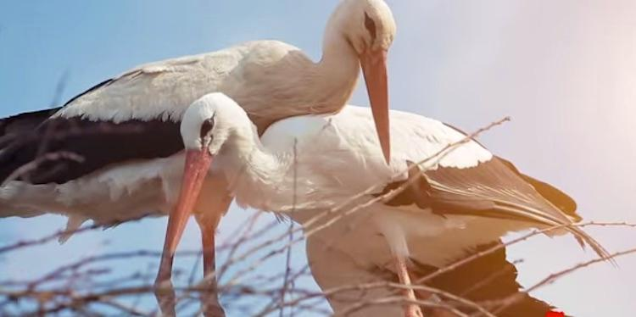
  I found this to be a beautiful and inspiring story, a true one. I hope you enjoy it too! http://www.goodnewsnetwork.org/stork-flies-5000-miles-every-year-visit-injured-soul-mate-watch/
  Bonding Hormone Enhances Spirituality
  You may have heard of Oxytocin, which is often referred to as the "bonding hormone." I first heard of it while I was still doing my radio show and interviewed an expert about it. We produce more of it when we are bonding with others -- a child, in a romantic relationship, etc.
  New research documents that when we have have more oxytocin we're more apt to feel spirituality. This really doesn't come as a surprise to me, given that true spirituality leads us to feel more connected to others; yet it's wonderful that science is documenting this. You can read about the study at https://today.duke.edu/2016/09/oxytocin-enhances-spirituality-new-study-says
  Sessions by Phone or Via Skype -- As Well as In Person
  If you didn't already know, I do sessions by phone and via Skype, in addition to in person. Skype can be especially helpful if you live in another country, as it makes calls for free.
  It can be quite useful to have a recording of a session, and I do record them, whether in person, by phone, or via Skype. If you don't already have Skype, you can download it at www.skype.com.
  A Call for Dreams
  I'm planning on writing another book on dreams, which will follow the one coming out in a year. It will primarily be dreams with their interpretations. I'm in the process of collecting dreams for that book. If you have some interesting ones, please do send them to me. Please note that all dreams are included anonymously to protect the dreamers' privacy Below is more information:
  Please Submit Dreams
  Your Dreams will be Included Anonymously
  I Will Interpret Your Dreams for Free
  I Will Send You a Free Copy of the Book After it's Published if Your Dream is Included
  Please Send Your Dreams in Complete Detail, as They Unfolded -- No Short Summaries
  The Publisher Requires, of Course, that a Release be Signed
  Please Email Them to Me at dianebrandonauthor@gmail.com
  I do have a Dream Group on Facebook, where people can record their dreams and receive interpretations. It's called Your Dream World and is at https://www.facebook.com/groups/125990490759247/ I would love to have you join!
  My Schedule at Dancing Moon in Raleigh
  (In Addition to My Regular Availability at Home)
  In addition to doing sessions at home by phone or in person, I also am available on a fairly regular basis in two other locations.
  Below are the dates through June when I'll be available for sessions at Dancing Moon in Raleigh. I also have the dates on my website, at http://www.dianebrandon.com/index_files/page0007.htm
  Of course, I am always available for sessions in person or by phone at my home.
  Dancing Moon in Raleigh
  1840 Wake Forest Road
  12:00 Noon - 6:00 PM
  For Appointments, Call 919 833-8081
  Thursday, March 9
  Wednesday, March 29
  (2nd Quarter Dates Have Not Yet Been Scheduled.)
  You can always check the calendar on Dancing Moon's website, at http://dancingmoonraleigh.com/wordpress/, to check for my availability.
  And don't forget that I'm always available for sessions in person or by phone from my home as well! Just email me at dianebrandonauthor@gmail.com or call me at 919 237-3204.
  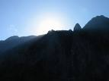
  Using Individualized Guided Meditation for Healing
  Many of us have been working on healing and clearing some of our old issues -- the pain and fears from unpleasant experiences in our past that can hold us back and block our happiness. This is one aspect of my intuitive work with other people. I strive to assist people on their paths to find more fulfillment, development their potential, and be happier.
  One modality that I have found extremely useful in my work is Guided Meditation. I do individualized Guided Meditation with people for several things: to enable people to meditate for the first time and find their center; to begin to find their own answers within; to meet guides; and to work on healing old issues. Doing this work via individualized Guided Meditation can be a gentle, yet powerful way of shifting and moving energy. Meditation in and of itself can have profound benefits. Using it for healing can be even more beneficial and powerful.
  I do individualized Guided Meditation both in person and by phone. Just contact me if you'd like to experience it in a session!
  Mentoring Group on Intuition
  I am mentoring some people who are in development for working professionally with their intuition and facilitating others. As you may know, my intuitive work is centered around facilitating others and assisting others on their paths. We're living in a time now when more people will be needed who can truly assist others and help to facilitate. The mentoring allows people to gain facilitating skills in a more rapid manner than the "on-the-job" training period one goes through when starting to work with others.
  My mentoring group is doing beautifully and I'm tickled with how those involved are doing and the perceptive questions they ask.
  If you are interested in being part of my mentoring group, please contact me. One prerequisite is first attending one of my workshops on developing intuition. Thereafter, we will meet in small groups for mentoring, practice, and guidance.
  Gift Certificates and a New Refer-a-Friend
  
  Gift Certificates
  I have been asked to offer gift certificates from time to time, whenever someone would like to give a friend or relative a session. I always seem to forget to mention that these are a possibility. So, if you would like to give the gift of a session to someone, please know that they are available.
  Refer-a-Friend
  I also wanted to let you know that, if you've had a session with me and wanted to refer someone you know, whenever you refer someone to me who has an hour session, I'll be happy to give you 15 minutes free for your next session with me. Just let me know whenever you refer someone!
  Websites Where You can Donate to Various Causes -- for Free
  The following is a listing of websites where you can donate to various causes, all for free. This is a wonderful idea!
  I'd like to thank Diana Henderson for this. She has an excellent weekly Prayer List and includes these sites in her weekly mailing.
  The Rainforest Site: http://www.therainforestsite.com/cgi-bin/WebObjects/CTDSites
  The Animal Rescue Site: http://www.theanimalrescuesite.com/clickToGive/home.faces?siteId=3
  (also several others along the top at this location)
  Care2.com's click-to-donate site http://www.care2.com/click2donate/ makes it easy to help many causes. Click on any one of them (rainforest, oceans, big cats, primates, et al) and the next page will show all of them listed near the top. Then click on each to donate to every single cause. It's a major help to have so many click-to-donate buttons on one site!
  The Ecology Fund: Save land for free at http://ecologyfund.com/ecology/_ecology.html
  (You'll be clicking four times on the Ecology Fund site: Click first the button that says Save Land; on the next page click the Save Land Coastal button; on the following page, click on Save Land under Species; on the following page, click on Save Land under U.S.A. and finally click on the Clean Air button.)
  Plant an Oak Tree: http://cannecy.free.fr/iforest/en/
  Help plant a tree (every five clicks plants a tree): http://www.landcareniagara.com/
  Save Old Growth Forests (Sweden): http://ettklickforskogen.se/
  Surrey Wildlife Trust: http://www.theenvironmentsite.org/donate.php
  Save rainforest: http://www.redjellyfish.com/wildlifeconservation.html
  Plant a tree in the rainforest: http://www.tree4life.com/ingles/ingles.htm.
  Feed Hungry Children in Argentina (click on button that says GRATIS): http://www.porloschicos.com/PorLosChicos.NET/
  Fight Hunger: http://www.hungerfighters.com/
  Feed Children: http://www.hungrychildren.com/
  Employ/Educate Impoverished: http://www.solvepoverty.com/
  If you'd like to share this email with anyone else, please fee free to forward it.
  As always, I wish you peace, light, love, and prosperity!
  Warmly, Diane
  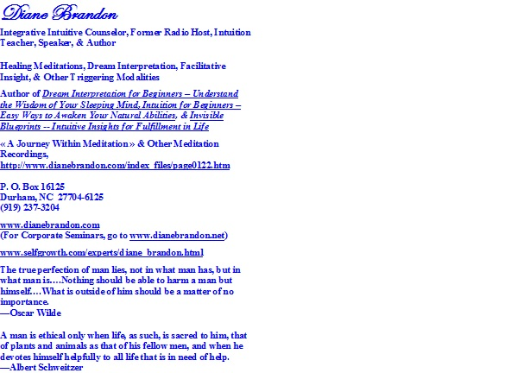
  P. O. Box 16125
  Durham, NC 27704
  (919) 237-3204

Diane Brandon, P. O. Box 16125, Durham, NC 27704
SafeUnsubscribe™ {recipient's email}

Forward email | Update Profile | About our service provider

Sent by dianebrandonauthor@gmail.com in collaboration with


Try it free today

