From: | Diane Brandon <dianebrandonauthor@gmail.com>
Subject: | Happy New Year, Rhine Presentation, Healing & Moving Forward, Living in Integrity, & More
Preheader: | Happy New Year, Rhine Presentation, Healing & Moving Forward, Living in Integrity, & More
Reply: | dianebrandonauthor@gmail.com


  Happy New Year, Rhine Presentation, Healing & Moving Forward, & More
  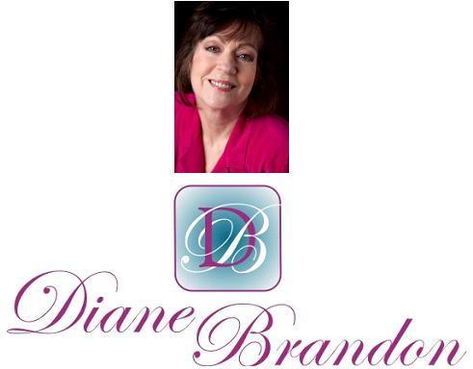
  January 2018 Newsletter
  January 7, 2018
  Happy New Year, Rhine Presentation, Healing & Moving Forward, Living in Integrity, & More
  Living in and Navigating Chaotic Times
  Happy New Year!
  I hope your holidays were enjoyable, peaceful, and full of love and hope! We now find ourselves in the new year of 2018, a time when we traditionally look forward with optimism and some planning.
  Where are we headed? And what's going on with the ambient energy?
  We all know that we continue to live in turbulent times, full of potential and yet full of tension as well. It's no secret that the polarization in our culture continues and is quite uncomfortable to live through. Given that we are still going through a time of the Paradigm Shift, I feel that it's to be expected that we would see tension and polarization, as well as uncertainty. Those who are aware of this massive Paradigm Shift and who are "awake" may have an easier time, as we tend to be clued into the shifts. That said, the polarization is still uncomfortable due to the tension, finger-pointing, and absence of peaceful understanding. We can only continue to put one foot in front of the other and hold a vision of that which is spiritual and spiritually right.
  This continues to be a time of change, especially with Pluto still going through Capricorn transforming structures in the world. It's definitely an uncomfortable time to live through and yet, at the same time, I feel that we're moving towards a better time and that humanity is moving forward in a positive direction, even if that movement feels imperceptible or uncertain at times. In times of change, there's bound to be uncertainty and a degree of stress.
  This is a time of continuing to see awakenings -- to the spiritual realm, to compassion for animals, to a concern for the environment and awareness of the need to protect it.
  I still think of what Carl Boudreau wrote about in December 2015 about the 30+-year Pluto-Saturn cycle that ushered in a period of greed, materialism, and lack of ethics in the 80s that was now reversing. He wrote that we would see a return to ethics and compassion and would see exposes of corruption. (Ring a bell?)
  In early November, Jupiter moved into Scorpio for a year's stay. Several astrologers said that we would see more exposes of corruption during this period of time. And we definitely have. They have started as exposes of sexual corruption/misconduct and have caught fire like a wildfire (which we've unfortunately seen more of this year). I have no doubt that the exposes of corruption we'll be seeing will not be restricted to solely sexual ones and there will be exposes of other types of wrongdoing as well.
  I feel that increasing numbers of people are being reminded of ethics and what's right, as well as of living in integrity (meaning that what we say, believe, and do are in alignment).
  At the same time, I feel that we're gradually moving from a tribal mentality to a global one (thanks to the internet and the world "getting smaller") and ultimately to a more universal one. In many aspects, the ways in which we've defined ourselves (as male or female, American, by race, species, etc.) have also divided us, as we've identified with our "tribe" and regarded all others as foreign or not kin. It's when we can see the consciousness and awareness in all others, including the non-human, and sense a kinship that we get bigger in ourselves and align ourselves more with spiritual realities. On the other side, as those of us born aware remember, everyone and everything is connected. We don't have "humans" on the other side. We have souls. We are souls.
  So this, in many ways, is where I feel that we're headed. On the way there, though, we will no doubt have ups and downs, chaos at times, and turbulence -- but if we hold to that which we know to be true and right the journey will be easier and so doing will have an effect on the overall energy and zeitgeist, which will also trigger others.
  Thus, I feel that this is not a time to get down in the dumps and pessimistic. We are indeed inexorably moving forward and there is Divine purpose to everything. And we all have roles to play in this drama and period of change.
  I feel that we'll see more awakenings in 2018, as well as some perhaps huge surprises being played out on the world stage (all of course in Divine order). So don't lose heart or hope.
  And please remember that I'm always available for sessions, facilitating, mentoring, and teaching.
  I have several things to share with you in this newsletter, which you'll find detailed below.
  As always, I wish you positive unfolding, love, prosperity, and joy!
  Presentation at Rhine Research Center
  "The Born Aware Phenomenon"
  
  I'm pleased to be presenting again at the Rhine Research Center. If you're not familiar with them, you may be familiar with J. B. Rhine, who was internationally renowned as one of the pioneering researchers into what was called ESP. He was a psychology professor at Duke, but his research into psi became too controversial for Duke and by my freshman year there his institute was no longer associated with Duke and was, instead, off campus. His daughter has kept the research center alive and it's now called Rhine Research Center and continues to do this research work.
  The Rhine Research Center not only conducts research into ESP, but also has presentations and some classes, which are open to the public.
  I'll be speaking at the Rhine Research Center in January about the Born Aware phenomenon, those of us who have always remembered what we thought when we were born, including some of us always remembering the other side.
  Below are the details for my presentation:
  "The Born Aware and its Corresponding Atypical Consciousness"
  Rhine Research Center
  Durham, NC
  Friday, January 19
  7:00 - 9:00 PM
  For more information and to buy tickets, Go to http://www.rhine.org/events-and-presentations.html
  The presentation will be simulcast online. Just go to the above link to learn how to watch it online, if you can't attend in person.
  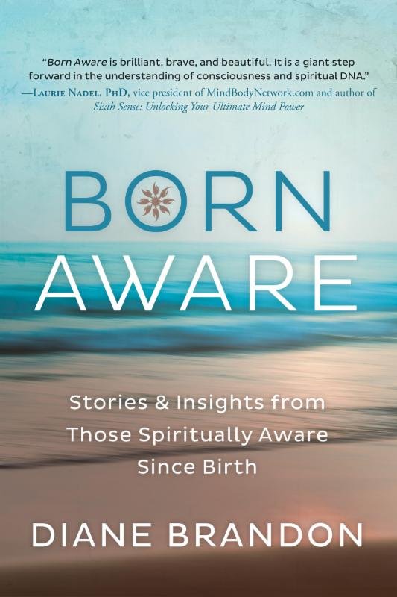
  My Next Book, "Born Aware," is Now Out!
  My new book, Born Aware: Stories & Insights from Those Spiritually Aware Since Birth," is now out! You can find it in bookstores and online at Amazon and Barnes & Noble.
  This book is about those of who have always remembered what we thought when we were born. Our thoughts when we were born were spiritual in nature and our awareness was clear and mature, not that of a baby. The book includes the accounts of 16 people (including my account), as well as spiritual insights one can gain from this phenomenon. I also discuss the Higher Soul Awareness and how we can groom this awareness, which brings us many spiritual benefits.
  I have been so gratified and pleased by the number of positive endorsements I received for the book. (Two people called it "brilliant" and one called it "an important book." I'm so gratified!)
  I hope you enjoy it! And please share this information with friends and family you feel would be interested in it!
  New Research Showing that Trees can Count
  
  I have seen more and research showing an awareness in trees. The latest indicates that trees can count. You can read an article on this research at
  https://www.ted.com/talks/greg_gage_electrical_experiments_with_plants_that_count_and_communicate
  A Feature Interview in Paranormal Underground
  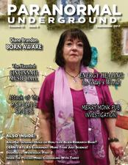
  I was interviewed a few months ago on the radio show, "Paranormal Underground." and it was a wonderful interview. The host, Cheryl Knight-Wilson, also has a magazine with the same title and interviewed me for her magazine as well, in a lovely feature article in the September issue. Archived copies are available at https://www.paranormalunderground.net/magazine-archive.html. I was honored to have been interviewed by her!
  Radio Interviews on The Born Aware Phenomenon
  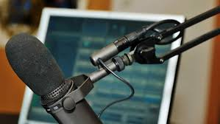
  I have several radio interviews lined up in the next few months to discuss my new book, Born Aware, thanks to the publicist at the publisher. She's also had me write several articles on the phenomenon, which should appear in various metaphysical publications. You'll be able to learn about both the interviews and articles on my website, at http://www.dianebrandon.com/workshops_classes.php. Links to already held interviews may be found at http://www.dianebrandon.com/interviews.php.
  Even though I'll be busy with interviews in the next few months, I will still be available for private sessions, as always.
  Octopus Appears to Thank Rescuers
  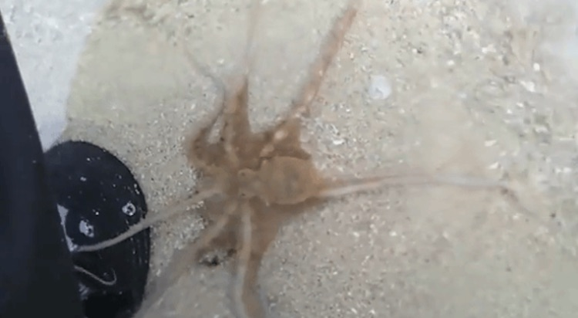
  This was a wonderful story of an octopus who was stranded and then rescued. He later appeared to thank the rescuers. You can read it at
  http://www.natureknows.org/2017/10/family-saves-stranded-octopus-the-next-day-he-returns-to-thank-them-in-remarkable-fashion.html
  A Touching "Deathbed" Reunion Between Chimp and Human
  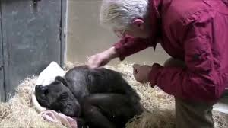
  I recently saw this video and was so moved by it. It's of an elderly chimp who is dying whose caretaker from years ago came to see him. You might want to have tissues at hand as you view it. It's at http://www.independent.co.uk/news/science/dying-chimpanzee-mama-royal-burgers-zoo-holland-netherlands-jan-van-hooff-a8007271.html
  New Email Address
  Please make a note of my new email address. I've had many problems with my old Bellsouth one and have changed it to a Gmail one, which is below:
  dianebrandonauthor@gmail.com
  My Books, Meditations, and Courses
  Below You'll Find Some of My Books, Meditations, and Courses. More information may be found at http://www.dianebrandon.com/books_audio_video.php
  My Book, "Born Aware"
  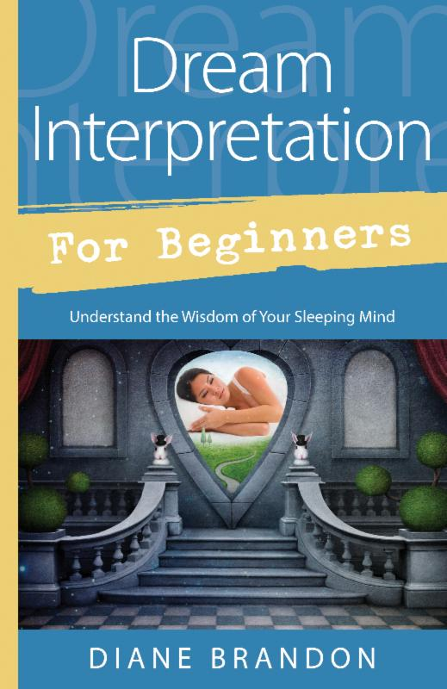
  My Book, "Dream Interpretation for Beginners"
  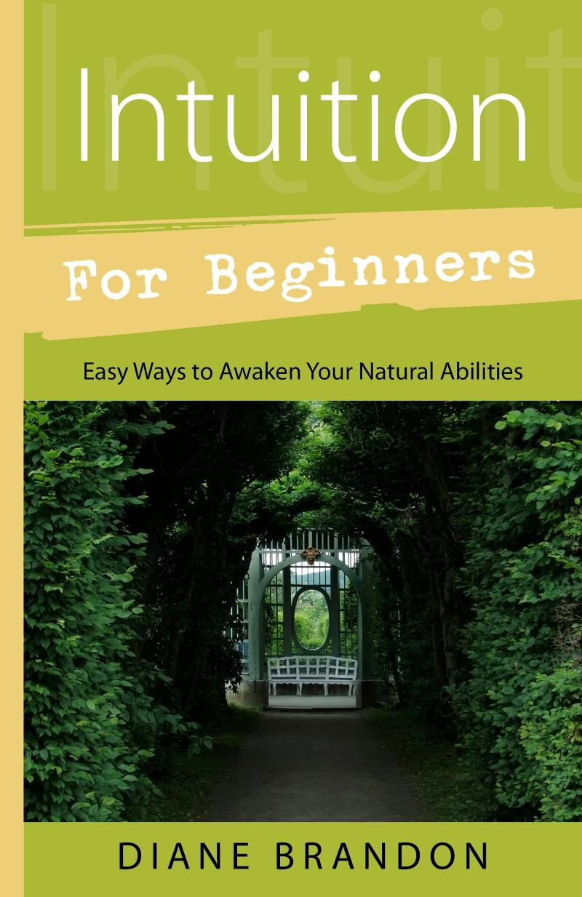
  My Book, "Intuition for Beginners"
  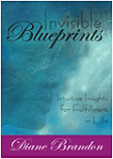
  My Book, "Invisible Blueprints"
  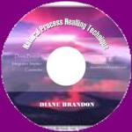
  "Natural Process Healing" CD
  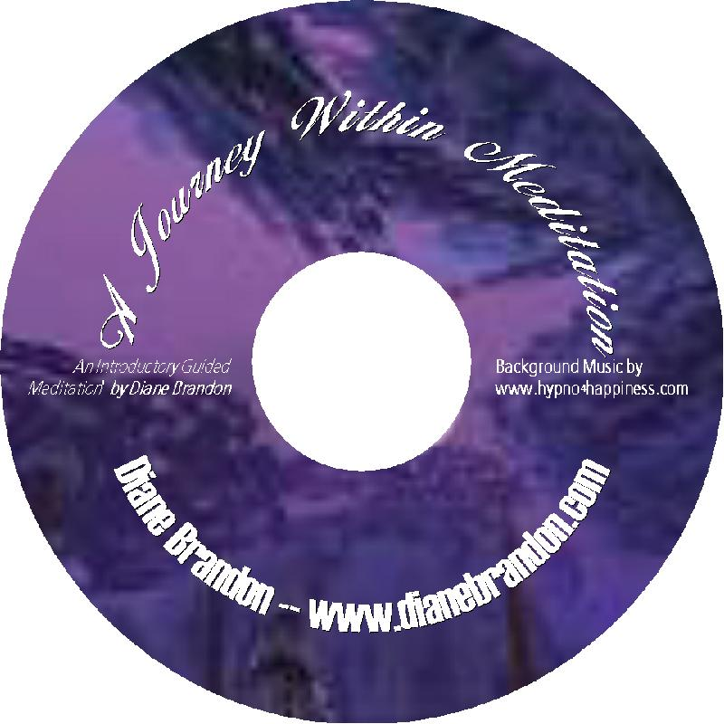
  "A Journey Within Meditation"
  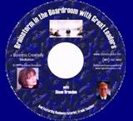
  "Brainstorm in the Boardroom with Great Leaders" Meditation
  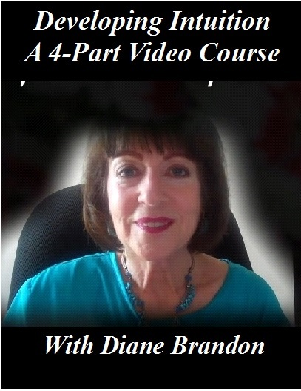
  "Developing Your Intuition & Accessing Information on Demand" Video
  Diane Brandon | dianebrandonauthor@gmail.com| 919 237-3204 |
  www.dianebrandon.com
  You Can Find Me on:
  
  Facebook
  
  Twitter
  My Dream Group on Facebook, "Your Dream World"
Diane Brandon, P. O. Box 16125, Durham, NC 27704
SafeUnsubscribe™ {recipient's email}

Forward this email | Update Profile | About our service provider

Sent by dianebrandonauthor@gmail.com in collaboration with

