
  "Born Aware" is Now Out, New Website Design, A Return to Heart Energies?
  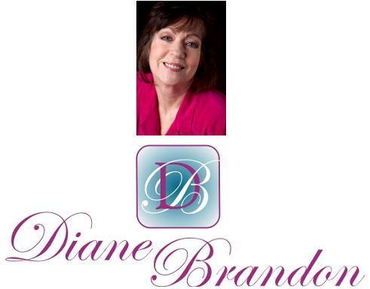
  July 2017 Newsletter
  July 7, 2017
  "Born Aware" Now Out, Website Re-Design, Heart Energies, & More
  A Lighter, Yet Still Problematic Energy
  I hope you've been doing well and have navigated the difficult energies well. Although the sense of polarized energies and tension is not gone completely, the energies do feel somewhat lighter, especially since the North Node moved into Leo in May.
  According to some astrologers, we've moved into more heart-based energies. Between that and a forecast emergence of a return to ethics and concern for others, the energies should indeed be improving. You can read a few forecasts from Carl Boudreau at https://www.facebook.com/notes/carl-boudreau/coming-soon-more-drama-less-trauma/10212656398553334, https://www.facebook.com/notes/carl-boudreau/the-eclipses-of-august-2017-reasons-of-the-heart/10212726264019927, and https://www.facebook.com/carl.boudreau/posts/10213364215048304.
  Even though this shift has to do with coming more from our hearts, this shift will take some time. Unfortunately, it can also push some buttons. We have sadly seen a significant increase in violence in the past months. This is a time to embrace our ideals, higher energies, and visions, while also trying to stay in our center as much as possible. Allowing ourselves to observe problematic situations, rather than getting down and dirty with negativity or polarization or finger-pointing, can also help. We must indeed "be the change we want to see in the world." At the same time, we don't want to repress any negative reactions of our own, but use them instead as an indicator of what we need to work on and heal, without externalizing them onto others.
  This is a good time to meditate, to develop our inner knowing and spiritual envisioning, and to see positive and higher possibilities. It's also a wonderful time to do inner work and healing. Of course, I'm available for private sessions to assist and facilitate.
  We are in the midst of great change in the world, and the process will not necessarily be a smooth or easy one. It should ultimately be moving, however, in a positive direction, even if gradually or incrementally. I still strongly feel that all of this tension and polarization have to do with the paradigm shift and the abrading between old thinking and new thinking. We simply cannot have fundamental change, even if we're shifting towards something more positive, without button-pushing and stirring up some negativity. We must ride the wave, while holding to our ideals, staying in our center as much as possible, doing our inner work, and facilitating as best we can.
  I have some items to share with you in this newsletter. (And you'll note the new design. I needed to get more au courant with technology!) I'm still feeling my way around this new format, so you'll likely see more changes to it in the future, as I figure it out more and do some tweaking.
  Speaking of re-designs, my website has also been re-designed. It's been up since 1995 and sorely needed revision. (You can see it at www.dianebrandon.com.)
  As always, I wish you positive unfolding, love, prosperity, and joy!
  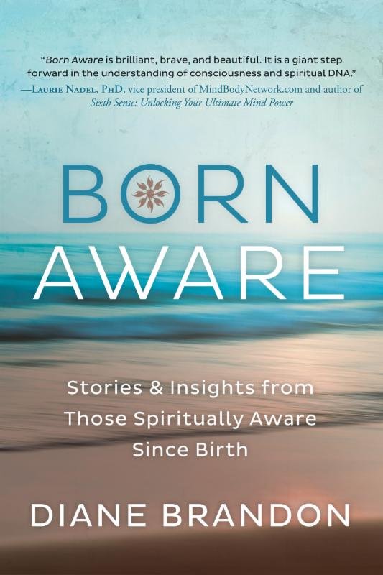
  My Next Book, "Born Aware," is Now Out!
  My new book, Born Aware: Stories & Insights from Those Spiritually Aware Since Birth," is now out! You can find it in bookstores and online at Amazon and Barnes & Noble.
  This book is about those of who have always remembered what we thought when we were born. Our thoughts when we were born were spiritual in nature and our awareness was clear and mature, not that of a baby. The book includes the accounts of 16 people (including my account), as well as spiritual insights one can gain from this phenomenon. I also discuss the Higher Soul Awareness and how we can groom this awareness, which brings us many spiritual benefits.
  Below is the cover flat for the book, showing both the front cover and the back cover:
  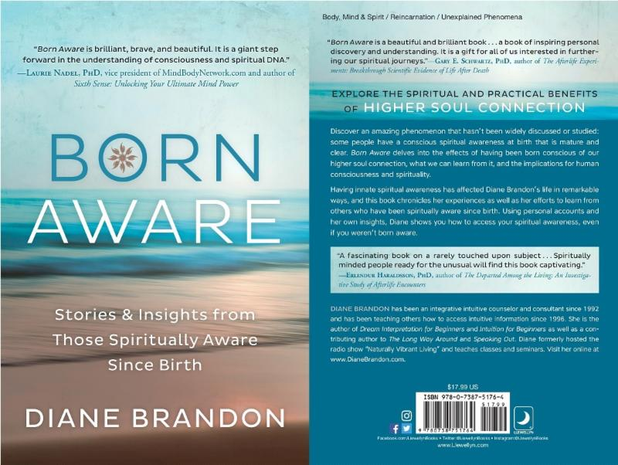
  I have been so gratified and pleased by the number of positive endorsements I received for the book. (Two people called it "brilliant" and one called it "an important book." I'm so gratified!)
  I hope you enjoy it! And please share this information with friends and family you feel would be interested in it!
  Thank You, Dancing Moon!
  
  You may be familiar with Dancing Moon Books and Gifts in Raleigh. The store has been open for over 25 years and I have gone there to do sessions since 1993. The store has grown and is a wonderful metaphysical resource not only in Raleigh, but also in the Research Triangle here in North Carolina.
  I was pleased to see that they have picked my new book, Born Aware, as their Book Pick of the Month for July. Thank you so much! They do have copies of it in stock!
  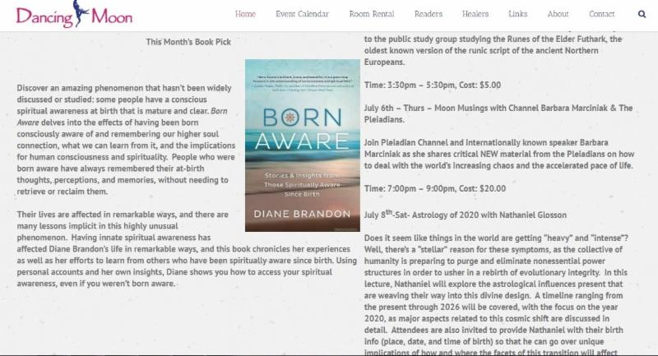
  More Fascinating Information on Trees and Plants
  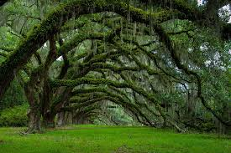
  I have read more new research on trees that I find fascinating. There is really more to trees and what they do than we have known. You can read some of this information at http://e360.yale.edu/features/exploring_how_and_why_trees_talk_to_each_other, https://www.treehugger.com/natural-sciences/injured-plants-warn-neighbors-danger.html, and http://www.cnn.com/2017/02/07/world/secret-life-of-trees/.
  Institute of HeartMath, which did ground-breaking research on the heart, health, and emotions, has been doing research on trees called the Tree Interconnectivity Project. You can find more information on it at https://www.heartmath.org/resources/videos/interconnectivity-tree-research-project/.
  There's also research showing that plants can hear: http://www.bbc.com/earth/story/20170109-plants-can-see-hear-and-smell-and-respond
  Nature helps to heal humans and there's research on how, which you can see at
  https://www.youtube.com/watch?v=y-wHq6yY2CI
  Online Class
  "What is the Born Aware Phenomenon?"
  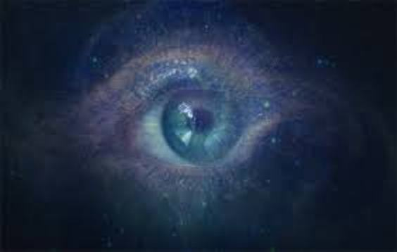
  I will teaching an online class on August 16th to explain and discuss the Born Aware phenomenon. Below are the details:
  What is the Born Aware Phenomenon?
  Wednesday, August 16th
  8:30 - 9:30 EDT/5:30 - 6:30 PDT
  On Learn it Live
  $10.00
  To Register or For More Information, Go to https://spirit.learnitlive.com/invite/class/10990/What-is-the-Born-Aware-Phenomenon
  Radio Interviews on The Born Aware Phenomenon
  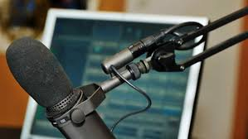
  I have several radio interviews lined up in the next few months to discuss my new book, Born Aware, thanks to the publicist at the publisher. She's also had me write several articles on the phenomenon, which should appear in various metaphysical publications. You'll be able to learn about both the interviews and articles on my website, at http://www.dianebrandon.com/workshops_classes.php. Links to already held interviews may be found at http://www.dianebrandon.com/interviews.php.
  Even though I'll be busy with interviews in the next few months, I will still be available for private sessions, as always.
  An Amazing and Beautiful Creation -- Not By a Human
  
  I was blown away when I watched this video. It's a little long, but well worth the time. It's a creation by a Japanese pufferfish and simply boggles the mind. It's at https://www.youtube.com/watch?v=p1PID91sEW8.
  Presentation at SFF, Spiritual Frontiers Fellowship
  With Bernie Ashman, Astrologer
  "Changing Consciousness Paradigm: Your Unlimited Vista is Around the Corner"
  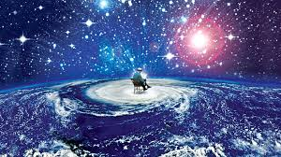
  I'll be speaking at SFF's monthly meeting in September, along with my friend, Bernie Ashman, who's an excellent astrologer. We'll be speaking about where consciousness is headed in the next several years. This will be a joint presentation: I'll speak about where consciousness has been and where it's headed and Bernie will discuss that various astrological triggers for shifts in consciousness in the next several years. (SFF always meets on the first Thursday of the month.) Below is more information on it:
  "Changing Consciousness Paradigm: Your Unlimited Vista is Around the Corner"
  Spiritual Frontiers Fellowship
  Thursday, September 7
  7:15 - 9:30 PM EDT
  Unity of the Triangle, 5570 Munford Road, Raleigh, NC 27612
  $10.00 or $8.00 for Seniors
  For More Information, Go to http://spiritual-frontiers.com
  New Email Address
  Please make a note of my new email address. I've had many problems with my old Bellsouth one and have changed it to a Gmail one, which is below:
  dianebrandonauthor@gmail.com
  My Books, Meditations, and Courses
  Below You'll Find Some of My Books, Meditations, and Courses. More at http://www.dianebrandon.com/books_audio_video.php
  My Book, "Born Aware"
  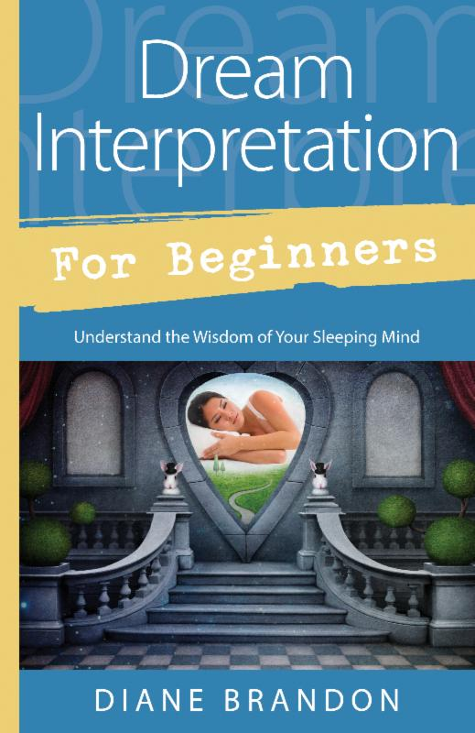
  My Book, "Dream Interpretation for Beginners"
  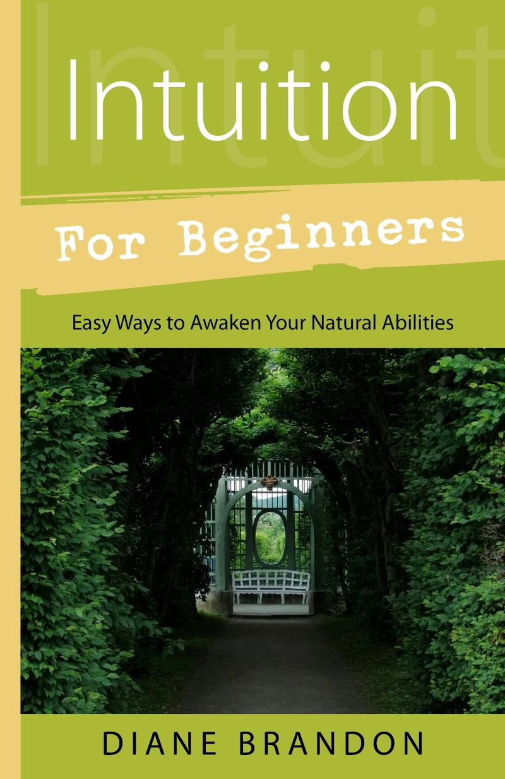
  My Book, "Intuition for Beginners"
  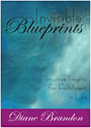
  My Book, "Invisible Blueprints"
  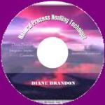
  "Natural Process Healing" CD
  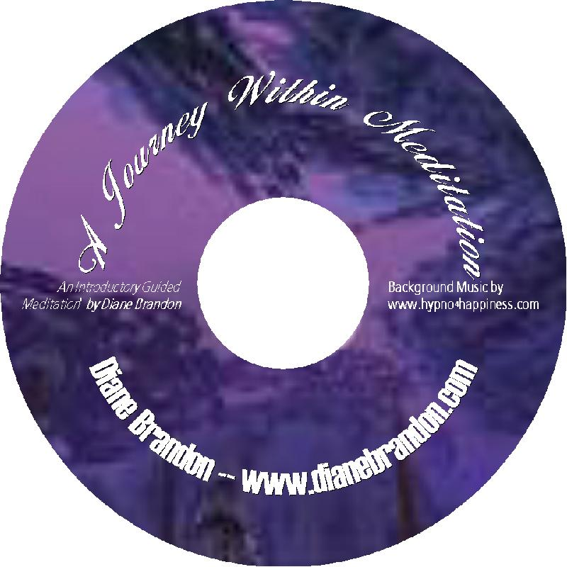
  "A Journey Within Meditation"
  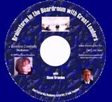
  "Brainstorm in the Boardroom with Great Leaders" Meditation
  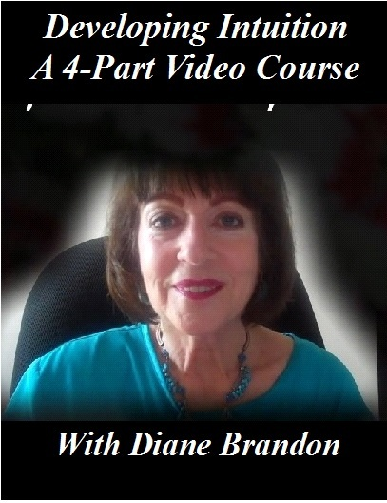
  "Developing Your Intuition & Accessing Information on Demand" Video
  Diane Brandon | dianebrandonauthor@gmail.com| 919 237-3204 |
  www.dianebrandon.com
  You Can Find Me on:
  
  Facebook
  
  Twitter
  My Dream Group on Facebook, "Your Dream World"
Diane Brandon, P. O. Box 16125, Durham, NC 27704
SafeUnsubscribe™ {recipient's email}

Forward this email | Update Profile | About our service provider

Sent by dianebrandonauthor@gmail.com in collaboration with


Try it free today

