From: | Diane Brandon <dianebrandonauthor@gmail.com>
Subject: | Navigating the Energies, New Book/Book Signing, Intuition Workshop, & More
Reply: | dianebrandonauthor@gmail.com


  Having trouble viewing this email? www.dianebrandon.com/index_files/page0178.htm

You are receiving this email from Diane Brandon because you purchased a product/service or subscribed on our website or at an event. To ensure that you continue to receive emails from us, add dianebrandon@bellsouth.net to your address book today. If you haven't done so already, click to confirm your interest in receiving email campaigns from us.

You may unsubscribe if you no longer wish to receive our emails.

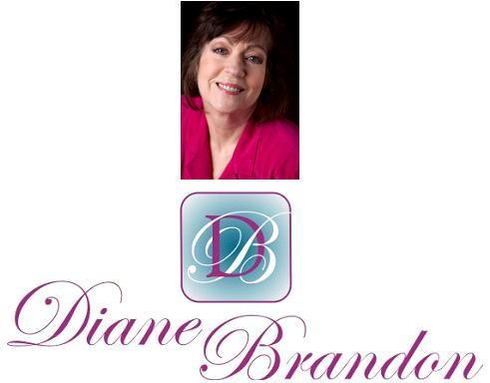

Integrative Intuitive Counselor, Intuition Teacher,
Speaker, & Author

March 15, 2015

Navigating the Energies, New Book/Book Signing, Intuition Workshop,
& More

  In This Newsletter
  New Book on Dreams
  Book Signing
  Workshop on Intuition
  New Email Address
  New Video Course on Intuition
  Skype for Recordings of Sessions
  Video on Benefits of Meditation
  Your Earliest Spiritual Memory
  Rumi Poem Set to Music
  A Call for Dreams
  Guided Meditation for Healing
  My Schedule at Dancing Moon
  Mentoring in Intuition
  Refer a Friend & Gift Certificates
  Donate Free to Causes
  Share
  Signature Block
  Links
  My Newest Book
  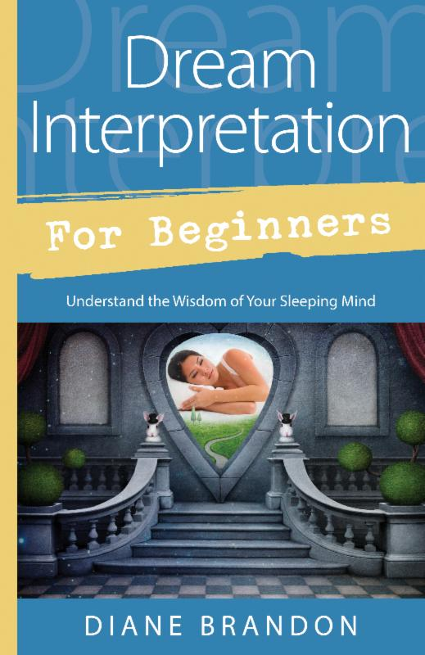
  Now Out & Available in Bookstores & Online
  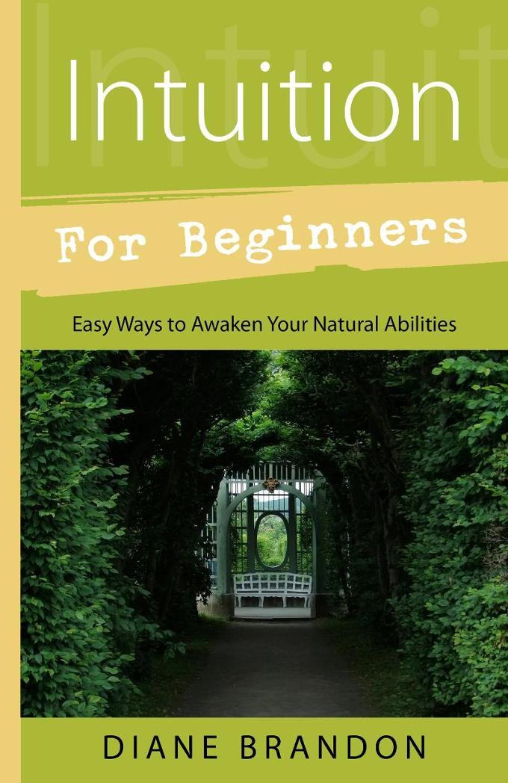
  Intuition for Beginners-- Now Out!
  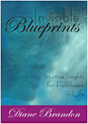
  Invisible Blueprints
  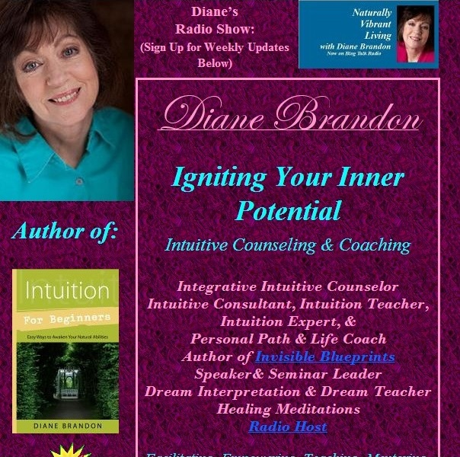
  My Site -- www.dianebrandon.com
  Dream Group on Facebook:
  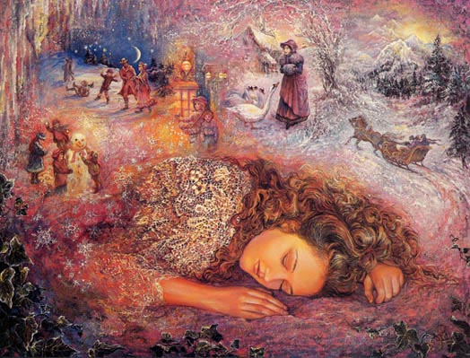
  Your Dream World
  Video, "The Wellness Aspects of Sleep & Dreams"
  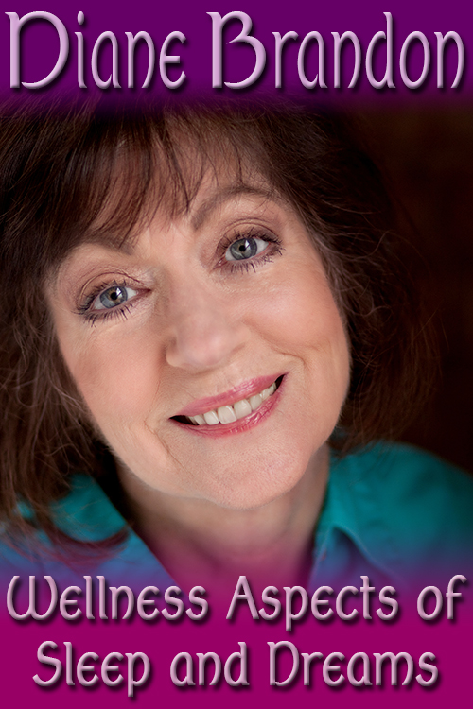
  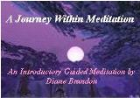
  "A Journey Within Meditation"
  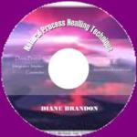
  "Natural Process Healing"
  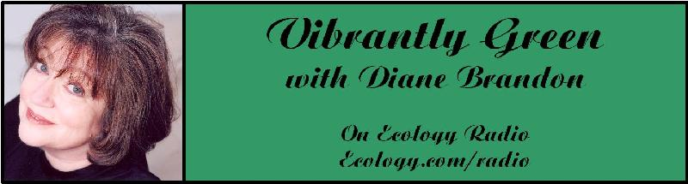
  "Vibrantly Green with Diane Brandon" Radio Show on Ecology.com
  
  Speaking Out
  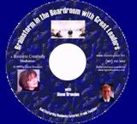
  "Brainstorm in the Boardroom with Great Leaders" Business Meditation CD
  More Cds/Mp3s, Including Intuition Exercises at
  http://www.dianebrandon.com/index_files/page0122.htm
  Find Me on:
  
  Twitter
  
  https://www.facebook.com/pages/Diane-Brandon/128849587146042
  I hope that this newsletter finds you well and having weathered this winter well. We all know that it's been quite an intense winter, with storms throughout the country and a lot of snow and ice. We didn't get hit here in North Carolina until February and then had four systems in a little over a week with frozen precipitation, the first time I've seen that here in my 30+ years of living here.
  I have several things to share with you in this newsletter. First of all, I'm pleased to let you know that my new book, Dream Interpretation for Beginners -- Understand the Wisdom of Your Sleeping Mind, has just been released. You'll find more information on it below, including a book signing in Raleigh in April.
  In addition to the weather, another way in which many of us have been affected has been the ambient energy in the past two or three months. Many have wondered what is going on with the energy and a general feeling of strangeness. The energies in the past couple of months turned out to be even more intense than anticipated, and many have commented on how heavy the energy has been. I did read one article by astrologer Carl Boudreau indicating that the conjunction of three asteroids would be creating such an energy -- and he indicated that it was indeed a heavy, intense energy. It does feel like it has shifted somewhat, although a feeling of intensity still feels to be somewhat evident. For some of us, it has manifested as a feeling of being swamped by demands on our time.
  Astrologically, March is supposed to be an active month, with the culmination of the Uranus-Pluto square (which has created more of a pressure for change) and the first of a pair of eclipses. There is supposed to be even more of a pressure for change this month.
  The energies do seem to be lightening, especially with the arrival of warmer temperatures. However, when I tune into the zeitgeist in the world at present, I feel a sense of turmoil and confusion, with many people, primarily those perhaps less aware, looking for something to hold onto and not knowing what will happen next, as if the underpinnings for stability were being eroded. I feel that more people have a sense now that things are changing in major ways, even if they're unsure of what specifically is changing or where things are headed. More people than usual may be looking for temporary fixes in order to feel better. For those of us who have been aware that this is a period of change may be less affected or thrown off, because we've known that a period of change has been underway.
  I feel that it's increasingly important for us to shift to a higher perspective, especially in meditation. Just keeping our perspective on the earth plane at present will not give us the insight, perspective, or respite that we need. Going to a higher perspective benefits us in numerous ways, including spiritually.
  I do feel that inner shifts and changes on deeper levels within us have been underway and that we may not consciously sense how we may have shifted and grown until we come out on the other side of the present energies. I do feel that the energy will have eased in the Spring (which, of course, is imminent), whether before or after the upcoming pair of eclipses, although the timing feels to me that it will be slightly afterwards.
  With that shift of energy, I feel, we will see more people exploring new ways of handling things instead of falling back on old patterns. This feels to me as if it will represent the end result and culmination of all the energies and triggers for inner change and clearing that we've experienced throughout 2014 and into the present. I also sense that we will see a greater consensus at large that we do need positive change, instead of clinging to old patterns of confrontation and finger-pointing. This Summer I'm sensing that we'll see more of a consensus and a feeling of unity -- not 100% of course, but a perceptible positive change.
  I also feel that we will be seeing an increase of higher energies, including spiritual ones, coming into Earth in various ways, perhaps imperceptibly at first, but which will grow over time. This will assist humans to get out of narrow, personally invested views and more into those of a higher level that consider the welfare of the whole.
  Once again, I feel it's becoming increasingly important to go to higher levels in our perception, rather than being mired in our limited human perspective. These have been difficult waters (and energies) to navigate, but a higher perspective can always benefit us and serve as a positive counterbalance -- and it helps to bring more light and healing into this level on Earth.
  You'll find some news items below, as well as information on my next Workshop on Developing Intuition, which will be held in June. If you know anyone who might benefit from it, please feel free to share the information.
  As always, I wish you great joy, health, love, peace, and prosperity! Please contact me should you want to schedule a private session!
  Take care,
  Diane
  P. S. If you have any trouble reading this, just go to www.dianebrandon.com/index_files/page0178.htm, where it will be archived in a day or two.
  New Book:
  Dream Interpretation for Beginners -- Understand the Wisdom of Your Sleeping Mind
  is Now Out & Available in Bookstores and Online
  My new book on dreams has just been published. It's entitled "Dream Interpretation for Beginners -- Understand the Wisdom of Your Sleeping Mind." It's a fairly comprehensive treatment of our world of sleep and dreams, how to interpret and understand our dreams, and how to use the insight we gain from them. It will also include many sample dreams with their interpretations and ideas on how to apply their insight.
  It is already listed on Amazon, at http://www.amazon.com/exec/obidos/ASIN/0738741914/dianebrandonintul,
  and on Barnes & Noble, at http://www.barnesandnoble.com/w/dream-interpretation-for-beginners-diane-brandon/1119693777?ean=9780738741918
  Book Signing at Dancing Moon
  I'll be doing a book signing at Dancing Moon in Raleigh for my new book. If you'd like to buy a copy and have it signed, just come to the store on Sunday, April 12th (information below). A few people have asked how they could get a signed copy, so, if you're not in the Research Triangle or in North Carolina, just email me and we'll make arrangements for you to obtain one.
  Book Signing
  Dream Interpretation for Beginners -- Understand the Wisdom of Your Sleeping Mind
  Sunday, April 12, 2015
  1:30 - 3:30 PM
  Dancing Moon Books & Gifts
  1840 Wake Forest Road
  Raleigh, NC
  919 833-8081
  Workshop:
  "Developing Your Intuition & Accessing Information on Demand"
  I've had several people ask me when my next workshop on intuition would be held. I've gotten it scheduled, and it will be held on Saturday, June 13th.
  I'm a huge believer in developing our intuition and being able to access intuitive information on demand. It can have so many key benefits in our lives, including the following ones:
  * Helps Us Make Decisions
  * Helps Us Solve Problems
  * Gives Us More Resources for Information
  * Helps Us Find and Strengthen our Inner Voice and Inner Knowing
  * Can Give Us More Self-Confidence & Have Empowering Effects
  * Can Give Us Better Insight into Others
  * Helps Us have Better Relationships
  * Helps Us Be Present in the Moment
  * Leads to Greater Objectivity and Perceiving Clearly
  * Can Lead Us to Be Less Reactive
  Just the two benefits of intuition leading us to be more inner-guided and its effects on improving our relationships are extremely significant ones. And it's imperative to receive pure and reliable intuitive information that's not contaminated by our personal stuff.
  In this all-day workshop, we'll explore what intuition is and do a range of exercises, from the basic ones to more advanced ones. There will be plenty of discussion in addition to the hands-on exploration, and you should have a much better sense of how your intuition works by the end of the day. Below are the particulars on the workshop:
  Workshop on "Developing Your Intuition & Accessing Information on Demand"
  Saturday, June 13th
  10:30 AM - 5:30 PM
  Dancing Moon Books & Gifts
  1840 Wake Forest Road
  Raleigh, NC
  $95, if Registered & Paid by June 12th Or $105 at the Door
  To Register, Contact Me at dianebrandonauthor@gmail.com
  New Email Address
  After having had seemingly regular problems with my Bellsouth email address, I have switched to a new one. Please contact me via the following email address, effective immediately:
  dianebrandonauthor@gmail.com
  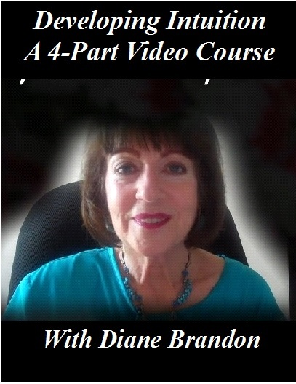
  New Video Course Available --
  "Developing Your Intuition & Accessing Information on Demand"
  https://vimeo.com/ondemand/DevelopingIntuition
  As you probably know, I have been teaching intuitive skills to others for several years now (since 1996, in fact) -- primarily how to access intuitive information on demand (as opposed to waiting for information to come) and how to bypass personal stuff, so as to receive pure and more reliable information.
  I've primarily taught this in an intensive all-day workshop (which I'll be teaching in Raleigh, NC on Saturday, September 20th), as well as in ongoing classes, as well as in one-on-one classes and coaching.
  I've now developed an abbreviated version of my workshop on video -- in a four-part course, entitled "Developing Your Intuition & Accessing Information on Demand." The following are the four parts of this video course:
  Part 1: Exploring What Intuition is -- & Isn't
  Part 2: Exploring Deeper Levels for Intuition
  Part 3: Exploring Certain Types of Intuition through Exercises
  Part 4: Honing Intuition through Advanced Exercises
  Available at https://vimeo.com/ondemand/DevelopingIntuition
  I'm excited to finally make this available in video format. It's still not the same as attending one of my workshops or classes in person, but it will make my teaching material more available, especially in conjunction with my book,Intuition for Beginners.
  Skype for Recordings of Sessions
  Having a recording of a session is a really useful tool, and I offer recordings for sessions in-person and by phone. Unfortunately, I've been having some intermittent problems with my recording equipment (which is used for phone sessions). The good thing is that sessions cam be recorded using Skype. So, if you'd like for phone sessions to be recorded, please download and install Skype on your computer. It's free and has been available for years, and "calling" via Skype is also free. You can download Skype at www.skype.com.
  A Video on the Benefits of Meditation
  A tremendous amount of research has been conducted on meditation in the past several years, and many physiological and psychological benefits of it have been identified. I recently came across this short video which details some of meditation's beneficial effects on the brain. You can view it athttps://www.youtube.com/watch?v=Aw71zanwMnY
  
  What is Your Earliest Memory? -- Looking to Interview People who were Born Aware
  I have always remembered what I thought when I was born. I never shared that with anyone until the past several years because I hadn't realized that it was unusual. I have come to know other people who have been spiritually aware since birth and remember their thoughts as an infant or extremely young child before they learned to speak -- or, in some cases, even before they were born -- and have begun to conduct interviews by phone and work on a book about it.
  I'm considering "spiritually aware since birth" to mean an awareness of not belonging here, or of higher levels, or of a connection to God or Spirit, or of not being the baby lying there, or even of coming from a different place or family, or having an awareness separate from the human persona/personality.
  I'm looking for people to interview with spontaneous memories and not those recalled after an external trigger such as regression, rebirthing, or any other modality.
  I'm looking for about 2 more people to include in the book and people can be included anonymously, unless they prefer to have their name used. I'll be sending a copy of the book to those people whose interviews are in the book.
  If you remember having spiritual thoughts or awarenesses at a very young age, please do let me know. (You can email me atdianebrandonauthor@gmail.com.) I feel that it's important for us to know that we're not alone and that we can all learn from these fascinating experiences.
  A Lovely Rumi Poem Set to Music in a Video
  I'm sure you're familiar with Rumi, whose poetry, which stems from the 13th Century, is both lyrical and inspiring. I recently came across a video of one of his poems. It's set to music and has beautiful images, and you can see it athttps://www.youtube.com/watch?v=u9MqSjY18MA#t=11
  A Call for Dreams
  I'm planning on writing another book on dreams, which will follow the one coming out in a year. It will primarily be dreams with their interpretations. I'm in the process of collecting dreams for that book. If you have some interesting ones, please do send them to me. Please note that all dreams are included anonymously to protect the dreamers' privacy Below is more information:
  Please Submit Dreams
  Your Dreams will be Included Anonymously
  I Will Interpret Your Dreams for Free
  I Will Send You a Free Copy of the Book After it's Published if Your Dream is Included
  Please Send Your Dreams in Complete Detail, as They Unfolded -- No Short Summaries
  The Publisher Requires, of Course, that a Release be Signed
  Please Email Them to Me at dianebrandonauthor@gmail.com
  I do have a Dream Group on Facebook, where people can record their dreams and receive interpretations. It's called Your Dream World and is at https://www.facebook.com/groups/125990490759247/ I would love to have you join!
  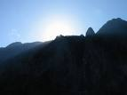
  Using Individualized Guided Meditation for Healing
  Many of us have been working on healing and clearing some of our old issues -- the pain and fears from unpleasant experiences in our past that can hold us back and block our happiness. This is one aspect of my intuitive work with other people. I strive to assist people on their paths to find more fulfillment, development their potential, and be happier.
  One modality that I have found extremely useful in my work is Guided Meditation. I do individualized Guided Meditation with people for several things: to enable people to meditate for the first time and find their center; to begin to find their own answers within; to meet guides; and to work on healing old issues. Doing this work via individualized Guided Meditation can be a gentle, yet powerful way of shifting and moving energy. Meditation in and of itself can have profound benefits. Using it for healing can be even more beneficial and powerful.
  I do individualized Guided Meditation both in person and by phone. Just contact me if you'd like to experience it in a session!
  My Schedule at Dancing Moon in Raleigh
  Below are the dates through March when I'll be available for sessions at Dancing Moon in Raleigh and at Eclectic by Nature in Greensboro. I also have the dates on my website, at www.dianebrandon.com
  I am always available for sessions in person or by phone at my home.
  Dancing Moon in Raleigh
  1840 Wake Forest Road
  12:00 Noon - 6:00 PM
  For Appointments, Call 919 833-8081
  Thursday, March 26
  April - June Dates TBA
  And don't forget that I'm always available for sessions in person or by phone from my home as well! Just email me atdianebrandonauthor@gmail.com or call me at 919 237-3204.
  Mentoring Group on Intuition
  I am mentoring some people who are in development for working professionally with their intuition and facilitating others. As you may know, my intuitive work is centered around facilitating others and assisting others on their paths. We're living in a time now when more people will be needed who can truly assist others and help to facilitate. The mentoring allows people to gain facilitating skills in a more rapid manner than the "on-the-job" training period one goes through when starting to work with others.
  My mentoring group is doing beautifully and I'm tickled with how those involved are doing and the perceptive questions they ask.
  If you are interested in being part of my mentoring group, please contact me. One prerequisite is first attending one of my workshops on developing intuition. Thereafter, we will meet in small groups for mentoring, practice, and guidance.
  Gift Certificates and a New Refer-a-Friend
  
  Gift Certificates
  I have been asked to offer gift certificates from time to time, whenever someone would like to give a friend or relative a session. I always seem to forget to mention that these are a possibility. So, if you would like to give the gift of a session to someone, please know that they are available.
  Refer-a-Friend
  I also wanted to let you know that, if you've had a session with me and wanted to refer someone you know, whenever you refer someone to me who has an hour session, I'll be happy to give you 15 minutes free for your next session with me. Just let me know whenever you refer someone!
  Websites Where You can Donate to Various Causes -- for Free
  The following is a listing of websites where you can donate to various causes, all for free. This is a wonderful idea!
  I'd like to thank Diana Henderson for this. She has an excellent weekly Prayer List and includes these sites in her weekly mailing.
  The Rainforest Site: http://www.therainforestsite.com/cgi-bin/WebObjects/CTDSites
  The Animal Rescue Site: http://www.theanimalrescuesite.com/clickToGive/home.faces?siteId=3
  (also several others along the top at this location)
  Care2.com's click-to-donate site http://www.care2.com/click2donate/ makes it easy to help many causes. Click on any one of them (rainforest, oceans, big cats, primates, et al) and the next page will show all of them listed near the top. Then click on each to donate to every single cause. It's a major help to have so many click-to-donate buttons on one site!
  The Ecology Fund: Save land for free at http://ecologyfund.com/ecology/_ecology.html
  (You'll be clicking four times on the Ecology Fund site: Click first the button that says Save Land; on the next page click the Save Land Coastal button; on the following page, click on Save Land under Species; on the following page, click on Save Land under U.S.A. and finally click on the Clean Air button.)
  Plant an Oak Tree: http://cannecy.free.fr/iforest/en/
  Help plant a tree (every five clicks plants a tree): http://www.landcareniagara.com/
  Save Old Growth Forests (Sweden): http://ettklickforskogen.se/
  Surrey Wildlife Trust: http://www.theenvironmentsite.org/donate.php
  Save rainforest: http://www.redjellyfish.com/wildlifeconservation.html
  Plant a tree in the rainforest: http://www.tree4life.com/ingles/ingles.htm.
  Feed Hungry Children in Argentina (click on button that says GRATIS): http://www.porloschicos.com/PorLosChicos.NET/
  Fight Hunger: http://www.hungerfighters.com/
  Feed Children: http://www.hungrychildren.com/
  Employ/Educate Impoverished: http://www.solvepoverty.com/
  If you'd like to share this email with anyone else, please fee free to forward it.
  As always, I wish you peace, light, love, and prosperity!
  Take care, Diane
  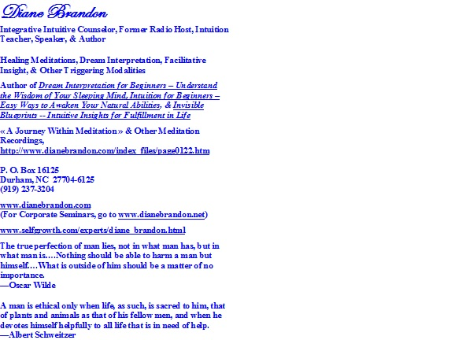
  P. O. Box 16125
  Durham, NC 27704
  (919) 237-3204

Forward email
This email was sent to dianebrandonauthor@gmail.com by dianebrandonauthor@gmail.com |
Update Profile/Email Address | Rapid removal with SafeUnsubscribe™ | Privacy Policy.

Diane Brandon | P. O. Box 16125 | Durham | NC | 27704

