From: | Diane Brandon <dianebrandonauthor@gmail.com>
Subject: | Shifts in the World, Upcoming Workshops, Reminder of Other Side, & Other Tidbits
Preheader:
Reply: | dianebrandonauthor@gmail.com


  Having trouble viewing this email? www.dianebrandon.com/index_files/page0178.htm

You are receiving this email from Diane Brandon because you purchased a product/service or subscribed on our website or at an event. To ensure that you continue to receive emails from us, add dianebrandon@bellsouth.net to your address book today. If you haven't done so already, click to confirm your interest in receiving email campaigns from us.

You may unsubscribe if you no longer wish to receive our emails.

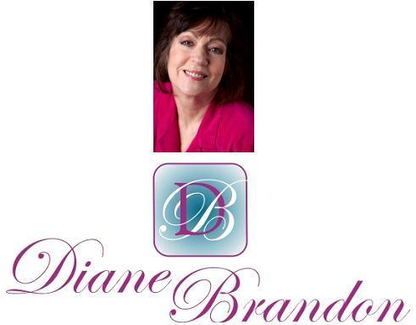

Integrative Intuitive Counselor, Intuition Teacher,
Speaker, & Author

March 29, 2016

Shifts in the World, Upcoming Workshops, Reminder of the Other Side & Higher Levels, & Other Tidbits

  In This Newsletter
  Essential Keys to Intuitive Development -- Workshops
  New Book, "Born Aware," Coming Out
  Beautiful Reminder of Higher Levels
  Radio Interviews
  New Metaphysical Expo
  Online Classes Live & On-Demand
  Global Shifts
  Skype for Recordings of Sessions
  Video on Benefits of Meditation
  A Call for Dreams
  My Schedule at Dancing Moon & Ohana
  Guided Meditation for Healing
  Mentoring in Intuition
  Refer a Friend & Gift Certificates
  Donate Free to Causes
  Share
  Signature Block
  Links
  My Newest Book
  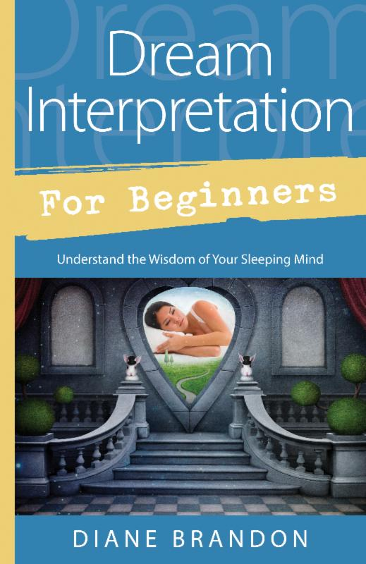
  Now Out & Available in Bookstores & Online
  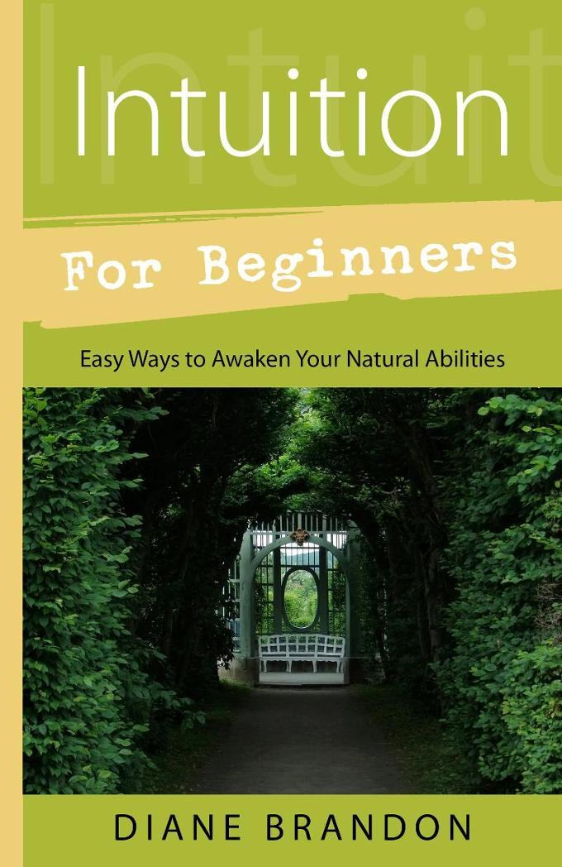
  Intuition for Beginners
  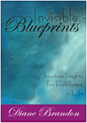
  Invisible Blueprints
  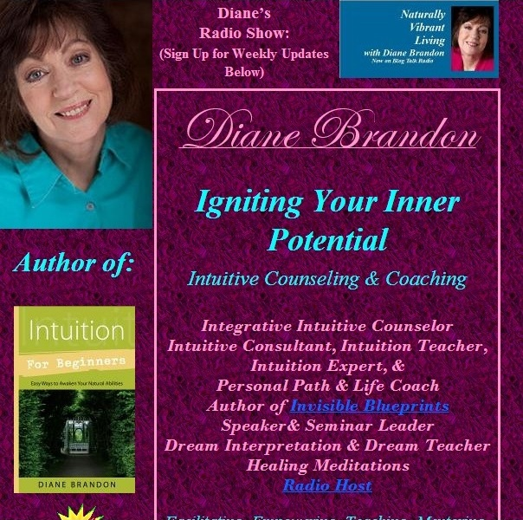
  My Site -- www.dianebrandon.com
  Dream Group on Facebook:
  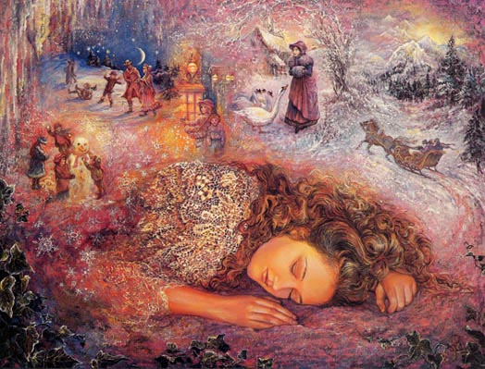
  Your Dream World
  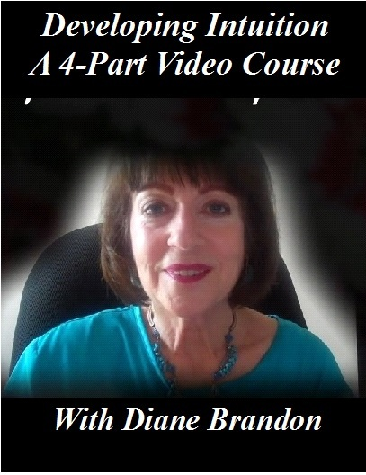
  A Four-Part Video Course on Developing Intuition
  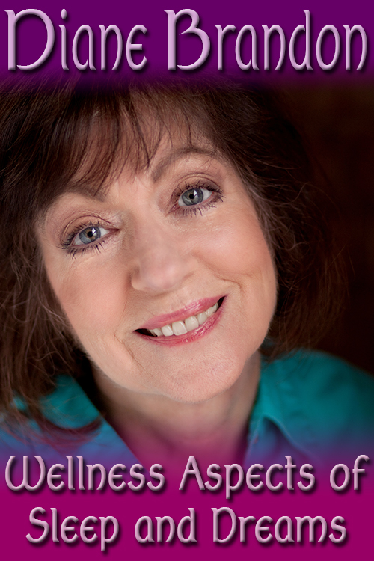
  Video, "The Wellness Aspects of Sleep & Dreams"
  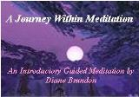
  "A Journey Within Meditation"
  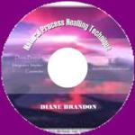
  "Natural Process Healing"
  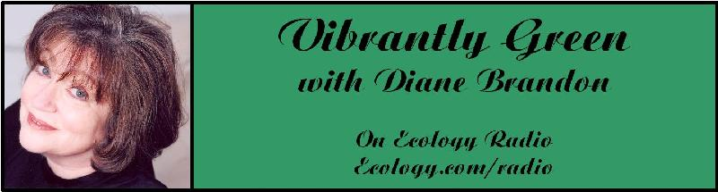
  "Vibrantly Green with Diane Brandon" Radio Show on Ecology.com
  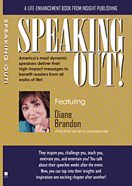
  Speaking Out
  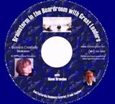
  "Brainstorm in the Boardroom with Great Leaders" Business Meditation CD
  More Cds/Mp3s, Including Intuition Exercises at
  http://www.dianebrandon.com/index_files/page0122.htm
  Find Me on:
  
  Twitter
  
  https://www.facebook.com/pages/Diane-Brandon/128849587146042
  It's hard to believe that we're almost at the end of March and that 1/4 of 2016 is almost over. There are so many shifts and changes in the world of late that time does indeed seem to fly.
  As of this writing, the tensions and polarization in the world -- that abrading between the old and the new paradigms -- would appear to still be in evidence, if not worsening. Yes, there have been more triggers for personal clearing and working on issues, not always comfortable, although necessary. Since my last newsletter in December, does it feel as if nothing has changed or that the energy is stuck?
  I would definitely say "no." I feel that many of us are being worked with on a deep level within us, for change and shifts and realizations. My sense is that a lot of this work occurs while we're sleeping. Some of us have felt that we have been "enlisted" to work on things or contribute to some sort of spiritual work during those deeper levels of sleep. If you find yourself chewing on new spiritual topics or aspects or if you're finding that it's taking more to push those human buttons, you may be experiencing some -- just some -- effects of that work being performed during sleep. If you've found that your sleeping patterns are changing or are interrupted from time to time, you may be experiencing some of this.
  I've also sensed a shift to more of a global consciousness -- an orientation to that which is greater or larger than our own personal lives or towns. I've sensed another shift in awareness, such that more people may be getting into what I call the "Higher Soul Awareness." It feels as if greater numbers of people are becoming sensitized to animals and animal welfare and feeling not just compassion for them, but also a connection to them. These are significant shifts and positive ones. So, even though it may feel that tension or polarization or even nastiness has increased, at the same time there would appear to be some solid, positive shifts in awareness, a seeding of the spiritual view, if you will, in more people.
  We cannot avoid changes in these times, no matter how uncomfortable change may make some people feel. Change is a hallmark of these times. And, of course, shifts in awareness are critical for healing so much that needs to be healed these days. We may not like or agree with a lot of what we see in the world these days, but there is tremendous potential for positive change.
  There is a lot of "seeding" going on of new awarenesses and shifts. So this is an exciting time, even if not always pleasant.
  One more note: I wrote the above before the awful terrorist bombings in Brussels. My prayers go out for all those affected. There are so many areas that need more light these days, and I feel that it's so important to focus on the light, rather than succumbing to the dark or negative or judgmental or despairing or fear. As Anne Frank wrote, "I simply can't build my hopes on a foundation of confusion, misery and death... I think... peace and tranquillity will return again."
  I have several other things to share with you in this newsletter, which you'll find below, including a couple of workshops, more radio appearances, a new book coming out in 2017, and more.
  As always, I wish you great joy, health, love, peace, and prosperity! Please contact me should you want to schedule a private session!
  Warmly,
  Diane
  P. S. If you have any trouble reading this, just go to www.dianebrandon.com/index_files/page0178.htm, where it will be archived in a day or two.
  Upcoming Workshops, "Essential Keys to Intuitive Development"
  As you know, I'm a strong proponent of developing your intuition and listening to your inner voice. Even though my intuition came out of left field for me, after I finally accepted that I was intuitive I could look back and see how I've always been inner-guided.
  Your intuition and inner voice are one of the greatest gifts you can have for spiritual awareness and unfolding, as well as for personal empowerment. How does your intuition speak to you? What are the many forms and facets of your intuition? How can you access your intuition on demand? How can you bypass your personal stuff to receive pure information? What are some dos and don'ts with your intuition? How can you develop and refine your gifts? These are some of the things we've be covering.
  I'll be teaching this workshop in Raleigh in April and in High Point, NC in May. Below is information on these two workshops:
  "Essential Keys to Intuitive Development" Workshop
  Saturday, April 16th
  10:30 AM - 5:30 PM EDT
  Dancing Moon Books & Gifts
  1840 Wake Forest Road
  Raleigh, NC
  Fee: $95 if Registered & Paid by April 15th or $105 at the Door
  To Register or for More Information, Email Me at diane@dianebrandon.com or Call 919 237-3204
  "Essential Keys to Intuitive Development" Workshop
  Saturday, May 14th
  11:00 AM - 6:00 PM EDT
  Ohaha Wellness Center
  615 Greensboro Road
  High Point, NC
  Fee: $95 if Registered & Paid by April 15th or $105 at the Door
  To Register or for More Information, Email Me at diane@dianebrandon.com or Call 919 237-3204 or 336 804-5779
  Your intuition is a wonderful gift -- and you can develop it, hone it, and reap its rewards!
  New Book Coming Out in 2017
  I'm pleased to share with you that I'll have another book published next year. The working title is Born Aware -- Memories of Those Spiritually Aware Since Birth. It's slated to come out in Llewellyn's Spring/Summer 2017 catalogue, but the exact month of publication has not year been set. It's possible that the publisher may want to change the title, and of course I'll keep you posted on what the final title will be, as well as the release date.
  This book has been a true labor of love and I've found the material in each person's account to be inspiring and exciting.
  More on it later!
  A Beautiful & Inspiring Reminder of Higher Levels & The Other Side
  I was pleased to read about a cave in which glowworms live. My pleased feeling shifted dramatically when I viewed a video of them. I was immediately transported and inspired by what I was watching, because I was reminded of being on higher levels when not here in body. (I've always remembered what I thought when I was born and have a vague memory of those higher levels before I came into this lifetime.) These glowworms reminded me of those light beings that we and others are when not here in body.
  You can see this video at http://mentalfloss.com/article/75526/step-inside-glowworm-cave-stunning-timelapse
  "Dr. Pat Show" & Other Radio Appearances
  I'm continuing to do radio appearances in which I'm interviewed, primarily about dreams. I've been working with dreams and poring over sleep and dream research for over 40 years, and I'm still learning about new facets of our sleep and dreams. Our sleeping world is beautifully complex and gives us so many things. We can use our dreams as a tool in our lives, as I detail in Dream Interpretation for Beginners. However, dreams aren't the only enriching aspect of our sleeping world. There are many spiritual aspects as well for us to experience. There's a lot going on in our sleeping world that can enrich our lives!
  I have more radio appearances coming up in March and April and am adding more.
  I try to post upcoming appearances and interviews at http://www.dianebrandon.com/index_files/page0007.htm.
  Many, although not all, interviews are archived and available for on-demand listening. For a list of these if you'd like to listen to some, just go to http://www.dianebrandon.com/index_files/page0210.htm.
  And please remember that I'm also available for dream interpretation and aiding you in dreamwork in private sessions. So just contact me whenever you'd like to schedule an appointment for some dreamwork!
  New Metaphysical Expo in the Triangle
  As you may know, I participated in the Body Mind Spirit Expos here in North Carolina since the first one back in the early 90s. I decided to discontinue my participation a couple of years ago, due to the changing energy there.
  There's a new metaphysical expo here in the Research Triangle called One Tribe Fest. I participated in it for the first time this past Fall, and the energy feels more pure and positive. Their next expo will be held on the last weekend in April (April 30th and May 1st). I'll be participating just on Saturday, the 30th.
  If you'd like more information on their expos, just go to https://onetribefestnc.com/.
  Online Classes
  
  I've started teaching some online classes on Learn it Live in their new Spirituality Center and am planning on offering an online intuitive development class, that will be held weekly over a 6-8 week period. I haven't scheduled it yet -- and will announce it here in my newsletter once I do.
  If you'd like to take any of my classes -- whether live or archived ones -- just go to https://www.learnitlive.com/search.php?type=classes-events&srcval=diane%20brandon
  Global Shifts in Consciousness
  So many of us have wondered if there have indeed been marked shifts in consciousness and awareness over the past several years. I was pleased to see an article on this topic recently, because it's quite encouraging. If you'd like to read this article, just go to http://www.huffingtonpost.com/gustavo-tanaka/something-extraordinary-happening-in-the-world_b_8820154.html?ncid=txtlnkusaolp00000592. So nice to see positive news!
  Skype for Recordings of Sessions
  Having a recording of a session is a really useful tool, and I offer recordings for sessions in-person and by phone. Unfortunately, I've been having some intermittent problems with my recording equipment (which is used for phone sessions). The good thing is that sessions cam be recorded using Skype. So, if you'd like for phone sessions to be recorded, please download and install Skype on your computer. It's free and has been available for years, and "calling" via Skype is also free. You can download Skype atwww.skype.com.
  A Video on the Benefits of Meditation
  A tremendous amount of research has been conducted on meditation in the past several years, and many physiological and psychological benefits of it have been identified. I recently came across this short video which details some of meditation's beneficial effects on the brain. You can view it athttps://www.youtube.com/watch?v=Aw71zanwMnY
  A Call for Dreams
  I'm planning on writing another book on dreams, which will follow the one coming out in a year. It will primarily be dreams with their interpretations. I'm in the process of collecting dreams for that book. If you have some interesting ones, please do send them to me. Please note that all dreams are included anonymously to protect the dreamers' privacy Below is more information:
  Please Submit Dreams
  Your Dreams will be Included Anonymously
  I Will Interpret Your Dreams for Free
  I Will Send You a Free Copy of the Book After it's Published if Your Dream is Included
  Please Send Your Dreams in Complete Detail, as They Unfolded -- No Short Summaries
  The Publisher Requires, of Course, that a Release be Signed
  Please Email Them to Me at dianebrandonauthor@gmail.com
  I do have a Dream Group on Facebook, where people can record their dreams and receive interpretations. It's called Your Dream World and is at https://www.facebook.com/groups/125990490759247/ I would love to have you join!
  My Schedule at Dancing Moon in Raleigh & Ohana in High Point
  (In Addition to My Regular Availability at Home)
  In addition to doing sessions at home by phone or in person, I also am available on a fairly regular basis in two other locations.
  Below are the dates through June when I'll be available for sessions at Dancing Moon in Raleigh. I also have the dates on my website, at http://www.dianebrandon.com/index_files/page0007.htm
  I'll also be doing sessions at a new wellness center in High Point, Ohana Arts & Wellness Center.
  Of course, I am always available for sessions in person or by phone at my home.
  Dancing Moon in Raleigh
  1840 Wake Forest Road
  12:00 Noon - 6:00 PM
  For Appointments, Call 919 833-8081
  Wednesday, March 30
  Thursday, April 14
  Thursday, May 12
  Sunday, May 22
  Thursday, June 9
  Wednesday, June 29
  I mentioned the new metaphysical center in High Point above. It has wonderful energy and light, and I'll be doing sessions and some classes there (TBA). Below are just a couple of dates, with more to come.
  Ohana Arts & Wellness Center
  615 Greensboro Road
  High Point, NC 27260
  For Appointments, Call 336 804-5779
  Saturday, June 18
  And don't forget that I'm always available for sessions in person or by phone from my home as well! Just email me at dianebrandonauthor@gmail.com or call me at 919 237-3204.
  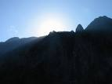
  Using Individualized Guided Meditation for Healing
  Many of us have been working on healing and clearing some of our old issues -- the pain and fears from unpleasant experiences in our past that can hold us back and block our happiness. This is one aspect of my intuitive work with other people. I strive to assist people on their paths to find more fulfillment, development their potential, and be happier.
  One modality that I have found extremely useful in my work is Guided Meditation. I do individualized Guided Meditation with people for several things: to enable people to meditate for the first time and find their center; to begin to find their own answers within; to meet guides; and to work on healing old issues. Doing this work via individualized Guided Meditation can be a gentle, yet powerful way of shifting and moving energy. Meditation in and of itself can have profound benefits. Using it for healing can be even more beneficial and powerful.
  I do individualized Guided Meditation both in person and by phone. Just contact me if you'd like to experience it in a session!
  Mentoring Group on Intuition
  I am mentoring some people who are in development for working professionally with their intuition and facilitating others. As you may know, my intuitive work is centered around facilitating others and assisting others on their paths. We're living in a time now when more people will be needed who can truly assist others and help to facilitate. The mentoring allows people to gain facilitating skills in a more rapid manner than the "on-the-job" training period one goes through when starting to work with others.
  My mentoring group is doing beautifully and I'm tickled with how those involved are doing and the perceptive questions they ask.
  If you are interested in being part of my mentoring group, please contact me. One prerequisite is first attending one of my workshops on developing intuition. Thereafter, we will meet in small groups for mentoring, practice, and guidance.
  Gift Certificates and a New Refer-a-Friend
  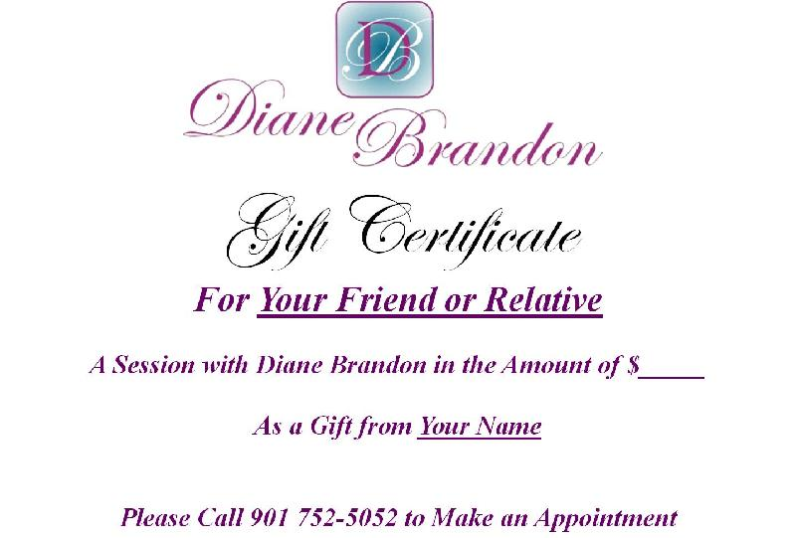
  Gift Certificates
  I have been asked to offer gift certificates from time to time, whenever someone would like to give a friend or relative a session. I always seem to forget to mention that these are a possibility. So, if you would like to give the gift of a session to someone, please know that they are available.
  Refer-a-Friend
  I also wanted to let you know that, if you've had a session with me and wanted to refer someone you know, whenever you refer someone to me who has an hour session, I'll be happy to give you 15 minutes free for your next session with me. Just let me know whenever you refer someone!
  Websites Where You can Donate to Various Causes -- for Free
  The following is a listing of websites where you can donate to various causes, all for free. This is a wonderful idea!
  I'd like to thank Diana Henderson for this. She has an excellent weekly Prayer List and includes these sites in her weekly mailing.
  The Rainforest Site: http://www.therainforestsite.com/cgi-bin/WebObjects/CTDSites
  The Animal Rescue Site: http://www.theanimalrescuesite.com/clickToGive/home.faces?siteId=3
  (also several others along the top at this location)
  Care2.com's click-to-donate site http://www.care2.com/click2donate/ makes it easy to help many causes. Click on any one of them (rainforest, oceans, big cats, primates, et al) and the next page will show all of them listed near the top. Then click on each to donate to every single cause. It's a major help to have so many click-to-donate buttons on one site!
  The Ecology Fund: Save land for free at http://ecologyfund.com/ecology/_ecology.html
  (You'll be clicking four times on the Ecology Fund site: Click first the button that says Save Land; on the next page click the Save Land Coastal button; on the following page, click on Save Land under Species; on the following page, click on Save Land under U.S.A. and finally click on the Clean Air button.)
  Plant an Oak Tree: http://cannecy.free.fr/iforest/en/
  Help plant a tree (every five clicks plants a tree): http://www.landcareniagara.com/
  Save Old Growth Forests (Sweden): http://ettklickforskogen.se/
  Surrey Wildlife Trust: http://www.theenvironmentsite.org/donate.php
  Save rainforest: http://www.redjellyfish.com/wildlifeconservation.html
  Plant a tree in the rainforest: http://www.tree4life.com/ingles/ingles.htm.
  Feed Hungry Children in Argentina (click on button that says GRATIS): http://www.porloschicos.com/PorLosChicos.NET/
  Fight Hunger: http://www.hungerfighters.com/
  Feed Children: http://www.hungrychildren.com/
  Employ/Educate Impoverished: http://www.solvepoverty.com/
  If you'd like to share this email with anyone else, please fee free to forward it.
  As always, I wish you peace, light, love, and prosperity!
  Warmly, Diane
  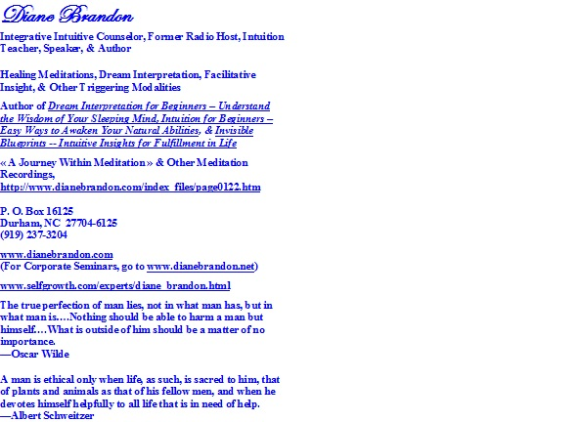
  P. O. Box 16125
  Durham, NC 27704
  (919) 237-3204

Diane Brandon, P. O. Box 16125, Durham, NC 27704
SafeUnsubscribe™ dianebrandonauthor@gmail.com

Forward email | Update Profile | About our service provider

Sent by dianebrandonauthor@gmail.com in collaboration with


Try it free today

