From: | Diane Brandon <diane@dianebrandon.com>
Subject: | Intuition Workshop, Weather Issues, Video Course, A Call for Dreams, & More
Reply: | diane@dianebrandon.com
You are receiving this email from Diane Brandon because you purchased a product/service or subscribed on our website or at an event. To ensure that you continue to receive emails from us, add dianebrandon@bellsouth.net to your address book today. If you haven't done so already, click toconfirm your interest in receiving email campaigns from us.

You may unsubscribe if you no longer wish to receive our emails.
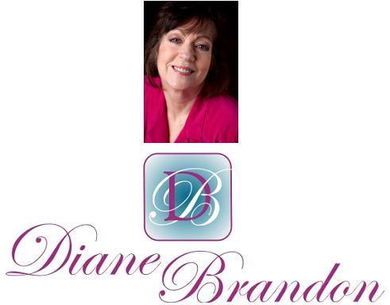

Integrative Intuitive Counselor, Radio Host, Intuition Teacher, & Author

May 1, 2014

Intuition Workshop, Weather Issues, Video Course, A Call for Dreams, & More

  In This Newsletter
  Workshop on Intuition
  An Article on Tomiko & Jerry Pittman
  New Video Course on Intuition
  A Beautiful Video
  New Book on Dreams
  A Call for Dreams
  Your Earliest Spiritual Memory
  Guided Meditation for Healing
  Important TED Video
  Dream Group
  Wellness Aspects of Sleep & Dreams
  Statement by the Elders
  My Schedule at Dancing Moon and Eclectic by Nature
  Mentoring in Intuition
  Refer a Friend & Gift Certificates
  A Journey Within Meditation CD
  Donate Free to Causes
  Share
  Signature Block
  Links
  New Book:
  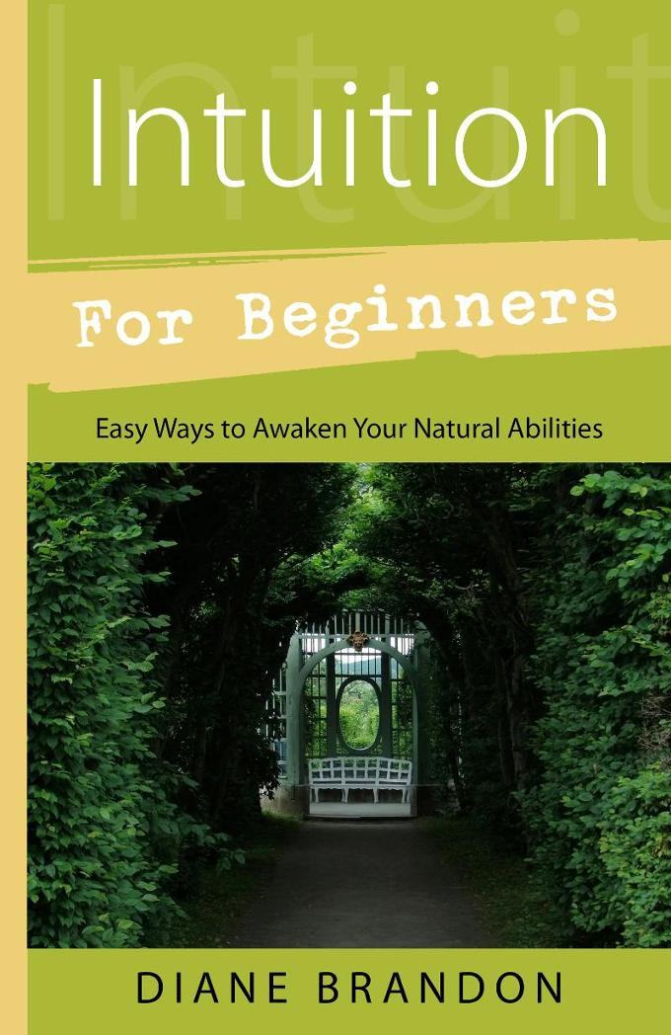
  Now Out!
  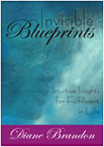
  Invisible Blueprints
  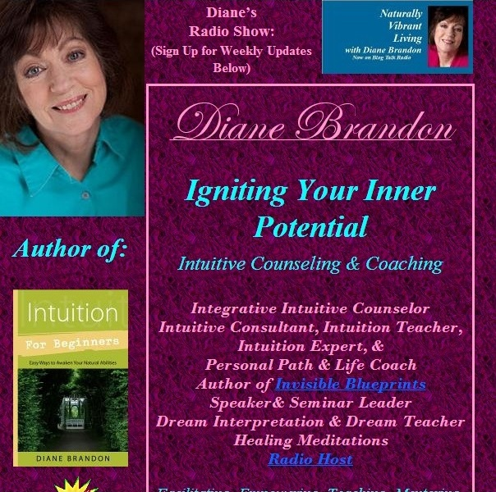
  My Site -- www.dianebrandon.com
  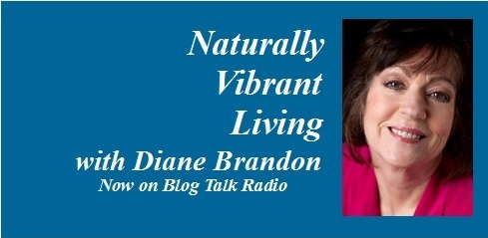
  "Naturally Vibrant Living" Radio Show on Blog Talk Radio has Now Ended -- Archived Shows Still Available for Listening
  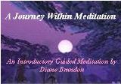
  "A Journey Within Meditation"
  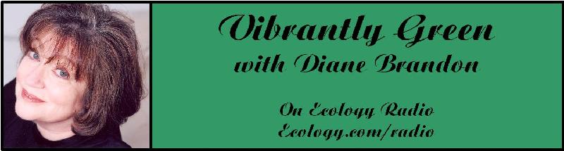
  "Vibrantly Green with Diane Brandon" Radio Show on Ecology.com
  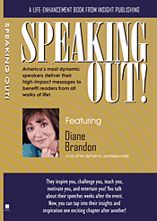
  Speaking Out
  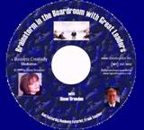
  "Brainstorm in the Boardroom with Great Leaders" Business Meditation CD
  Find Me on:
  
  Twitter
  
  https://www.facebook.com/pages/Diane-Brandon/128849587146042
  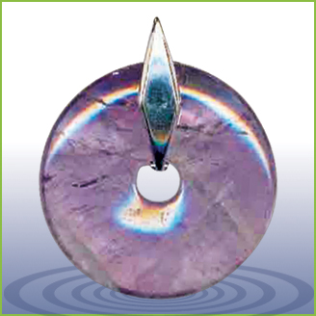
  EMF Radiation Protection Pendants
  I hope this newsletter finds you well and that you haven't been negatively affected by any of the storms or tornadoes!
  If you're sensitive to energy, I'm sure you know that the energy has felt quite strange or off for the past 1 - 2 months. We have just come through the Cardinal Grand Cross, that I wrote about in my last newsletter and which was sandwiched in between two strong eclipses. If the energy felt strange to you, there's a good reason for it.
  The Cardinal Grand Cross created feelings of tension. I started to feel it about two months in advance, as people seemed to be more tense and reactive. Many astrologers have said that it was triggering personal transformation and taking action in areas where we may have been stuck. The two eclipses, a lunar one on April 15th and a solar one on April 29th, were also said to be powerful ones, especially in concert with the Cardinal Grand Cross. It's all about personal transformation and growth, and one astrologer wrote that it had to do with a new major phase beginning in the world.
  I have felt a shift in the past day or so, after the second eclipse. The energy had felt stuck for the past several weeks and now feels as if it's moving forward again.
  At the same time, we've had more weather anomalies, including the strong storm system that continues as I write this. There were several tornadoes, one of which was on the ground for two hours, according to reports I heard. (I was awakened early Wednesday morning by a strong and noisy storm here and discovered when I got up that we had had a tornado warning for some time.) Sadly, there have been dozens of deaths in several states, as well as soaking rains resulting in never-before-seen flooding in Pensacola.
  The seemingly increasing severity of storms can be quite scary. However, I'm not writing about this in order to scare you.
  I have shared with others for several years now that I felt that in the future no place would be safe. When we hear about floods, tornadoes, hurricanes, earthquakes, etc., we may often try to think of a place that would be safe to live in and free of natural disasters. However, I'm not convinced that such places, by and large, exist -- at least not anymore. Any place can be susceptible to anomalous weather, especially these days.
  In spite of the fact that I have felt this for some time, I am not afraid -- and, indeed, I feel that there's no need for fear.
  I have always felt that everything happens for a reason, and you may feel the same way. We're living in a time of change and I feel that it's happening for positive reasons. Through doing my radio show for over six years, I learned so much about the ongoing damage we've been doing to the environment, wildlife, and our own health through some of our modern practices. (The omnipresence of toxic chemicals and drastic environmental degradation are just two examples.) Unfortunately, many people are still not aware of these problems. However, I feel that we're being asked to open our eyes, become more aware, and develop healthier, more sustainable practices -- and that this is a time to change our harmful practices and begin to heal the damage done to our world, including the environment, habitats, and wildlife.
  So I don't see what is happening with natural disasters or other calamities as punishing us, but more as triggers for change -- all for a more positive outcome and world.
  I feel that it's becoming increasingly important to sync ourselves up with our spirituality and the source of it. I know that I have been recommending for some time to listen to your inner voice and pay attention to it. I would now go a step further.
  I feel that it's vitally important to have a clear vision of your purpose in this lifetime and your path -- and to connect to Source (however you term it, whether God, the Divine, the Universe, etc.) and listen. You will be guided and we will all be guided if we do this. You will be guided to where you should be (if a different place) and what you should be doing. I feel that we are all being asked to do this at this point, even more so than in the past.
  We've seen increasing polarization and tension in the past year or two between old thinking and new thinking (or the old paradigm and the new one). My hope is that this tension may be easing in the not-so-distant future.
  Some have said that 2014 is a year of personal clearing and transformation, before things start to move forward more externally in 2015.
  We are all here at this time for a reason and we all play a role in the world and for others. I do not fear for the future -- and I hope you don't either. We need positive energy in this world and fear is the opposite of it.
  Allow yourself to envision your path and your work -- and envision a positive, healthy world. We all have work to do.
  As I'm sure you know, I'm always available for sessions, both by phone and in person. These times of change can feel unsettling at times, I know, and a reading can help to put things into perspective while yielding helpful insight.
  I have several things to share with you in this newsletter, including a workshop, a new video course, etc. I would also like to have you participate in some projects of mine, all of which you'll find below.
  As always, I wish you great joy, health, love, peace, and prosperity! Please contact me should you want a private session!
  Take care,
  Diane
  P. S. If you have any trouble reading this, just go to www.dianebrandon.com/index_files/page0178.htm, where it will be archived in a day or two.
  Workshop
  On Developing Intuition & Accessing it On Demand
  Most people have had experiences with their intuition when they have received information spontaneously. However, we can also learn how to access intuitive information on demand. Once we have learned that critical skill, developing it can be a lot easier. Of course, we also want to make sure that we're receiving information that is as pure and reliable as possible.
  Intuition can be a powerful tool for us in our lives. It helps us to find some of our own answers within, connect more with the Divine, and can be quite empowering. Paying attention to our inner voice can also aid in our own unfolding and lead us to be more centered, less reactive, and feel more confident --
  and can benefit our relationships -- as well as other areas of our lives.
  Some of us who have developed our intuition and regularly listen to our inner voice can not only attest to it being an aid in our daily living, but have also found that it can lead us to live our lives at times as somewhat of a walking meditation.
  Developing our intuition can be a matter of learning how ours works, and which form(s) it takes, learning to listen to it and not doubt it, learning how to get pure information unclouded or affected by our personal "stuff," learning how to work with the information we receive, and remembering to be open to what we're given. Using our intuition for others can also require developing our own set of ethics and personal responsibility.
  I have been teaching others this wonderful skill since 1996 and will be teaching an all-day workshop on it in September that will go from the basics to advanced exercises. Below are the details:
  Accessing Intuitive Information on Demand -- Workshop
  Dancing Moon
  1840 Wake Forest Road
  Raleigh, NC
  http://dancingmoonraleigh.com
  Saturday, May 17, 2014
  10:30 AM - 5:30 PM
  $95.00 if Registered & Paid in Advance, $105.00 at the Door
  To Register, Just Contact Me
  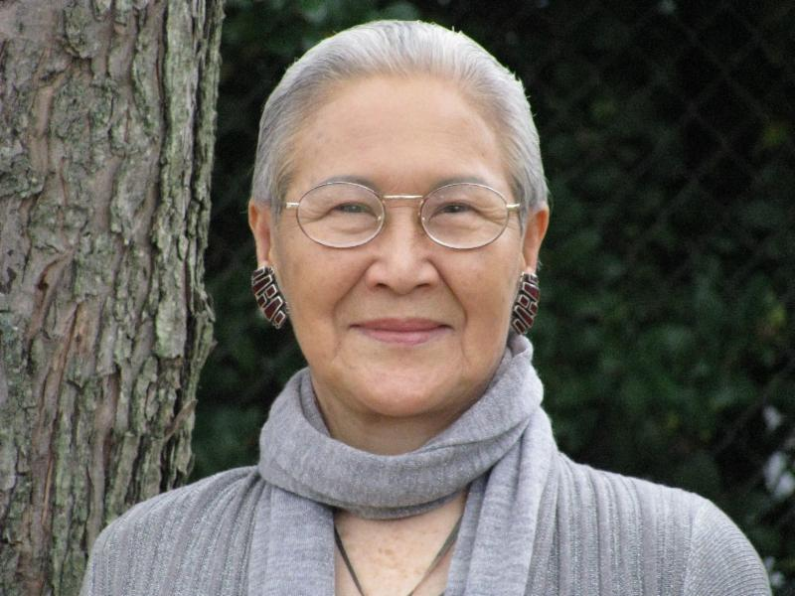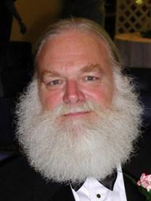
  An Article on Tomiko and Jerry Pittman
  I had shared with you how shocked and saddened I was to learn of Tomiko's passing. Then on the heels of that news, I learned that Jerry Pittman, M. D. had passed away just after I last emailed you in October. These two people were giants here in the Research Triangle and had a positive influence on the lives of many people. I had shared Tomiko's influence on me with you. Jerry's influence was also profound. Without my acquaintance with him, I would not have half of the knowledge that I do of findings in new science.
  Karen Newton of Innerchange Magazine asked me to write an article memorializing both Tomiko and Jerry, which I did. You can find that article on Innerchange's website athttp://innerchangemag.com/articles/the-loss-of-two-beloved-giants. You'll also find a somewhat expanded version on my website, at http://www.dianebrandon.com/index_files/page0123.htm.
  Whether you knew them or not, you have been affected by them through your work with me. I deeply grieve their losses!
  New Video Course --
  On "Developing Your Intuition & Accessing Information on Demand"
  As you probably know, I have been teaching intuitive skills to others for several years now (since 1996, in fact) -- primarily how to access intuitive information on demand (as opposed to waiting for information to come) and how to bypass personal stuff, so as to receive pure and more reliable information.
  I've primarily taught this in an intensive all-day workshop (which I'll be teaching in Raleigh, NC on Saturday, May 17th), as well as in ongoing classes, as well as in one-on-one classes and coaching.
  I've now developed an abbreviated version of my workshop on video -- in a four-part course, entitled "Developing Your Intuition & Accessing Information on Demand." The following are the four parts of this video course:
  Part 1: Exploring What Intuition is -- & Isn't
  Part 2: Exploring Deeper Levels for Intuition
  Part 3: Exploring Certain Types of Intuition through Exercises
  Part 4: Honing Intuition through Advanced Exercises
  The course runs a little over 4 hours and is still being edited.
  I'm excited to finally make this available in video format. It's still not the same as attending one of my workshops or classes in person, but it will make my teaching material more available, especially in conjunction with my book, Intuition for Beginners.
  I'll let you know when the course is ready!
  A Beautiful Video
  I recently saw a beautiful video of the sky and landscape, shot over Yosemite National Park, in time-lapse photography. It's at http://www.projectyose.com. Enjoy!
  New Book on Dreams, "Dream Interpretation for Beginners"
  My new book on dreams will be published in Winter of 2015 and will be entitled "Dream Interpretation for Beginners -- Understand the Wisdom of Your Sleeping Mind." It will be a fairly comprehensive treatment of our world of sleep and dreams, how to interpret and understand our dreams, and how to use the insight we gain from them. It will also include many sample dreams with their interpretations and ideas on how to apply their insight.
  I've almost finished the revisions to the manuscript for my March 7th deadline!
  A Call for Dreams
  I'm planning on writing another book on dreams, which will follow the one coming out in a year. It will primarily be dreams with their interpretations. I'm in the process of collecting dreams for that book. If you have some interesting ones, please do send them to me. Please note that all dreams are included anonymously to protect the dreamers' privacy Below is more information:
  Please Submit Dreams
  Your Dreams will be Included Anonymously
  I Will Interpret Your Dreams for Free
  I Will Send You a Free Copy of the Book After it's Published if Your Dream is Included
  Please Send Your Dreams in Complete Detail, as They Unfolded -- No Short Summaries
  Please Email Them to Me at diane@dianebrandon.com
  I do have a Dream Group on Facebook, where people can record their dreams and receive interpretations. It's called Your Dream World and is at https://www.facebook.com/groups/125990490759247/ I would love to have you join!
  What is Your Earliest Spiritual Memory?
  I have always remembered what I thought when I was born. I never shared that with anyone until the past several years because I hadn't realized that it was unusual. I have come to know two other people who remember their thoughts as an infant or extremely young child before they learned to speak.
  I've been wondering if there are more of us who have these memories than we may realize. Scientists would pooh-pooh the thought of babies having such awareness, but I know firsthand that they can.
  If you remember having spiritual thoughts or awarenesses at a very young age, please do let me know. (You can email me at diane@dianebrandon.com.) I feel that it's important for us to know that we're not alone and it may be interesting for us to share our experiences with each other.
  Using Individualized Guided Meditation for Healing
  Many of us have been working on healing and clearing some of our old issues -- the pain and fears from unpleasant experiences in our past that can hold us back and block our happiness. This is one aspect of my intuitive work with other people. I strive to assist people on their paths to find more fulfillment, development their potential, and be happier.
  One modality that I have found extremely useful in my work is Guided Meditation. I do individualized Guided Meditation with people for several things: to enable people to meditate for the first time and find their center; to begin to find their own answers within; to meet guides; and to work on healing old issues. Doing this work via individualized Guided Meditation can be a gentle, yet powerful way of shifting and moving energy. Meditation in and of itself can have profound benefits. Using it for healing can be even more beneficial and powerful.
  I do individualized Guided Meditation both in person and by phone. Just contact me if you'd like to experience it in a session!
  An Important TED Video
  I feel that increasing numbers of people have been becoming more sensitized to animals and the need to protect our environment. As you may know, my radio show that I hosted for over six years was focused on green topics. As a result, I learned more and more about the problems in our world and the unfortunate growing environmental damage, as well as threats to our health.
  One thing that many don't realize is how complex ecosystems can be and how interwoven they are. The demise of one type of animal can affect the health of an ecosystem. I just saw a Ted video that I found mind-blowing. It shows the effect of just one animal on an entire ecosystem. You can watch it at
  http://blog.ted.com/2014/02/18/video-how-wolves-can-alter-the-course-of-rivers/
  Dream Group
  If you're on Facebook and are interested in Dreams, I wanted to let you know about a dream group I have there, Your Dream World. As a member, you can post your dreams and receive comments, as well as post comments on others' dreams.
  I've been working with dreams for over 30 years now, helping others to understand theirs and use them as a tool for unfolding in their lives. I know how powerful our dreams can be and how much they can enrich our lives.
  If you'd like to join the group, just go to http://www.facebook.com/group.php?gid=125990490759247&ref=search&sid=KZDFUfM7BzZqEwsalPR2OA.1574544751..1#!/group.php?gid=125990490759247
  A Video on
  The Wellness Aspects of Sleep and Dreams
  As part of my research on dreams, I've also delved into our world of sleep and have been fascinated by the amount of research that has been done on it. A whole body of research findings have come out in the past ten years on the health aspects of this other world of ours. As a result, I've done some lectures on the Wellness Aspects of Sleep and Dreams.
  There is now a video available of one of my lectures and it's now accessible to rent or to purchase. Just go to
  http://vimeo.com/ondemand/sleepanddreams
  I also have a page on my website where all my Books, CDs, Recordings, and Videos can be found. I did have them scattered throughout, but it should be easier to find things with them all on one page. They're at http://www.dianebrandon.com/index_files/page0122.htm
  A Statement by the Native American Elders
  From time to time, the Native American Elders issue a statement on our world and the condition of it, especially in these times of change. I find their words to be profound and often prophetic. They recently issued a new one, and you can read it at http://caretakersofmotherearth.com/
  My Schedule at Dancing Moon in Raleigh and Eclectic by
  Nature in Greensboro
  Below are the dates through March when I'll be available for sessions at Dancing Moon in Raleigh and at Eclectic by Nature in Greensboro. I also have the dates on my website, at www.dianebrandon.com
  I am always available for sessions in person or by phone at my home.
  Dancing Moon in Raleigh
  1840 Wake Forest Road
  12:00 Noon - 6:00 PM
  For Appointments, Call 919 833-8081
  Thursday, May 15
  Thursday, May 29
  Thursday, June 26
  Eclectic by Nature in Greensboro
  402 State Street
  For Appointments, Call 336 373-0733
  TBA
  And don't forget that I'm always available for sessions in person or by phone from my home as well! Just email me at diane@dianebrandon.com or call me at 919 237-3204.
  Mentoring Group on Intuition
  I am mentoring some people who are in development for working professionally with their intuition and facilitating others. As you may know, my intuitive work is centered around facilitating others and assisting others on their paths. We're living in a time now when more people will be needed who can truly assist others and help to facilitate. The mentoring allows people to gain facilitating skills in a more rapid manner than the "on-the-job" training period one goes through when starting to work with others.
  My mentoring group is doing beautifully and I'm tickled with how those involved are doing and the perceptive questions they ask.
  If you are interested in being part of my mentoring group, please contact me. One prerequisite is first attending one of my workshops on developing intuition. Thereafter, we will meet in small groups for mentoring, practice, and guidance.
  Gift Certificates and a New Refer-a-Friend
  
  Gift Certificates
  I have been asked to offer gift certificates from time to time, whenever someone would like to give a friend or relative a session. I always seem to forget to mention that these are a possibility. So, if you would like to give the gift of a session to someone, please know that they are available.
  Refer-a-Friend
  I also wanted to let you know that, if you've had a session with me and wanted to refer someone you know, whenever you refer someone to me who has an hour session, I'll be happy to give you 15 minutes free for your next session with me. Just let me know whenever you refer someone!
  "A Journey Within"
  New Guided Meditation Recording Now Available
  I'm so pleased to now be able to offer this guided meditation recording. I'm a huge proponent of guided meditation for several reasons, and I do individualized guided meditations with clients regularly. Meditation allows us to get into our center and when one does this for the first time it can be very striking. We immediately feel more centered afterwards and begin to feel more in command of ourselves. It also allows us to begin to find our inner voice and intuition.
  I also use Guided Meditation to work on specific issues. In fact, "A Journey Within Meditation" is an introductory guided meditation and I plan on doing a series of meditation recordings.
  Meditation also gives us many health benefits, including the following ones:
  The Gifts Meditation can Give
  · Stress Reduction via reduced levels of two stress hormones, cortisol and lactate
  · Reduction of High Blood Pressure
  · Enhanced Concentration and Mental Focus
  · Better Skin Conductance (indicative of lowered stress)
  · Enhancement of Relaxation
  · Decreased Anxiety
  · Decreased Depression (increases production of serotonin)
  · Decreased Irritability and Enhanced Sense of Contentment
  · Lowered Cholesterol
  · Improved Memory
  · Improved Breathing Air Flow
  · Higher Level of DHEA in Elderly
  · Lowered Metabolic Rate, Heart Rate, and Reduced Burden on Heart
  · Reduction of Free Radicals
  · Reduces PMS Symptoms
  · Enhances Immune System
  · Has Anti-Aging Effects
  Meditation has also been shown to reduce crime and increase compassion.
  "A Journey Within" is available either as an MP3 file that you can download or as a hard-copy CD.
  "A Journey Within"
  Hard-Copy of CD: $18.95 + Shipping
  To Order the CD, Go to www.dianebrandon.net/products.asp
  MP3 Downloadable File of Meditation: $16.95
  To Order the MP3 File, Go to www.dianebrandon.com/index_files/page0176.htm
  I'm excited to finally be able to offer some Guided Meditation Recordings and feel very positive about the future ones I'll be doing as well!
  Websites Where You can Donate to Various Causes -- for Free
  The following is a listing of websites where you can donate to various causes, all for free. This is a wonderful idea!
  I'd like to thank Diana Henderson for this. She has an excellent weekly Prayer List and includes these sites in her weekly mailing.
  The Rainforest Site: http://www.therainforestsite.com/cgi-bin/WebObjects/CTDSites
  The Animal Rescue Site: http://www.theanimalrescuesite.com/clickToGive/home.faces?siteId=3
  (also several others along the top at this location)
  Care2.com's click-to-donate site http://www.care2.com/click2donate/ makes it easy to help many causes. Click on any one of them (rainforest, oceans, big cats, primates, et al) and the next page will show all of them listed near the top. Then click on each to donate to every single cause. It's a major help to have so many click-to-donate buttons on one site!
  The Ecology Fund: Save land for free at http://ecologyfund.com/ecology/_ecology.html
  (You'll be clicking four times on the Ecology Fund site: Click first the button that says Save Land; on the next page click the Save Land Coastal button; on the following page, click on Save Land under Species; on the following page, click on Save Land under U.S.A. and finally click on the Clean Air button.)
  Plant an Oak Tree: http://cannecy.free.fr/iforest/en/
  Help plant a tree (every five clicks plants a tree): http://www.landcareniagara.com/
  Save Old Growth Forests (Sweden): http://ettklickforskogen.se/
  Surrey Wildlife Trust: http://www.theenvironmentsite.org/donate.php
  Save rainforest: http://www.redjellyfish.com/wildlifeconservation.html
  Plant a tree in the rainforest: http://www.tree4life.com/ingles/ingles.htm.
  Feed Hungry Children in Argentina (click on button that says GRATIS): http://www.porloschicos.com/PorLosChicos.NET/
  Fight Hunger: http://www.hungerfighters.com/
  Feed Children: http://www.hungrychildren.com/
  Employ/Educate Impoverished: http://www.solvepoverty.com/
  If you'd like to share this email with anyone else, please fee free to forward it.
  As always, I wish you peace, light, love, and prosperity!
  Take care, Diane
  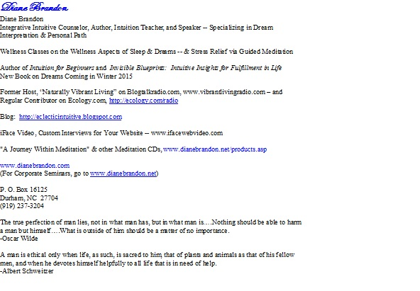
  P. O. Box 16125
  Durham, NC 27704
  (919) 237-3204

Forward email

This email was sent to dianebrandon@bellsouth.net by diane@dianebrandon.com |
Update Profile/Email Address | Instant removal with SafeUnsubscribe™ | Privacy Policy.
Diane Brandon | P. O. Box 16125 | Durham | NC | 27704

