From: | Diane Brandon <dianebrandonauthor@gmail.com>
Subject: | Embracing Positive Shifts, Intuition Workshop, & More
Reply: | dianebrandonauthor@gmail.com


  Having trouble viewing this email? www.dianebrandon.com/index_files/page0178.htm

You are receiving this email from Diane Brandon because you purchased a product/service or subscribed on our website or at an event. To ensure that you continue to receive emails from us, add dianebrandon@bellsouth.net to your address book today. If you haven't done so already, click to confirm your interest in receiving email campaigns from us.

You may unsubscribe if you no longer wish to receive our emails.

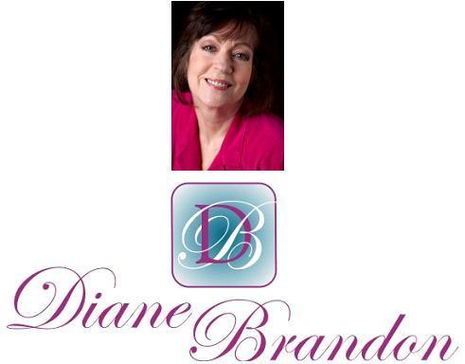

Integrative Intuitive Counselor, Intuition Teacher,
Speaker, & Author

May 17, 2015

Embracing Positive Shifts, Intuition Workshop, & Other Tidbits

  In This Newsletter
  Workshop on Intuition
  New Book on Dreams
  New Email Address
  Reincarnation Segment on NBC
  Radio Appearances
  An Important Video
  Whale Imitating a Human
  Skype for Recordings of Sessions
  Video on Benefits of Meditation
  A Call for Dreams
  Guided Meditation for Healing
  My Schedule at Dancing Moon
  Mentoring in Intuition
  Refer a Friend & Gift Certificates
  Donate Free to Causes
  Share
  Signature Block
  Links
  My Newest Book
  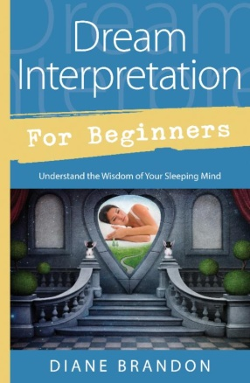
  Now Out & Available in Bookstores & Online
  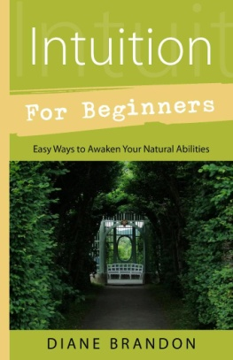
  Intuition for Beginners
  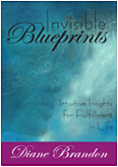
  Invisible Blueprints
  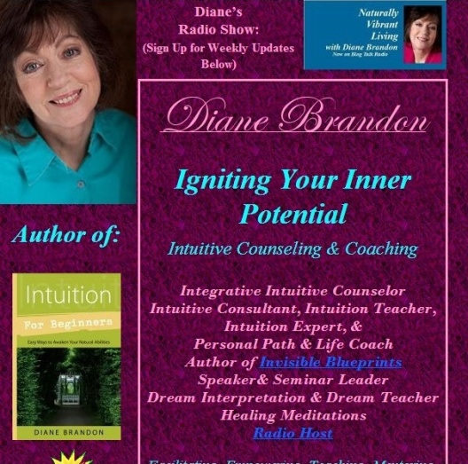
  My Site -- www.dianebrandon.com
  Dream Group on Facebook:
  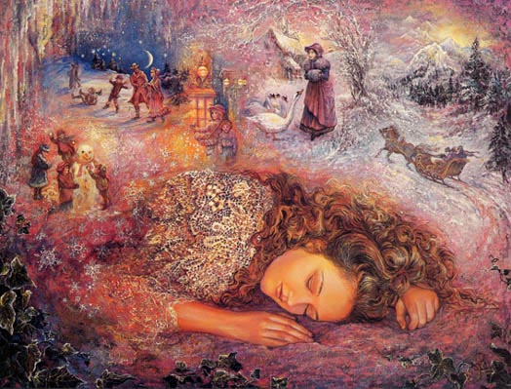
  Your Dream World
  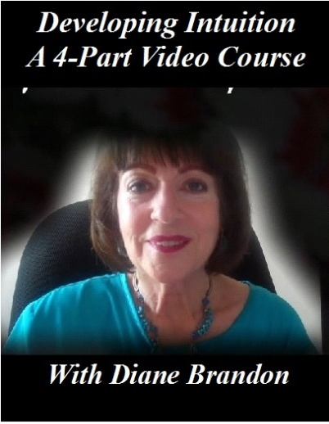
  A Four-Part Video Course on Developing Intuition
  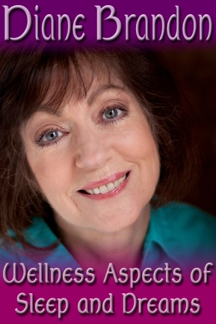
  Video, "The Wellness Aspects of Sleep & Dreams"
  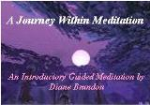
  "A Journey Within Meditation"
  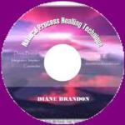
  "Natural Process Healing"
  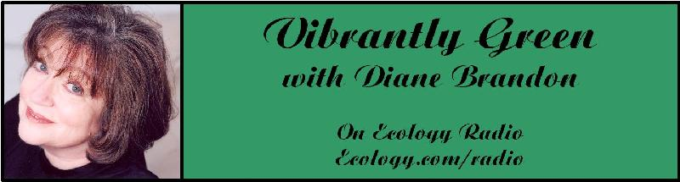
  "Vibrantly Green with Diane Brandon" Radio Show on Ecology.com
  
  Speaking Out
  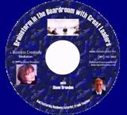
  "Brainstorm in the Boardroom with Great Leaders" Business Meditation CD
  More Cds/Mp3s, Including Intuition Exercises at
  http://www.dianebrandon.com/index_files/page0122.htm
  Find Me on:
  
  Twitter
  
  https://www.facebook.com/pages/Diane-Brandon/128849587146042
  I hope that this newsletter finds you well and enjoying the warmer weather. We've had a beautiful Spring here in the Triangle with nice, seasonal temperatures and the hot weather holding off, although the pollen count has definitely been high.
  I know that, as I have shared what I've picked up in the ambient energy in the past several newsletters, I seem to have talked about the energies being strange and/or intense several times. And I feel that we have all been looking for that to shift and to see a positive change. We do seem, however, to be living in a period of time in which the energy is not the norm.
  We all know that we're living in a time of huge change and are in the throes of a major paradigm shift. It would appear that these changes aren't happening without strange energy.
  You've no doubt noticed that the energy has continued to feel strange and has also been intense. At the same time, it appears that the polarization between people of opposing views has gotten even stronger. I would love to say that I feel that that will change soon, but I feel that it may take some time. Carl Boudreau wrote an excellent article on the astrological basis for the strange energy, which you can read at https://www.facebook.com/notes/carl-boudreau/astrology-status-for-may-11th-2015-why-all-the-intensity/10206845238317960
  If you think about it, while in the midst of a paradigm shift, as some people shift and become more aware, that in and of itself can cause a rift (or polarization) with those still adhering to older views.
  I do feel that there are strong shifts going on underneath the surface in many people. Increasing numbers of people are slowly waking up spiritually and I do feel that more are becoming aware of environmental issues. Since everyone and everything is connected, we are part of the environment and whatever harm is done to the environment ultimately impacts us. I also feel that there are positive shifts occurring on a deep, unconscious level in many people. While we may not be consciously aware of them, their happening does affect the whole in a positive way.
  There's a growing movement among religious organizations -- of all faiths -- to want to protect the environment, viewing it as God's creation. (I actually did a show on this when I still had my radio show.)
  I have also seen a slow, increasing sensitivity to animals and wildlife, which is a hopeful sign.
  I feel that it's important for us to be aware of these issues because they are indeed spiritual issues, because we are all interwoven threads of the overall tapestry.
  It's also important for us to continue working on clearing our own personal issues, which can keep us mired in our challenges and block our spiritual sides. Merely opening up spiritually, as important as that is, is only part of our work. Indeed, clearing our personal stuff can allow us freer access to spiritual levels.
  Despite all the harsh events in our world, whether weather-related, terrorism, economic deprivation, etc., I still feel that we're headed in a positive direction and that it all happens for a reason -- to effect positive change and awareness. The polarization will likely continue for a while, as will other problems we've seen. However, I have sensed that we're globally being infused with some lovely higher spiritual energies and awareness, almost imperceptibly. Awareness is growing and has an inevitability, and I feel that we will be seeing more positive changes in the next five years. We all have a lot of work to do!
  You'll find some news items below, as well as information on my next Workshop on Developing Intuition, which will be held in June. If you know anyone who might benefit from it, please feel free to share the information.
  As always, I wish you great joy, health, love, peace, and prosperity! Please contact me should you want to schedule a private session!
  Take care,
  Diane
  P. S. If you have any trouble reading this, just go to www.dianebrandon.com/index_files/page0178.htm, where it will be archived in a day or two.
  Workshop:
  "Developing Your Intuition & Accessing Information on Demand"
  Saturday, June 13th
  I've had several people ask me when my next workshop on intuition would be held. I've gotten it scheduled, and it will be held on Saturday, June 13th.
  I'm a huge believer in developing our intuition and being able to access intuitive information on demand, while also bypassing our personal stuff so that we may receive clear and reliable information. Intuition can have so many key benefits in our lives, including the following ones:
  * Helps Us Make Decisions
  * Helps Us Solve Problems
  * Gives Us More Resources for Information
  * Helps Us Find and Strengthen our Inner Voice and Inner Knowing
  * Can Give Us More Self-Confidence & Have Empowering Effects
  * Can Give Us Better Insight into Others
  * Helps Us have Better Relationships
  * Helps Us Be Present in the Moment
  * Leads to Greater Objectivity and Perceiving Clearly
  * Can Lead Us to Be Less Reactive
  Just the two benefits of intuition leading us to be more inner-guided and its effects on improving our relationships are extremely significant ones. And it's imperative to receive pure and reliable intuitive information that's not contaminated by our personal stuff.
  In this all-day workshop, we'll explore what intuition is and do a range of exercises, from basic ones to more advanced ones. There will be plenty of discussion in addition to the hands-on exploration, and you should have a much better sense of how your intuition works by the end of the day. Below are the particulars on the workshop:
  Workshop on "Developing Your Intuition & Accessing Information on Demand"
  Saturday, June 13th
  10:30 AM - 5:30 PM
  Dancing Moon Books & Gifts
  1840 Wake Forest Road
  Raleigh, NC
  $95, if Registered & Paid by June 12th Or $105 at the Door
  To Register, Contact Me at dianebrandonauthor@gmail.com
  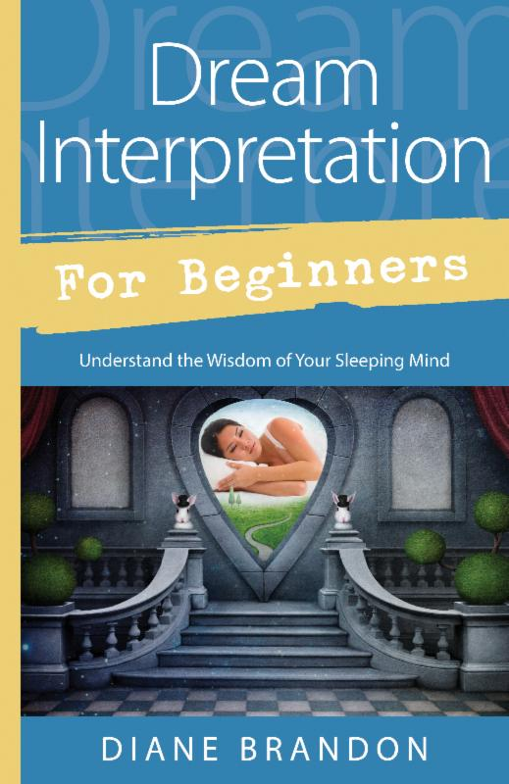
  New Book:
  Dream Interpretation for Beginners -- Understand the Wisdom of Your Sleeping Mind
  is Now Out & Available in Bookstores and Online
  My new book on dreams has just been published. It's entitled "Dream Interpretation for Beginners -- Understand the Wisdom of Your Sleeping Mind." It's a fairly comprehensive treatment of our world of sleep and dreams, how to interpret and understand our dreams, and how to use the insight we gain from them. It will also include many sample dreams with their interpretations and ideas on how to apply their insight.
  It is available on Amazon, at http://www.amazon.com/exec/obidos/ASIN/0738741914/dianebrandonintul,
  and on Barnes & Noble, at http://www.barnesandnoble.com/w/dream-interpretation-for-beginners-diane-brandon/1119693777?ean=9780738741918 as well as in book stores.
  New Email Address
  After having had seemingly regular problems with my Bellsouth email address, I have switched to a new one. Please contact me via the following email address, effective immediately:
  dianebrandonauthor@gmail.com
  A Child's Past-Life Memory Featured on NBC New
  I was very pleased to see NBC feature an instance of a boy's past-life memory on its news broadcast. As you know, it's fairly rare for a mainstream news outlet to cover reincarnation -- and quite rare for such coverage to be done in an open and non-skeptical fashion. I had previously read about this child's past-life memory and it's an excellent example of what some children remember.
  You can view the segment at http://www.nbcnews.com/nightly-news/boy-says-he-remembers-past-life-hollywood-agent-n327506
  Upcoming Radio Appearances
  I'll be interviewed on some radio shows in the next couple of months. Two have been pre-recorded and are not yet scheduled for airing. Two will be live and the information on them follows.
  The Monique Chapman Show
  Wednesday, June 10
  8:00 PM EDT/5:00 PM PDT
  To Listen, Go to http://achieveradio.com/masterful-choices/
  Intuitive Transformation Show with Matthew Engel
  Wednesday, June 17
  8:00 PM EDT/5:00 PM PDT
  To Listen, Go to http://www.blogtalkradio.com/intuitivetransformationradio
  Please tune it!
  An Important Video
  I first saw this video about a year or so ago and was highly impressed by it. Some have tended to feel that if one is spiritual one is not of this world and that, thus, events in the world are less important.
  The truth, however, is that this level is part of the universe and what happens on this level affects everyone. This is one reason why spiritually aware people have been concerned about environmental issues.
  This video, "How Wolves Change Rivers," shows in well-researched and concrete terms how one species can affect a whole ecosystem. I would highly recommend it!
  You can view it at https://www.youtube.com/watch?v=ysa5OBhXz-Q
  A Whale Imitating the Moves of a Diver -- Video
  One diver recently had a wonderful encounter with a whale. As the diver made various moves, the whale imitated him, in a wonderful example of intended communication. You can see the video at http://www.grindtv.com/wildlife/whale-whisperer-gets-sperm-whale-in-the-wild-to-mimic-him/#M15puTGTIXelAc5f.97
  Skype for Recordings of Sessions
  Having a recording of a session is a really useful tool, and I offer recordings for sessions in-person and by phone. Unfortunately, I've been having some intermittent problems with my recording equipment (which is used for phone sessions). The good thing is that sessions cam be recorded using Skype. So, if you'd like for phone sessions to be recorded, please download and install Skype on your computer. It's free and has been available for years, and "calling" via Skype is also free. You can download Skype at www.skype.com.
  A Video on the Benefits of Meditation
  A tremendous amount of research has been conducted on meditation in the past several years, and many physiological and psychological benefits of it have been identified. I recently came across this short video which details some of meditation's beneficial effects on the brain. You can view it athttps://www.youtube.com/watch?v=Aw71zanwMnY
  A Call for Dreams
  I'm planning on writing another book on dreams, which will follow the one coming out in a year. It will primarily be dreams with their interpretations. I'm in the process of collecting dreams for that book. If you have some interesting ones, please do send them to me. Please note that all dreams are included anonymously to protect the dreamers' privacy Below is more information:
  Please Submit Dreams
  Your Dreams will be Included Anonymously
  I Will Interpret Your Dreams for Free
  I Will Send You a Free Copy of the Book After it's Published if Your Dream is Included
  Please Send Your Dreams in Complete Detail, as They Unfolded -- No Short Summaries
  The Publisher Requires, of Course, that a Release be Signed
  Please Email Them to Me at dianebrandonauthor@gmail.com
  I do have a Dream Group on Facebook, where people can record their dreams and receive interpretations. It's called Your Dream World and is at https://www.facebook.com/groups/125990490759247/ I would love to have you join!
  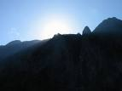
  Using Individualized Guided Meditation for Healing
  Many of us have been working on healing and clearing some of our old issues -- the pain and fears from unpleasant experiences in our past that can hold us back and block our happiness. This is one aspect of my intuitive work with other people. I strive to assist people on their paths to find more fulfillment, development their potential, and be happier.
  One modality that I have found extremely useful in my work is Guided Meditation. I do individualized Guided Meditation with people for several things: to enable people to meditate for the first time and find their center; to begin to find their own answers within; to meet guides; and to work on healing old issues. Doing this work via individualized Guided Meditation can be a gentle, yet powerful way of shifting and moving energy. Meditation in and of itself can have profound benefits. Using it for healing can be even more beneficial and powerful.
  I do individualized Guided Meditation both in person and by phone. Just contact me if you'd like to experience it in a session!
  My Schedule at Dancing Moon in Raleigh
  Below are the dates through March when I'll be available for sessions at Dancing Moon in Raleigh and at Eclectic by Nature in Greensboro. I also have the dates on my website, at www.dianebrandon.com
  I am always available for sessions in person or by phone at my home.
  Dancing Moon in Raleigh
  1840 Wake Forest Road
  12:00 Noon - 6:00 PM
  For Appointments, Call 919 833-8081
  Friday, May 29
  Thursday, June 18
  And don't forget that I'm always available for sessions in person or by phone from my home as well! Just email me atdianebrandonauthor@gmail.com or call me at 919 237-3204.
  Mentoring Group on Intuition
  I am mentoring some people who are in development for working professionally with their intuition and facilitating others. As you may know, my intuitive work is centered around facilitating others and assisting others on their paths. We're living in a time now when more people will be needed who can truly assist others and help to facilitate. The mentoring allows people to gain facilitating skills in a more rapid manner than the "on-the-job" training period one goes through when starting to work with others.
  My mentoring group is doing beautifully and I'm tickled with how those involved are doing and the perceptive questions they ask.
  If you are interested in being part of my mentoring group, please contact me. One prerequisite is first attending one of my workshops on developing intuition. Thereafter, we will meet in small groups for mentoring, practice, and guidance.
  Gift Certificates and a New Refer-a-Friend
  
  Gift Certificates
  I have been asked to offer gift certificates from time to time, whenever someone would like to give a friend or relative a session. I always seem to forget to mention that these are a possibility. So, if you would like to give the gift of a session to someone, please know that they are available.
  Refer-a-Friend
  I also wanted to let you know that, if you've had a session with me and wanted to refer someone you know, whenever you refer someone to me who has an hour session, I'll be happy to give you 15 minutes free for your next session with me. Just let me know whenever you refer someone!
  Websites Where You can Donate to Various Causes -- for Free
  The following is a listing of websites where you can donate to various causes, all for free. This is a wonderful idea!
  I'd like to thank Diana Henderson for this. She has an excellent weekly Prayer List and includes these sites in her weekly mailing.
  The Rainforest Site: http://www.therainforestsite.com/cgi-bin/WebObjects/CTDSites
  The Animal Rescue Site: http://www.theanimalrescuesite.com/clickToGive/home.faces?siteId=3
  (also several others along the top at this location)
  Care2.com's click-to-donate site http://www.care2.com/click2donate/ makes it easy to help many causes. Click on any one of them (rainforest, oceans, big cats, primates, et al) and the next page will show all of them listed near the top. Then click on each to donate to every single cause. It's a major help to have so many click-to-donate buttons on one site!
  The Ecology Fund: Save land for free at http://ecologyfund.com/ecology/_ecology.html
  (You'll be clicking four times on the Ecology Fund site: Click first the button that says Save Land; on the next page click the Save Land Coastal button; on the following page, click on Save Land under Species; on the following page, click on Save Land under U.S.A. and finally click on the Clean Air button.)
  Plant an Oak Tree: http://cannecy.free.fr/iforest/en/
  Help plant a tree (every five clicks plants a tree): http://www.landcareniagara.com/
  Save Old Growth Forests (Sweden): http://ettklickforskogen.se/
  Surrey Wildlife Trust: http://www.theenvironmentsite.org/donate.php
  Save rainforest: http://www.redjellyfish.com/wildlifeconservation.html
  Plant a tree in the rainforest: http://www.tree4life.com/ingles/ingles.htm.
  Feed Hungry Children in Argentina (click on button that says GRATIS): http://www.porloschicos.com/PorLosChicos.NET/
  Fight Hunger: http://www.hungerfighters.com/
  Feed Children: http://www.hungrychildren.com/
  Employ/Educate Impoverished: http://www.solvepoverty.com/
  If you'd like to share this email with anyone else, please fee free to forward it.
  As always, I wish you peace, light, love, and prosperity!
  Take care, Diane
  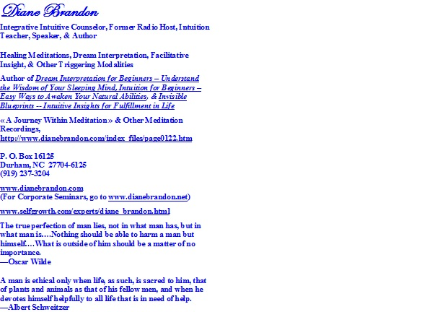
  P. O. Box 16125
  Durham, NC 27704
  (919) 237-3204

Forward email
This email was sent to dianebrandonauthor@gmail.com by dianebrandonauthor@gmail.com |
Update Profile/Email Address | Rapid removal with SafeUnsubscribe™ | Privacy Policy.

Diane Brandon | P. O. Box 16125 | Durham | NC | 27704

