From: | Diane Brandon <diane@dianebrandon.com>
Subject: | Workshop on Accessing Intuitive Information on Demand, Spiritually Aware Since Birth, Video Course, & More
Reply: | diane@dianebrandon.com
Having trouble viewing this email? www.dianebrandon.com/index_files/page0178.htm
You are receiving this email from Diane Brandon because you purchased a product/service or subscribed on our website or at an event. To ensure that you continue to receive emails from us, add dianebrandon@bellsouth.net to your address book today. If you haven't done so already, click toconfirm your interest in receiving email campaigns from us.

You may unsubscribe if you no longer wish to receive our emails.
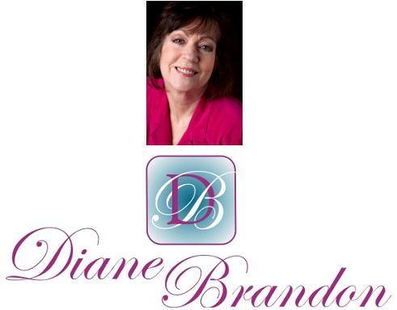

Integrative Intuitive Counselor, Radio Host, Intuition Teacher, & Author

September 6, 2014

Workshop on Accessing Intuitive Information on Demand, Spiritually Aware Since Birth, Video Course,
& More

  In This Newsletter
  Workshop on Intuition
  New Video Course on Intuition
  Your Earliest Spiritual Memory
  11:11 Phenomenon
  New Book on Dreams
  Photos of the Cosmos
  Intuition & Writing
  A Call for Dreams
  Guided Meditation for Healing
  Dream Group
  Wellness Aspects of Sleep & Dreams
  "Animals are Awesome"
  My Schedule at Dancing Moon
  Mentoring in Intuition
  Refer a Friend & Gift Certificates
  A Journey Within Meditation CD
  Donate Free to Causes
  Share
  Signature Block
  Links
  New Book:
  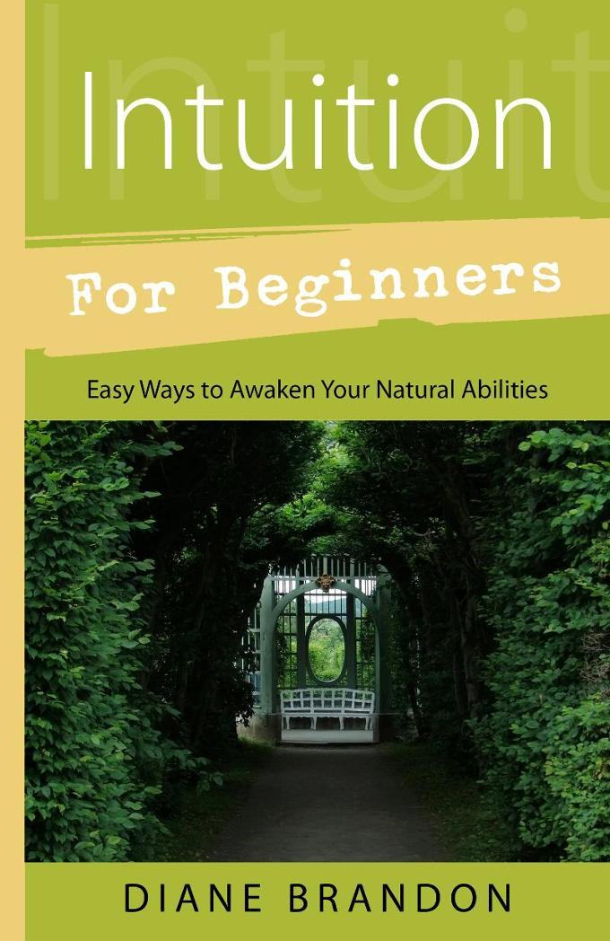
  Now Out!
  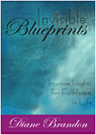
  Invisible Blueprints
  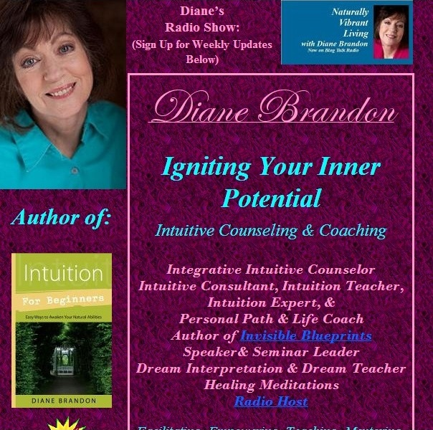
  My Site -- www.dianebrandon.com
  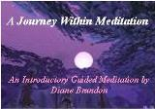
  "A Journey Within Meditation"
  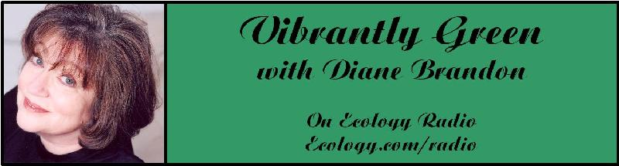
  "Vibrantly Green with Diane Brandon" Radio Show on Ecology.com
  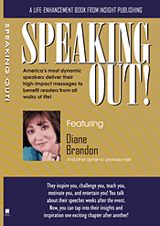
  Speaking Out
  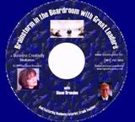
  "Brainstorm in the Boardroom with Great Leaders" Business Meditation CD
  Find Me on:
  
  Twitter
  
  https://www.facebook.com/pages/Diane-Brandon/128849587146042
  Happy Fall Season! I hope this newsletter finds you doing well and prospering!
  It's hard to believe that Fall is almost here. This year, despite its intensity, has been going by seemingly quickly, perhaps more quickly than we may have anticipated.
  If you've felt that this year has been intense, you're not alone. Various astrological aspects this year seem to be keeping us inner-focused and trying to put figurative fires out in our lives, while from time to time encountering polarization and volatility. It has felt that, as soon as we move through one difficult phase, another challenging astrological aspect is upon us. Many astrologers have written that this year is about inner work and clearing -- and it has indeed felt that way!
  The current intensity should begin to lighten up, according to what I've read, after the 14th. Another astrologer has written that the last week of December through part of August 2015 should bring considerably lighter energy. We may all feel ready for that!
  We appear to have more turmoil in our world externally now, compared to a few months ago. All the more reason, I feel, for us to try to center, meditate, work on personal clearing and healing, and feel positive energy in and around us. As we each clear and feel more positive, we are adding more positive energy to this world, in addition to not contributing to the external turmoil.
  I don't have a lot of new things to share with you in this newsletter. I did want to remind you about my upcoming workshop on intuition on Saturday, September 20th in Raleigh. This workshop is a wonderful opportunity to uncover your intuition and begin to hone it, while practicing accessing pure information that is not affected by any personal stuff. It's an all-day intensive with many exercises and discussion. You'll find more information on it below.
  We are truly living in interesting times, and it feels as if the triggers for positive change and awakening in our world have definitely been increasing. Some of what we're seeing externally in the world may feel scary or disconcerting. Knowing that there's a higher purpose for everything can enable us to stay centered and remember our spiritual origins and orientation.
  As always, I wish you great joy, health, love, peace, and prosperity! Please contact me should you want a private session!
  Take care,
  Diane
  P. S. If you have any trouble reading this, just go to www.dianebrandon.com/index_files/page0178.htm, where it will be archived in a day or two.
  
  Workshop in September
  On Developing Intuition & Accessing it On Demand
  Most people have had experiences with their intuition when they have received information spontaneously. However, we can also learn how to access intuitive information on demand. Once we have learned that critical skill, developing it can be a lot easier. Of course, we also want to make sure that we're receiving information that is as pure and reliable as possible.
  Intuition can be a powerful tool for us in our lives. It helps us to find some of our own answers within, connect more with the Divine, and can be quite empowering. Paying attention to our inner voice can also aid in our own unfolding and lead us to be more centered, less reactive, and feel more confident --
  and can benefit our relationships -- as well as other areas of our lives.
  Some of us who have developed our intuition and regularly listen to our inner voice can not only attest to it being an aid in our daily living, but have also found that it can lead us to live our lives at times as somewhat of a walking meditation.
  Developing our intuition can be a matter of learning how ours works, and which form(s) it takes, learning to listen to it and not doubt it, learning how to get pure information unclouded or affected by our personal "stuff," learning how to work with the information we receive, and remembering to be open to what we're given. Using our intuition for others can also require developing our own set of ethics and personal responsibility.
  I have been teaching others this wonderful skill since 1996 and will be teaching an all-day workshop on it in September that will go from the basics to advanced exercises. Below are the details:
  Accessing Intuitive Information on Demand -- Workshop
  Dancing Moon
  1840 Wake Forest Road
  Raleigh, NC
  http://dancingmoonraleigh.com
  Saturday, September 20, 2014
  10:30 AM - 5:30 PM
  $95.00 if Registered & Paid in Advance, $105.00 at the Door
  To Register, Just Contact Me
  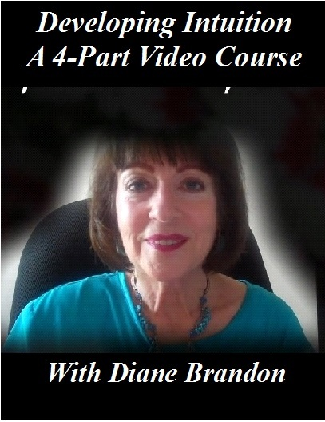
  New Video Course Available --
  "Developing Your Intuition & Accessing Information on Demand"
  https://vimeo.com/ondemand/DevelopingIntuition
  As you probably know, I have been teaching intuitive skills to others for several years now (since 1996, in fact) -- primarily how to access intuitive information on demand (as opposed to waiting for information to come) and how to bypass personal stuff, so as to receive pure and more reliable information.
  I've primarily taught this in an intensive all-day workshop (which I'll be teaching in Raleigh, NC on Saturday, September 20th), as well as in ongoing classes, as well as in one-on-one classes and coaching.
  I've now developed an abbreviated version of my workshop on video -- in a four-part course, entitled "Developing Your Intuition & Accessing Information on Demand." The following are the four parts of this video course:
  Part 1: Exploring What Intuition is -- & Isn't
  Part 2: Exploring Deeper Levels for Intuition
  Part 3: Exploring Certain Types of Intuition through Exercises
  Part 4: Honing Intuition through Advanced Exercises
  Available at https://vimeo.com/ondemand/DevelopingIntuition
  I'm excited to finally make this available in video format. It's still not the same as attending one of my workshops or classes in person, but it will make my teaching material more available, especially in conjunction with my book, Intuition for Beginners.
  
  What is Your Earliest Memory? -- Looking to Interview People who were Born Aware
  I have always remembered what I thought when I was born. I never shared that with anyone until the past several years because I hadn't realized that it was unusual. I have come to know other people who remember their thoughts as an infant or extremely young child before they learned to speak -- or, in some cases, even before they were born -- and have begun to conduct interviews by phone and work on a book about it.
  I'm considering "spiritually aware since birth" to mean an awareness of not belonging here, or of higher levels, or of a connection to God or Spirit, or of not being the baby lying there, or even of coming from a different place or family, or having an awareness separate from the human persona/personality.
  I'm looking for people to interview with spontaneous memories and not those recalled after an external trigger such as regression, rebirthing, or any other modality.
  I'm looking for about 7 more people to include in the book and people can be included anonymously, unless they prefer to have their name used. I'll be sending a copy of the book to those people whose interviews are in the book.
  If you remember having spiritual thoughts or awarenesses at a very young age, please do let me know. (You can email me at diane@dianebrandon.com.) I feel that it's important for us to know that we're not alone and that we can all learn from these fascinating experiences.
  An Article on the 11:11 Phenomenon
  I'm sure you've heard of the 11:11 phenomenon and have probably experienced it yourself. Back in the 90s, clients started asking me about it, after they had experienced it. In a synchronistic fashion, they started seeing the same number sequence over and over again, whether 11:11, 12:12, 3:33, 4:44, etc. They might wake up and look at a clock and see 11:11, for example. They would see the same number sequence over and over again. And please note that this is not at all limited to 11:11, as other number sequences are part of this phenomenon.
  Even though I first heard about this phenomenon (and experienced it myself) back in the 90s, apparently the phenomenon has really gotten more widespread in the past year or so. As a result, a colleague of mine, Alexis Brooks, interviewed a few intuitives about it and wrote an article about it "11:11 and the Multiplicity of Meaning."
  You can find her article on it at
  http://higherjourneys.blogspot.com/2014/06/1111-and-multiplicity-of-meaning.html
  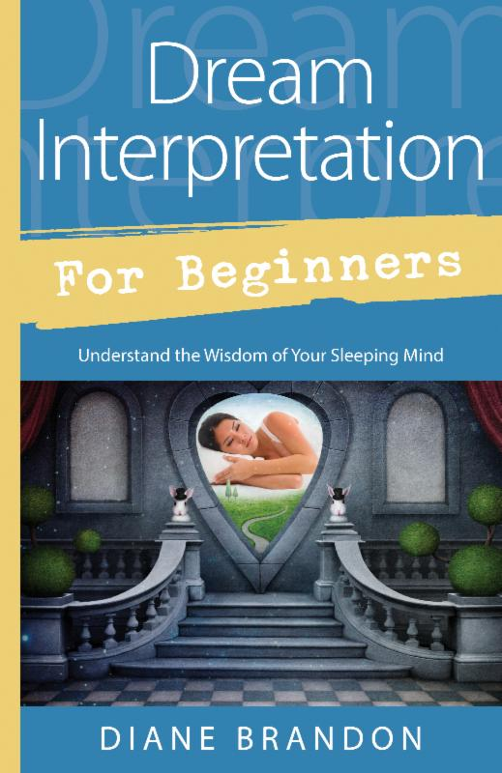
  New Book on Dreams, "Dream Interpretation for Beginners" Coming Out in March 2015
  My new book on dreams will be published in Winter of 2015 and will be entitled "Dream Interpretation for Beginners -- Understand the Wisdom of Your Sleeping Mind." It will be a fairly comprehensive treatment of our world of sleep and dreams, how to interpret and understand our dreams, and how to use the insight we gain from them. It will also include many sample dreams with their interpretations and ideas on how to apply their insight.
  Stunning Photos of the Cosmos
  
  You have probably seen some of the stunning images that the Hubble Space Telescope has taken. I recently saw more of them, some more recent. They're breathtaking. You can see them at
  http://www.weather.com/news/science/top-100-photos-hubble-space-telescope-20140424
  Intuition and Writing
  
  I was recently interviewd by a mystery writer, Carolyn Rowland, on using intuition as a tool for writing. It was a fascinating interview because Carolyn asked some excellent and thought-provoking questions. If you're a writer, into mysteries, or interested in this topic, you can find her interview on her blog, at http://mostlymystery.com/intuition-and-writing-an-interview-with-diane-brandon/
  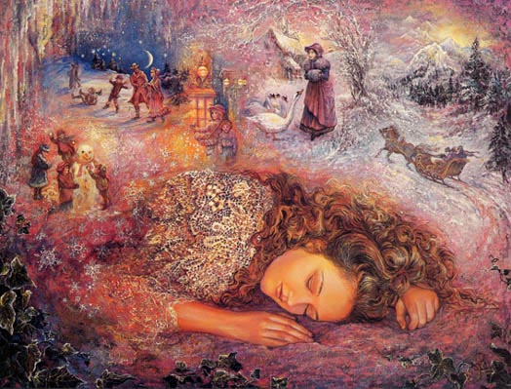
  A Call for Dreams
  I'm planning on writing another book on dreams, which will follow the one coming out in a year. It will primarily be dreams with their interpretations. I'm in the process of collecting dreams for that book. If you have some interesting ones, please do send them to me. Please note that all dreams are included anonymously to protect the dreamers' privacy Below is more information:
  Please Submit Dreams
  Your Dreams will be Included Anonymously
  I Will Interpret Your Dreams for Free
  I Will Send You a Free Copy of the Book After it's Published if Your Dream is Included
  Please Send Your Dreams in Complete Detail, as They Unfolded -- No Short Summaries
  The Publisher Requires, of Course, that a Release be Signed
  Please Email Them to Me at diane@dianebrandon.com
  I do have a Dream Group on Facebook, where people can record their dreams and receive interpretations. It's called Your Dream World and is at https://www.facebook.com/groups/125990490759247/ I would love to have you join!
  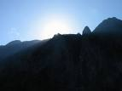
  Using Individualized Guided Meditation for Healing
  Many of us have been working on healing and clearing some of our old issues -- the pain and fears from unpleasant experiences in our past that can hold us back and block our happiness. This is one aspect of my intuitive work with other people. I strive to assist people on their paths to find more fulfillment, development their potential, and be happier.
  One modality that I have found extremely useful in my work is Guided Meditation. I do individualized Guided Meditation with people for several things: to enable people to meditate for the first time and find their center; to begin to find their own answers within; to meet guides; and to work on healing old issues. Doing this work via individualized Guided Meditation can be a gentle, yet powerful way of shifting and moving energy. Meditation in and of itself can have profound benefits. Using it for healing can be even more beneficial and powerful.
  I do individualized Guided Meditation both in person and by phone. Just contact me if you'd like to experience it in a session!
  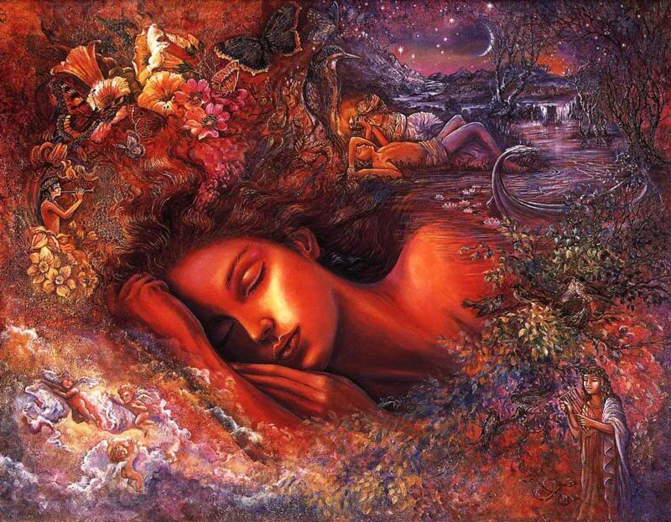
  Dream Group on Facebook
  If you're on Facebook and are interested in Dreams, I wanted to let you know about a dream group I have there, Your Dream World. As a member, you can post your dreams and receive comments, as well as post comments on others' dreams.
  I've been working with dreams for over 30 years now, helping others to understand theirs and use them as a tool for unfolding in their lives. I know how powerful our dreams can be and how much they can enrich our lives.
  If you'd like to join the group, just go to http://www.facebook.com/group.php?gid=125990490759247&ref=search&sid=KZDFUfM7BzZqEwsalPR2OA.1574544751..1#!/group.php?gid=125990490759247
  A Video on
  The Wellness Aspects of Sleep and Dreams
  As part of my research on dreams, I've also delved into our world of sleep and have been fascinated by the amount of research that has been done on it. A whole body of research findings have come out in the past ten years on the health aspects of this other world of ours. As a result, I've done some lectures on the Wellness Aspects of Sleep and Dreams.
  There is now a video available of one of my lectures and it's now accessible to rent or to purchase. Just go to
  http://vimeo.com/ondemand/sleepanddreams
  I also have a page on my website where all my Books, CDs, Recordings, and Videos can be found. I did have them scattered throughout, but it should be easier to find things with them all on one page. They're at http://www.dianebrandon.com/index_files/page0122.htm
  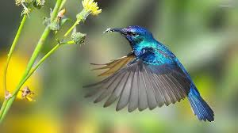
  Video: "Animals are Awesome"
  I'm an animal lover. To me, they're directly connected spiritually and speak to us of innocence and purity. I love this video that I recently saw and hope you will to. It's at https://www.youtube.com/watch?v=QcvmJTH84KA
  My Schedule at Dancing Moon in Raleigh
  Below are the dates through March when I'll be available for sessions at Dancing Moon in Raleigh and at Eclectic by Nature in Greensboro. I also have the dates on my website, at www.dianebrandon.com
  I am always available for sessions in person or by phone at my home.
  Dancing Moon in Raleigh
  1840 Wake Forest Road
  12:00 Noon - 6:00 PM
  For Appointments, Call 919 833-8081
  Thursday, September 11
  Thursday, September 25
  And don't forget that I'm always available for sessions in person or by phone from my home as well! Just email me at diane@dianebrandon.com or call me at 919 237-3204.
  Mentoring Group on Intuition
  I am mentoring some people who are in development for working professionally with their intuition and facilitating others. As you may know, my intuitive work is centered around facilitating others and assisting others on their paths. We're living in a time now when more people will be needed who can truly assist others and help to facilitate. The mentoring allows people to gain facilitating skills in a more rapid manner than the "on-the-job" training period one goes through when starting to work with others.
  My mentoring group is doing beautifully and I'm tickled with how those involved are doing and the perceptive questions they ask.
  If you are interested in being part of my mentoring group, please contact me. One prerequisite is first attending one of my workshops on developing intuition. Thereafter, we will meet in small groups for mentoring, practice, and guidance.
  Gift Certificates and a New Refer-a-Friend
  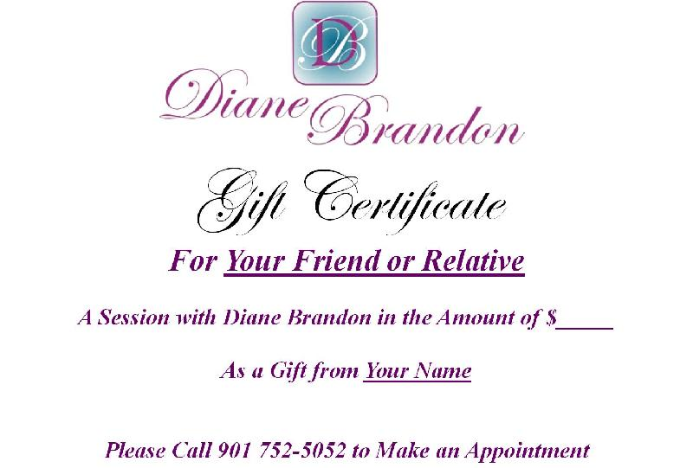
  Gift Certificates
  I have been asked to offer gift certificates from time to time, whenever someone would like to give a friend or relative a session. I always seem to forget to mention that these are a possibility. So, if you would like to give the gift of a session to someone, please know that they are available.
  Refer-a-Friend
  I also wanted to let you know that, if you've had a session with me and wanted to refer someone you know, whenever you refer someone to me who has an hour session, I'll be happy to give you 15 minutes free for your next session with me. Just let me know whenever you refer someone!
  "A Journey Within"
  New Guided Meditation Recording Now Available
  I'm so pleased to now be able to offer this guided meditation recording. I'm a huge proponent of guided meditation for several reasons, and I do individualized guided meditations with clients regularly. Meditation allows us to get into our center and when one does this for the first time it can be very striking. We immediately feel more centered afterwards and begin to feel more in command of ourselves. It also allows us to begin to find our inner voice and intuition.
  I also use Guided Meditation to work on specific issues. In fact, "A Journey Within Meditation" is an introductory guided meditation and I plan on doing a series of meditation recordings.
  Meditation also gives us many health benefits, including the following ones:
  The Gifts Meditation can Give
  · Stress Reduction via reduced levels of two stress hormones, cortisol and lactate
  · Reduction of High Blood Pressure
  · Enhanced Concentration and Mental Focus
  · Better Skin Conductance (indicative of lowered stress)
  · Enhancement of Relaxation
  · Decreased Anxiety
  · Decreased Depression (increases production of serotonin)
  · Decreased Irritability and Enhanced Sense of Contentment
  · Lowered Cholesterol
  · Improved Memory
  · Improved Breathing Air Flow
  · Higher Level of DHEA in Elderly
  · Lowered Metabolic Rate, Heart Rate, and Reduced Burden on Heart
  · Reduction of Free Radicals
  · Reduces PMS Symptoms
  · Enhances Immune System
  · Has Anti-Aging Effects
  Meditation has also been shown to reduce crime and increase compassion.
  "A Journey Within" is available either as an MP3 file that you can download or as a hard-copy CD.
  "A Journey Within"
  Hard-Copy of CD: $18.95 + Shipping
  To Order the CD, Go to www.dianebrandon.net/products.asp
  MP3 Downloadable File of Meditation: $16.95
  To Order the MP3 File, Go to www.dianebrandon.com/index_files/page0176.htm
  I'm excited to finally be able to offer some Guided Meditation Recordings and feel very positive about the future ones I'll be doing as well!
  Websites Where You can Donate to Various Causes -- for Free
  The following is a listing of websites where you can donate to various causes, all for free. This is a wonderful idea!
  I'd like to thank Diana Henderson for this. She has an excellent weekly Prayer List and includes these sites in her weekly mailing.
  The Rainforest Site: http://www.therainforestsite.com/cgi-bin/WebObjects/CTDSites
  The Animal Rescue Site: http://www.theanimalrescuesite.com/clickToGive/home.faces?siteId=3
  (also several others along the top at this location)
  Care2.com's click-to-donate site http://www.care2.com/click2donate/ makes it easy to help many causes. Click on any one of them (rainforest, oceans, big cats, primates, et al) and the next page will show all of them listed near the top. Then click on each to donate to every single cause. It's a major help to have so many click-to-donate buttons on one site!
  The Ecology Fund: Save land for free at http://ecologyfund.com/ecology/_ecology.html
  (You'll be clicking four times on the Ecology Fund site: Click first the button that says Save Land; on the next page click the Save Land Coastal button; on the following page, click on Save Land under Species; on the following page, click on Save Land under U.S.A. and finally click on the Clean Air button.)
  Plant an Oak Tree: http://cannecy.free.fr/iforest/en/
  Help plant a tree (every five clicks plants a tree): http://www.landcareniagara.com/
  Save Old Growth Forests (Sweden): http://ettklickforskogen.se/
  Surrey Wildlife Trust: http://www.theenvironmentsite.org/donate.php
  Save rainforest: http://www.redjellyfish.com/wildlifeconservation.html
  Plant a tree in the rainforest: http://www.tree4life.com/ingles/ingles.htm.
  Feed Hungry Children in Argentina (click on button that says GRATIS): http://www.porloschicos.com/PorLosChicos.NET/
  Fight Hunger: http://www.hungerfighters.com/
  Feed Children: http://www.hungrychildren.com/
  Employ/Educate Impoverished: http://www.solvepoverty.com/
  If you'd like to share this email with anyone else, please fee free to forward it.
  As always, I wish you peace, light, love, and prosperity!
  Take care, Diane
  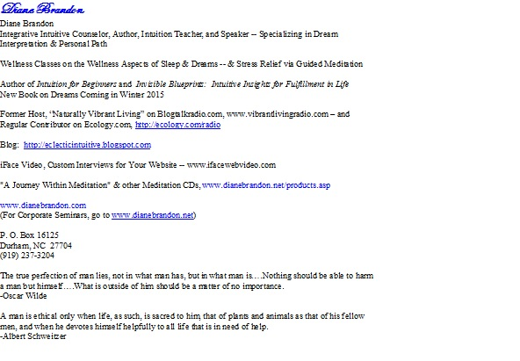
  P. O. Box 16125
  Durham, NC 27704
  (919) 237-3204


  Forward email
  This email was sent to dianebrandon@bellsouth.net by diane@dianebrandon.com |
  Update Profile/Email Address | Rapid removal with SafeUnsubscribe™ | Privacy Policy.
  
  Diane Brandon | P. O. Box 16125 | Durham | NC | 27704

